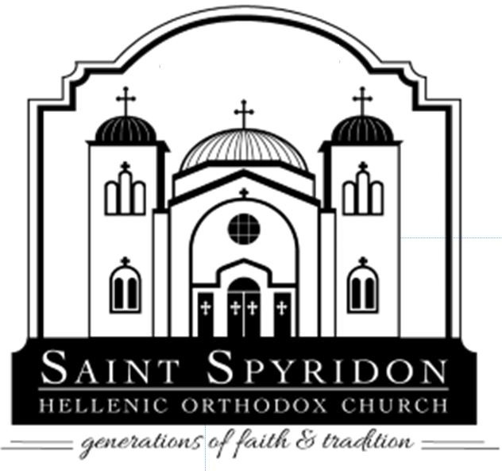
Saint Spyridon Hellenic Orthodox Church

Charles C. Condes Memorial Scholarship

The Memorial Scholarship Committee of St. Spyridon, Palos Heights offers a scholarship to a college undergraduate or graduate student who has completed a minimum of one year in their respective major in an accredited college or university and who is a steward of our parish. This is a competitive scholarship based on the criteria outlined below.

Charles C. Condes Memorial Scholarships Offered:
(1) $2,500
(1) $1,250
(1) $1,250
Requirements are the following:
- Currently enrolled college students with 1 year (2 semesters) completed are eligible to apply.
- Applicant must be a son/daughter of a steward of St. Spyridon Hellenic Orthodox Church.
- A copy of college transcript with school’s official seal that illustrates one-year completion.
- Essay and Formal Resume
- References (minimum one of the below options):
  - the first from a teacher or professor, advisor, counselor, or dean.
  - the second – personal or business reference that is a non-family member.
    - Letters of recommendation must be on school or business letterhead.

APPLICATION & ALL REQUIRED DOCUMENTS MUST BE SUBMITTED AND SIGNED ELECTRONICALLY ON OR BY JULY 24TH, 2026 TO OFFICE@SAINT-SPYRIDON.NET.

NOTE: PREVIOUS WINNERS OF THE CONDES SCHOLARSHIP ARE NOT ELIGIBLE TO APPLY

*If cannot submit electronically, please print application, sign, and scan in documents to be submitted via email.*

Incomplete applications or those postmarked after this date will not be processed. All information received from applicants will be treated as confidential.
After a review of a candidate’s application and equal consideration of eligibility requirements, the winner will be selected upon a recommendation of an independent anonymous Scholarship Review Board.

Scholarship will be awarded on August 23 2026, following the Divine Liturgy.

Applicant Information

Full Name: |  | Application Date:
Last | First | M.I.

Address:
Street Address | Apartment/Unit #

City | State | ZIP Code

Phone: Email
Education
High School: Address:

From: | To: | Did you graduate? | YES | NO | GPA :

College: Address:

Start Date: | Anticipated Graduation Date: | Major: | GPA:
Scholarship Criteria
Essay (attach a separate document)
Please provide a one-page (500 word) typed essay that illustrates how a personal accomplishment, event, or volunteer experience directly impacted your academic or career goals.

Resume (attach a separate document)
Please provide your formal resume that illustrates your work experience, academic activities and honors, and community/parish involvement.
References
(First & Last Name, Title, School or Company) (Attach reference documents separately)
- Academic:

- Personal (Non-Family) or Business:

Application Certification

Signature of Applicant: Date:

