Toxins are Neutralized with Alkaline Ionized Water
Our bodies need water to eliminate or buffer acidic conditions caused by the normal aging process as well as a poor diet, stress, physical activity and environmental toxins. The ionization process concentrates available alkaline minerals in the source water to aid the buffering systems in the body.
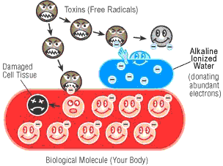
Toxins (free radicals) in the body, break down the cells, making them susceptible to disease. More effective than any other antioxidant, alkaline ionized water readily donates its abundant electrons to neutralize excessive free radicals so they do not cause damage by stealing electrons from healthy living cells.

There are benefits in Smaller Water!
Through ionization, large tap water clusters are reduced from their original size. The smaller cluster size gives the water excellent hydrating properties, high solubility and good permeability which enables ionized water to penetrate deep into tissues of the body.
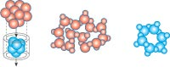
Microwater closely replicates the "living" qualities of high altitude mountain spring water. It's fresh, delicious, life enhancing water produced right at your own faucet!

Alkaline Ionized Water is backed by Solid Scientific Evidence
"We are advancing the theory that the most effective and economical source for an antioxidant is ordinary tap water after it is filtered and treated with electrolysis. This electrolyzed water, called Microwater, is one of the most exciting developments of preventative medicine in Japan in recent years." - Hidemitsu Hayashi, M.D. Director, Water Institute of Japan

