**FL2-O Stuart “Treasure Coast Riders” Ride Report – Friday 10, 2025**

Captains Gallery – Fort Pierce: FL2-O Stuart met-up with FL2-D Melbourne for brunch at the Captains Callery, where some had breakfast and others lunch. We had good service and the food was good. It was a chilly morning to start the day off but it turn-out prefect day for riding. My Big Red went 125 miles today, John DuBose

FL2-O Stuart Riders: John, Jim and Joe

FL2-D Melbourne Riders: Harry & Lynn, Loraine, Paul and Tom

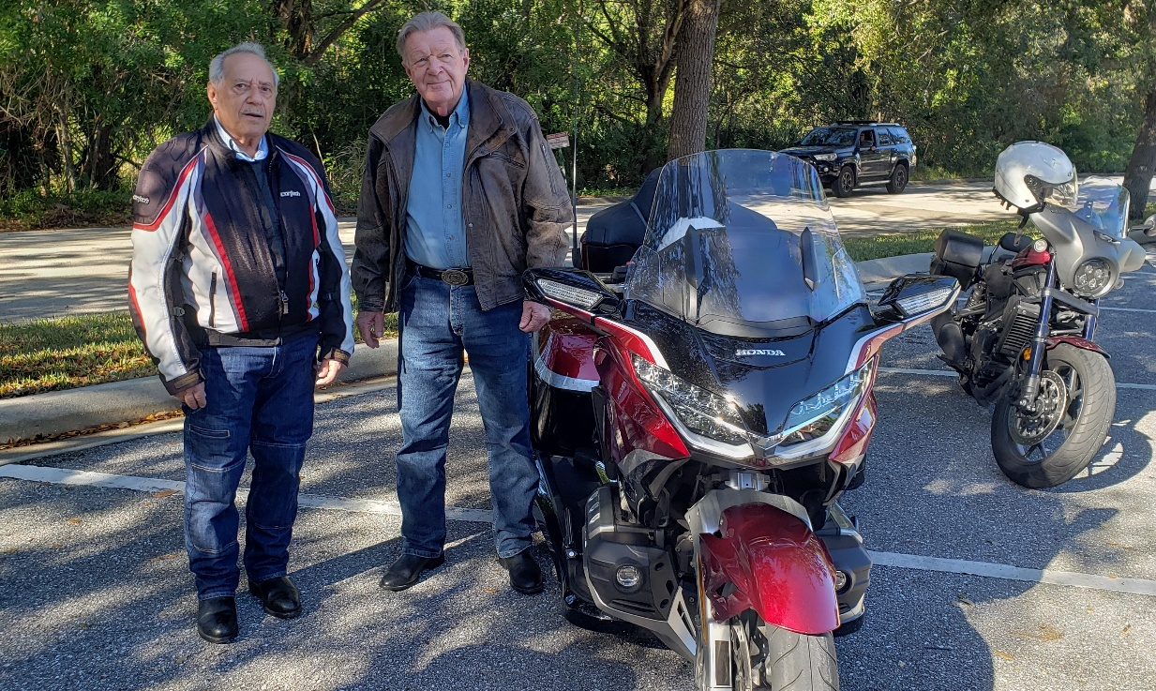

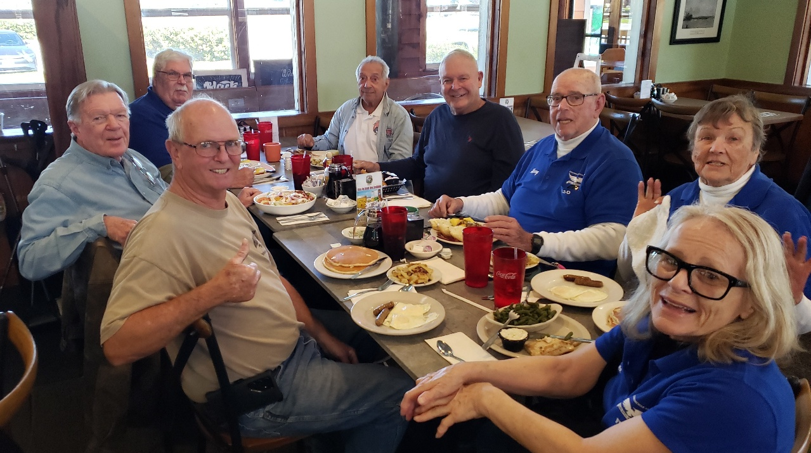FL2-O Jim Rich and Joe Pisano

**FL2-O Stuart:** Jim– John – Joe with **FL2-D Melbourne:** Paul – Harry & Lynn – Loraine - Tom