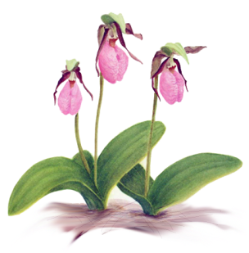

Sandown Garden Club Scholarship

Our club symbol is the pink Lady’s Slipper Orchid
(Cypripedium acaule), which grows wild in the mixed hardwood
and pine forests in Sandown.

The Sandown Garden Club was founded in April 2008 and is a member of the New Hampshire Federation of Garden Clubs and the National Garden Clubs, Inc.

The purpose of the SGC is to share the knowledge of gardening with each other and the community; to participate in activities that increase the beauty of the town’s public and historic grounds; to encourage the preservation of native plant species; encourage respect for the environment and demonstrate techniques that conserve natural resources.
The Sandown Garden Club Scholarship is awarded to one student* in their senior year at Timberlane Regional High School (TRHS) who meets the following criteria:
- Be expected to graduate at the end of their senior year
- Be accepted to an accredited institution of higher education (either a 2-year or 4-year program)
- Pursue a major or minor in a gardening-related field such as agronomy, agriculture education, floriculture, horticulture, landscape design, plant biology, wildlife science, soil/plant science, city (rural/urban) planning, habitat or forest systems ecology, forestry, environmental concerns, botany, chemistry, biology, environmental conservation, land management, sustainable agriculture and food systems or earth science

Selection Deadline: May 21, 2027

Name ____________________________________________Town _____________________
To help with the selection process, please include your academic choice and any additional information to show how you meet the Sandown Garden Club scholarship criteria.

___________________________________________________________________________
___________________________________________________________________________
___________________________________________________________________________

Name of accredited institution of higher education (either a 2-year or 4-year program) and intended major or minor in a gardening-related field

What are your goals in this field?
___________________________________________________________________________
___________________________________________________________________________

