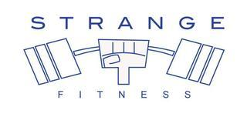
Disclaimer of Liability

Shera Strange is not a physician or psychologist, and the scope of his/her consultation services does not include treatment or diagnosis of specific illnesses or disorders. If I, the client, suspect I may have an ailment or illness that may require medical attention, then it is my responsibility to consult with a licensed physician immediately. Only a licensed physician can prescribe drugs.

﻿Any mention of drugs in the course of consultation is only to provide a complete history of drugs that the client is taking and not for Shera Strange to judge the appropriateness of the medication. Any change in prescription or dosage is a decision the client makes with his or her physician.

Rather than dealing with the treatment of disease, Shera Strange focuses on wellness and prevention of illness through the use of natural nutritional therapies to achieve optimal health. As a certified Health Coach and Personal Trainer, Shera Strangeprimarily educates and motivates clients to assume more personal responsibility for their health by adopting a healthy attitude, lifestyle, and diet.

While people generally experience greater health and wellness due to embracing a healthier attitude, lifestyle, and diet, Shera Strange does not promise or guarantee protection from future illness.
By signing below, I acknowledge that I understand that Shera Strange is a Personal Trainer and Certified Health Coach, not a physician and that I should see a doctor if I think I have a medical condition. Shera Strange will not be held liable for failure to diagnose or treat an illness, nor will she/he be liable for failure to prevent future illness.

In addition, I have given Shera Strange a complete and accurate account of any medical conditions I may have and any medications I am taking.

By Signing, I agree to the terms. ____________________________

DATE:

