Communication and Language  *Bean action song (runner bean, jumping bean etc.)  *Listen to Jack and the beanstalk – retell the story using puppets/masks.  *Play audio books in a quiet area – can they follow along with the book?  *Go on a listening walk outside – what can you hear? | Personal Social and Emotional Development  *Cut out pictures from magazines to make a garden picture, how do the flowers make them feel?  *Florist/garden centre role play area.  *Make a friendship tree – add leaves when children do something kind with another child.  *Taking in turn games. | Physical Development  *Thread cereal onto spaghetti to make a beanstalk.  *How is food grown? Does it grow on top of or under the soil?  *Observe how food changes over time.  *Make salt dough trees and plants then decorate when dried.  *Baking – flower in a garden chocolate cupcake.  *What food has seeds in it? Look at the difference between the seeds.  *Seed sorting – finger gym activity.  *Flower themed cutting activity.  *Look at foods that are healthy and not healthy. | Literacy  *Alphabet beans – make your name out of beans.  *Jack in the beanstalk story map.  *Build a rhyming Beanstalk outside.  *Design a packet for seeds.  *Look rhyming books and discuss which words rhyme.
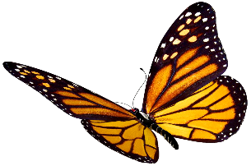
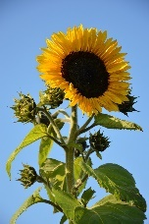
Term: Summer term 1
This Photo by Unknown Author is licensed under CC BY-NC
Topic: Growing and Planting
Additional Activities  *Dentist Visit  *Butterfly Farm  *Baby pictures – can you guess who the baby pictures are?  *Add non-fiction books to the reading area.  Messy Play  *Green Jelly  *Green Shaving foam  *Soil  *Seeds/beans/lentils |  |  | Mathematics  *Green leaves with numbers and dots – match the number to quantity.  *How to make 5? Use a vase and flowers, how many ways can you make 5?  *Scales in soil. Add natural objects to investigate what ways the same.  *How tall am I? Measure children at the start if term and at the end. How much have they grown over the term?  *Sort seeds into trays.  *Flower dominoes.
 | Expressive Arts and Design  *Cloud painting.  *Blob and fold butterfly pictures.  *Pick flowers and make a picture to laminate.  *Finger paint flowers.  *Make a fairy garden using items they find outside.  *Use musical instruments when singing nursery rhymes.  *Junk modelling to make a castle at the top of the beanstalk. | Understanding the World  *Plant life cycle.  *What do seeds/plants need to grow? Look at different environments.  *Paint Sunflowers.  *Life cycle on a caterpillar.  *Plant hunt in the garden using a checklist to tick of when they have found different flowers.  *Set up a planting area outside.  *Grow different types of plants/food – cress heads, sunflowers, beans, carrots. Tomatoes.  *Plant a seed at different times over a week and watch how they grow observing each stage of the seed growing.  *Plant seeds and keep them in different conditions (light/dark. Water/no water).

