The Divine Embodiment Soul Gathering

Sedona Retreat, March 20-22, 2020

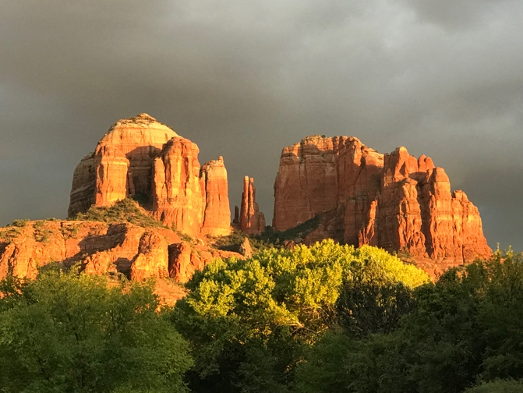

We present - An Enlightened Event of Freeing Yourself from Limitation and Living a Life of sovereignty, a life of purpose, Joy, LOVE, Prosperity and the reunification of your soul family.

We join together in amazing Sedona, AZ as the bridges of the Nu Earth co-creating a life of Consciousness and propel the collective into the “new area”.

Imagine AWAKENING YOU TO YOUR FULL DIVINE POTENTIAL!!!

All Inclusive Sedona Event is being held
March 20th - March 22nd 2020 and we are Excited to share this with you ALL!!!

THE DESTINATION

SOLD OUT!!!

3 days and 2 nights all-inclusive; Private home in Sedona. SOLD OUT!!!

What’s Included:
- Deluxe accommodations for three days and 2 nights @ private home.
- Picnic lunches (2 days)
- Tea, snacks, and sacred water
- Welcoming dinner
- Activations + All Entrance Fees + Transportation + Guide for all excursions
(Optional *Guided Vortex excursions are available at an extra cost.)
- Teachings, invocations, spiritual expansion
- Crystals for site offerings
- Goodie Bag!!!
- Personal Time, for contemplation, integration, journaling
- Personal Time to Crystal Shop!!

Personal Investment: $1,111.
- additional guest, (spouse or shared bed) $888
$333 deposit required to hold your reservation. Space is limited
$ balance due 2/2/2020
Remit payment to: SOLD OUT!!

*Optional guided vortex tours and healings are available
Private healing sessions $150
Private Vortex Guided Tours $222 per person per day
Extend your stay! Optional nights are available upon request for an additional $275 per person per night.

What’s Not Included:

- Your round-trip airfare from home.
- Personal Transportation from airport to Sedona
- Souvenir shopping, spa services, taxis, etc
- Personal, medical or trip cancellation insurance.
- Personal Transportation to and from town
- Food and beverages
2 Day Retreat Entrance cost only, (All other site accommodations)

- Includes activations and activities
- Picnic lunches (2 days)
- Tea, snacks, and sacred water
- Activations + All Entrance Fees + Transportation + Guide for all excursions
(Optional *Guided Vortex excursions are available at an extra cost.)
- Teachings, invocations, spiritual expansion
- Crystals for site offerings
- Goodie Bag
- Personal Time, for contemplation, integration, journaling
- Personal Time to Crystal Shop!!
- Crystals for site offerings

Personal Investment: $555 per person

$144 deposit is required to hold reservation (non-refundable)
Remit payment to: https://www.paypal.com/paypalme/ABBNMH
Venmo Me: 214-502-9317

Remaining balance due: 2-2-2020

*Optional guided vortex tours and healings are available
Private healing sessions $150
Private Vortex Guided Tours $222 per person per day

What’s Not Included

- Your round-trip airfare from home.
- Personal Transportation from airport to Sedona
- Hotel accommodations
- Souvenir shopping, spa services, taxis, etc
- Personal, medical or trip cancellation insurance.
- Personal Transportation to and from town
- Food and beverages

One DAY PASS Option $333.00

Optional One Day Pass, for those who cannot attend all three days we are offering a ONE day pass option. Payment can be submitted days prior to the actual event. A ticket will be sent via e-mail to grant access along with details and location meeting place. All payments must be made to: https://www.paypal.com/paypalme/ABBNMH or Venmo Me: 214-502-9317

- Includes entrance to ONE day of activities and activations

What’s Not Included:

- Your round-trip airfare from home.
- Personal Transportation from airport to Sedona
- Souvenir shopping, spa services, taxis, etc
- Personal, medical or trip cancellation insurance.
- Personal Transportation to and from town
- Food and beverages
- Hotel accommodations
- Meals (optional meal supplements are available at the event $25 per meal)

*Optional guided vortex tours and healings are available
Private healing sessions $150
Private Vortex Guided Tours $222 per person per day

We look forward to seeing you in Sedona and We our honored be to be of service.

Audrey

Questions: audrey@whitangelacademy.com or audreybb@me.com

Location
Private home. Location will be sent upon 2-2-2020

Considerations
Spring and Fall is prime season in Sedona. Sedona is small and things are not too far but likely crowded a bit. If you are not renting a car, Uber is available in Sedona.

Flights and Transportation
Phoenix International Airport (PHX) will likely have the most available flights. It is a two hour drive from Sedona. You can rent a car or take a shuttle service into Sedona. There are also car rentals available in Sedona.

You can also fly into Flagstaff (FLG), which is a 45 minute drive from Sedona, though it may not have as many flight choices or savings. Shuttle services are available from Flagstaff as well.

Airport Shuttles

Option 1:
Coming from PHOENIX SKY HARBOR INTERNATIONAL AIRPORT to Angel Valley by Shuttle,
Ace Xpress brings you to our office and picks you up upon departure. Your driver picks you up at the airport when they know your flight number and arrival time. For your return they make sure you will be at the airport in time to catch your flight and inform you at what time you will be picked up at Angel Valley. Please, book your return flight in such a way that you allow Ace Xpress enough time to work you into their schedule. They are available for late arrivals and early departures.
Visit www.AceXShuttle.com.

Option 2:
If you prefer more personalized and faster transportation from and to PHOENIX SKY HARBOR,
we recommend Red Rock Transportation. Visit www.RedRockTransportation.com.
Option 3:
Coming from FLAGSTAFF PULLIAM AIRPORT, there is a shuttle service that leaves from the train station at 8:00AM and at 4:00PM. This shuttle drops you off in Sedona Uptown. The only other option is to rent a car. Visit www.ArizonaShuttle.com.

Recommended Attire

Since a lot of our time will be spent outdoors, lite hiking. Early mornings the temperature will vary as it can be cold in the am and then warmer middays, then cooler in the evenings.
This is prime season for beautiful weather, so bring your hiking shoes,

What to bring:

Casual clothing to dress in layers
March: light clothing for the daytime and a sweater for night-time.
Early mornings: warm clothing is recommended mid March the average temperature is a high in the 70s and low in the 40- 50s.
Comfortable shoes - water bottle - flashlight - journal.
For your outdoor activities: hiking boots - sun protection - binoculars – camera, sunscreen, sunglasses and a hat.

WEATHER Climate in Sedona:

Spring and Fall are prime season’s in Sedona. With Sedona's elevation of 4500 ft., we find ourselves in the high desert. This means an abundance of sunshine and little rain. The differences in temperature of day and night are considerable all through the year. March it may be below freezing at night. However, the days are often pleasant enough for only a light coat or a sweater.

We are so honored and grateful and look forward to joyfully co-creating the New Earth with You All!!!

For those staying with us, please let me know if you have any special dietary request and get me your flight information as well, so I know when to expect your arrival time for Friday.

Much Love and Light,

Audrey

