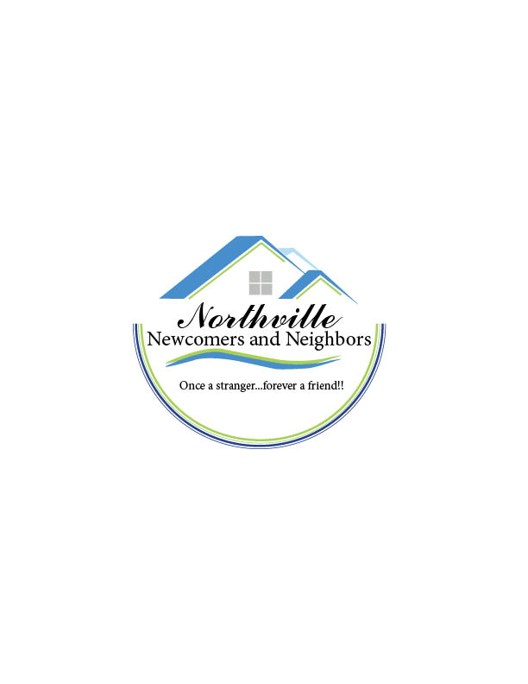 Northville Newcomers & Neighbors

New Member Registration Form – 2021-22

Welcome! We are so glad that you are interested in joining! Please complete the information on this form for inclusion in our annual membership directory. You will receive our newsletters monthly at the email you indicate below.

*Today’s Date:_____________*

*Your Name _____________________________________________ Partner _____________________________*

*Address _______________________________________ City __________________ State ____ Zip_________*

*Subdivision Name_____________________________________________________________________________*

*Birthday (month/day)_________ Email Address_____________________________________________________*

*Home Phone______________________________ Cell Phone_______________________________________*

**IF A NEW MEMBER:** Where have you moved from if new to the area?______________________________________

How did you learn about the Northville Newcomers? ___________________________________________________

**INTEREST GROUPS:** Please indicate if you are interested in any of the following current/suggested Interest Groups. You can visit our website at [www.northvillenewcomers.com](http://www.northvillenewcomers.com) for a detailed description of each Interest Group.

_____Book Review _____Books Too _____Starlight Book Club _____Books & Breakfast ____Bowling _____Bunco _____Bridge

_____Couples Canasta _____Crafting _____Partners Euchre _____Daytime Euchre _____Partners Euchre _____Friendship Circle

_____Ladies 9 Hole Golf _____Allcomers Golf _____Genealogy _____Movie Club _____Line Dancing _____Mah Jongg (Day-All Levels)

_____Out to Lunch _____Pinochle _____Partners Pinochle _____So Happy It’s Thursday _____Walking ____Wine Tasting

If you wish to pursue a leadership opportunity with Northville Newcomers & Neighbors (NNN), as an Interest Group Chair or NNN Board Member, please indicate your area of interest: ________________________________________________________________________________________________________

**PAYMENT INFORMATION**

**ANNUAL DUES:** **$35** for the full year (Sept- Aug)

Complete the information on this form and return it with a check for $35 made payable to ‘***Northville Newcomers & Neighbors****’* and mail to the address below:

***Northville Newcomers & Neighbors, Janice Cantelon, Membership Chair,***

***P O Box 5263, Northville, MI 48167***

Please direct any questions to Janice Cantelon, NNN President & Membership Chair, at [Janicecantelon@aol.com](mailto:Janicecantelon@aol.com).

Northville Newcomers & Neighbors is a non-profit organization. Solicitations to NNN members by other members is not permitted.

Once a stranger, forever a friend!