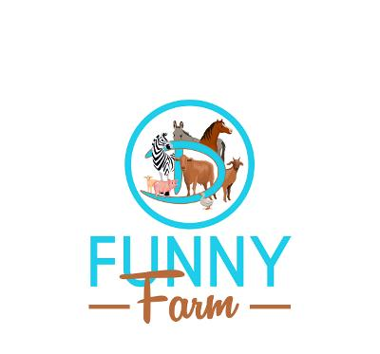**Circle D Funny Farm Visitor Waiver & Release of Liability Form**

**This form must be signed prior to visiting Circle D Funny Farm.**

We are very excited about your visit to Circle D Funny Farm Petting Zoo and are sure that you will have a FUN time—it will be an experience you will NEVER forget. Admission is $10 per person. We do not accept checks or credit cards for field trips. **Please bring cash**.

1. Individuals will be allowed to pet and feed the animals. Be aware that animals can and will bite. You may feed and pet the animals at your own risk.
2. Please be sure to wear old clothes and shoes to the farm. This is a real farm—WATCH YOUR STEP! 😊
3. All playgrounds and activities require adult supervision. This is the responsibility of teachers and/or parents. Circle D Funny Farm is not responsible for injuries or for supervising visitors to the farm.
4. We often take photos and/or videos of farm visitors interacting with the animals. These photos may appear on our website, social media, and/or published materials. We encourage our guests to send us photos taken at our farm and tag us on social media (@circledfunnyfarm). Images can be sent via text to 501-304-7330 or emailed to circledfunnyfarm@gmail.com.

**ATTENDANCE/PICTURE/VIDEO RELEASE**

I agree to participate voluntarily in activities sponsored by Circle D Funny Farm, located at 11384 Hwy 222, Malvern, AR. I understand and accept that my participation is at my own risk. I hereby release and discharge Circle D Funny Farm, its owners, employees, and any affiliated entities from any liability for loss, damage, injuries, claims, demands, lawsuits, expenses, or any other liabilities of any kind, whether directly or indirectly arising from my visit or participation in any activity.

Furthermore, I agree to hold harmless, indemnify, and reimburse the Released Parties for any sums, costs, or expenses incurred or paid by them to any person (including myself or my insurers) in connection with any accident, loss, damage, or injury sustained by me or others related to my attendance or participation in the farm activities. This includes reimbursing the Released Parties for any claims made against them based on injuries I may suffer.

Additionally, I grant Circle D Funny Farm permission to use my likeness in photographs for any and all of its publications, including on its website, without payment or any other compensation. I understand that these materials will become the property of Circle D Funny Farm. I irrevocably authorize Circle D Funny Farm to edit, alter, copy, exhibit, publish, or distribute these photographs for advertising purposes. I waive the right to inspect or approve the final product, including any written or electronic copy, and relinquish any claim to royalties or other compensation related to the use of the photograph or video.

**Visitor/Participant**

Visitor Name: ___________________________________ Signature:___________________________

**If visitor is UNDER 18 years of age, parent must sign**

Parent Name: __________________________________ Parent Signature:______________________

Email Address:_________________________________ Phone Number:_______________________