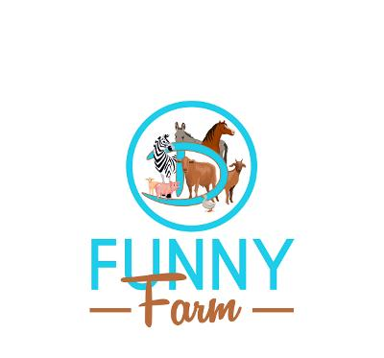
Circle D Funny Farm Visitor Waiver & Release of Liability Form
This form must be signed prior to visiting Circle D Funny Farm.

We are very excited about your visit to Circle D Funny Farm!
And, are sure you will have a FUNNY time- it will be an experience you will NEVER forget.

1. Individuals will be allowed to pet, groom, and feed the animals
Be aware that animals can and will bite. You may feed, pet & groom animals at your own rick.
2. Please be sure that old clothes and shoes are worn to the farm.
This is a real farm- WATCH YOUR STEP!!
3. We often take photos and/or videos of farm visitors interacting with the animals. These photos may appear on our website, on social media, and/or published materials. We encourage our guests to send us photos you take at our farm and tag us on social media (circledfunnyfarm). Images can be sent via text to 501-304-7330 or emailed to circledfunnyfarm@gmail.com.

ATTENDANCE/PICTURE/VIDEO RELEASE
I agree an willfully participate in activities sponsored by Circle D Funny Farm, at 11384 Hwy 222, Malvern, AR. I understand and agree that I do so at my own risk. I hereby release and waive all claims against Circle D Funny farm, owners, workers, and any other entities affiliated with the foregoing from liability for any and all loss, damage, injuries, claims, demands, lawsuits, expenses, and any other liability of any kind, of or to me or any other person, directly or indirectly arising out of, or in connection with my visit or participation in any activity. I further agree to hold harmless, indemnify and reimburse the Released Parties from and for any sums, costs, or expenses incurred by any of the Released Parties or paid by them to any person (including me or my insurers) in connection with any accident, loss, damage, or injury sustained by me or others in connection with my attendance, at or participation in, the above described activity. This means that I will reimburse the Released Parties if anyone makes a claims against them based on injuries I may suffer.
I hereby grant Circle D Funny Farm permission to use my likeness in a photograph in any and all of it’s publications, including website entries, without payment or any other considerations. I agree and understand that these materials will become property of Circle D Funny Farm. I hereby irrevocably authorize Circle D Funny Farm to edit, alter, copy exhibit, publish, or distribute this photo for advertising purposes. In addition, I waive the right to inspect or approve the finish product, including written or electronic copy, wherein my likeness appears. Additionally, I waive my right to royalties or any other compensation arising or related to the use of the photograph or video.

Visitor/Participant
Visitor Name: ___________________________________ Signature:___________________________

If visitor is UNDER 18 years of age, parent must sign
Parent Name: __________________________________ Parent Signature:______________________
Email Address:_________________________________ Phone Number:_______________________

Emergency Contact Information
Emergency Contact:_____________________________ Relationship:__________________________
Phone Number:_________________________________

