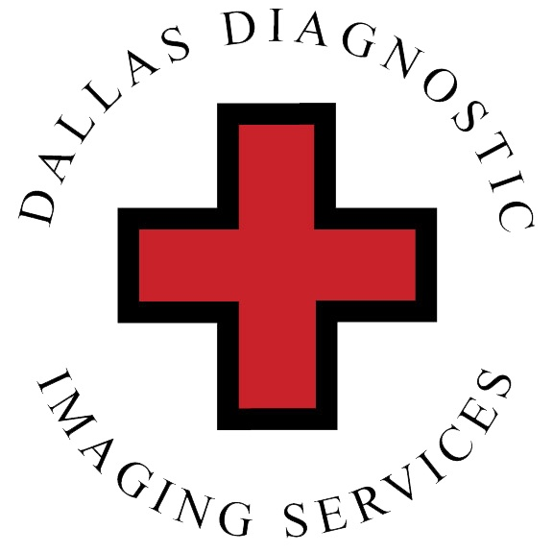
DALLAS DIAGNOSTIC IMAGING SERVICES

__________________________________________________________________________

FIBROSCAN QUESTIONNAIRE

PATIENT NAME: ____________________________________________DOB: ___________________________

ADDRESS: ______________________________________CITY: ________________STATE: _______ZIP CODE: _________

TELEPHONE: ______________________________WEIGHT: _____________LBS

EMAIL: ___________________________________________________________________________________

FATTY LIVER DISEASE ( NAFLD OR NASH ) ? □ YES □ NO

FIBROSIS ( SCARRING ) OF THE LIVER ? □ YES □ NO

CIRRHOSIS ? □ YES □ NO

HEPATITIS A, B, C ? □ YES □ NO

HAVE YOU HAD HEPATITIS C ? □ YES □ NO

HAVE YOU HAD CANCER ? TYPE: ______________________ YEAR: ______________ □ YES □ NO

LIVER TRANSPLANT ? WHEN: ______________________________________________ □ YES □ NO

OTHER LIVER DISEASE ? _____________________________________________________________________

BLOOD TEST LIVER ENZYMES ELEVATED ? ( AST) __________ ( ALT ) ___________ □ YES □ NO

ALCOHOL ? HOW MUCH _____________ HOW OFTEN: _______________ YEARS: __________ □ YES □ NO

DIET ? □ REGULAR □ VEGETARIAN □ DIABETIC □ OTHER: ___________________________________

NOTES: _________________________________________________________________________________________

_________________________________________________________________________________________

_____________________________________________________ ____________________________

PATIENT SIGNATURE DATE

2701 S. HAMPTON RD. SUITE 140., DALLAS, TX. 75224

