Larson Angus Bull Sale

Saturday, March 28

Sale starts at 1:00pm
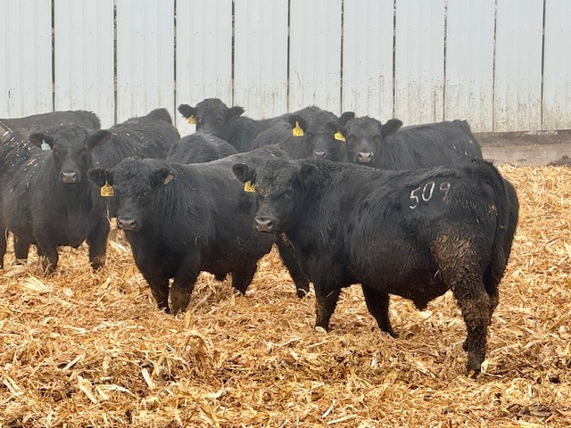
One of our breeding goals is to raise bulls that will sire hard working trouble free cows.

- 53 Years AI
- 50 Years production records
- Semen tested
- Ultra sound tested for carcass traits
- Bulls kept till June 1 at no additional charge
- Free lunch sale day
- Bulls have a magnet and freeze brand
- Free delivery up to 250 miles
- Low stress buyer friendly silent auction sale format

Sale Location

Larson Angus • 4747 240th Ave.
Webb, IA 51366
Cell (712) 260-6144
larsonj@evertek.net • www.larsonangus.com

