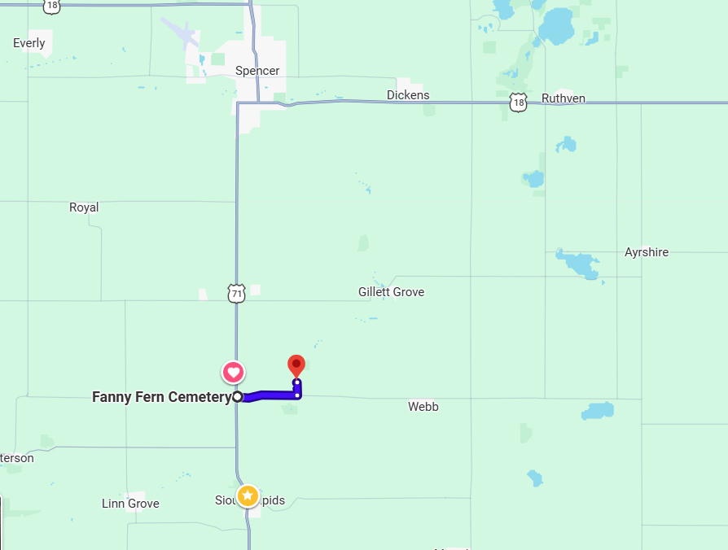Sale located at 4747 240th Ave Webb, IA at David Hermstad’s farm.  LOCATION: The Bridge is open this year! The map shows the location of the sale. It is the same location as the past few years, just East of Hwy 71 off B63 (Webb road).  Auction Process:  - Viewing starts at 10am, Sale starts at 1pm. Bull minimum $3500 & Heifer minimum $2500  - Complimentary lunch prior to sale  - Bulls kept at no added charge until June 1, 2026 (payment due upon delivery of bull to your farm)  - Heifer payment due day of sale with pick up soon after.
  March 28, 2026, BULL & HEIFER SALE:
  4747 240th Ave Webb, IA 51366
  (2 miles East of Jim’s farm at Dave Hermstad’s)
  Yearling bulls and heifers sold by: Jim & Marcia Larson, and partners: Marc & Drew Hinners Greg & David Hermstad.
  Contact Us:
  Phone: (712)260-6144 Jim/Marcia; Susan (402)980-5089;
  Email: larsonangus@gmail.com
  Web: www.larsonangus.com Home Address: 4685 Hwy 71 Sioux Rapids, IA 50585.
  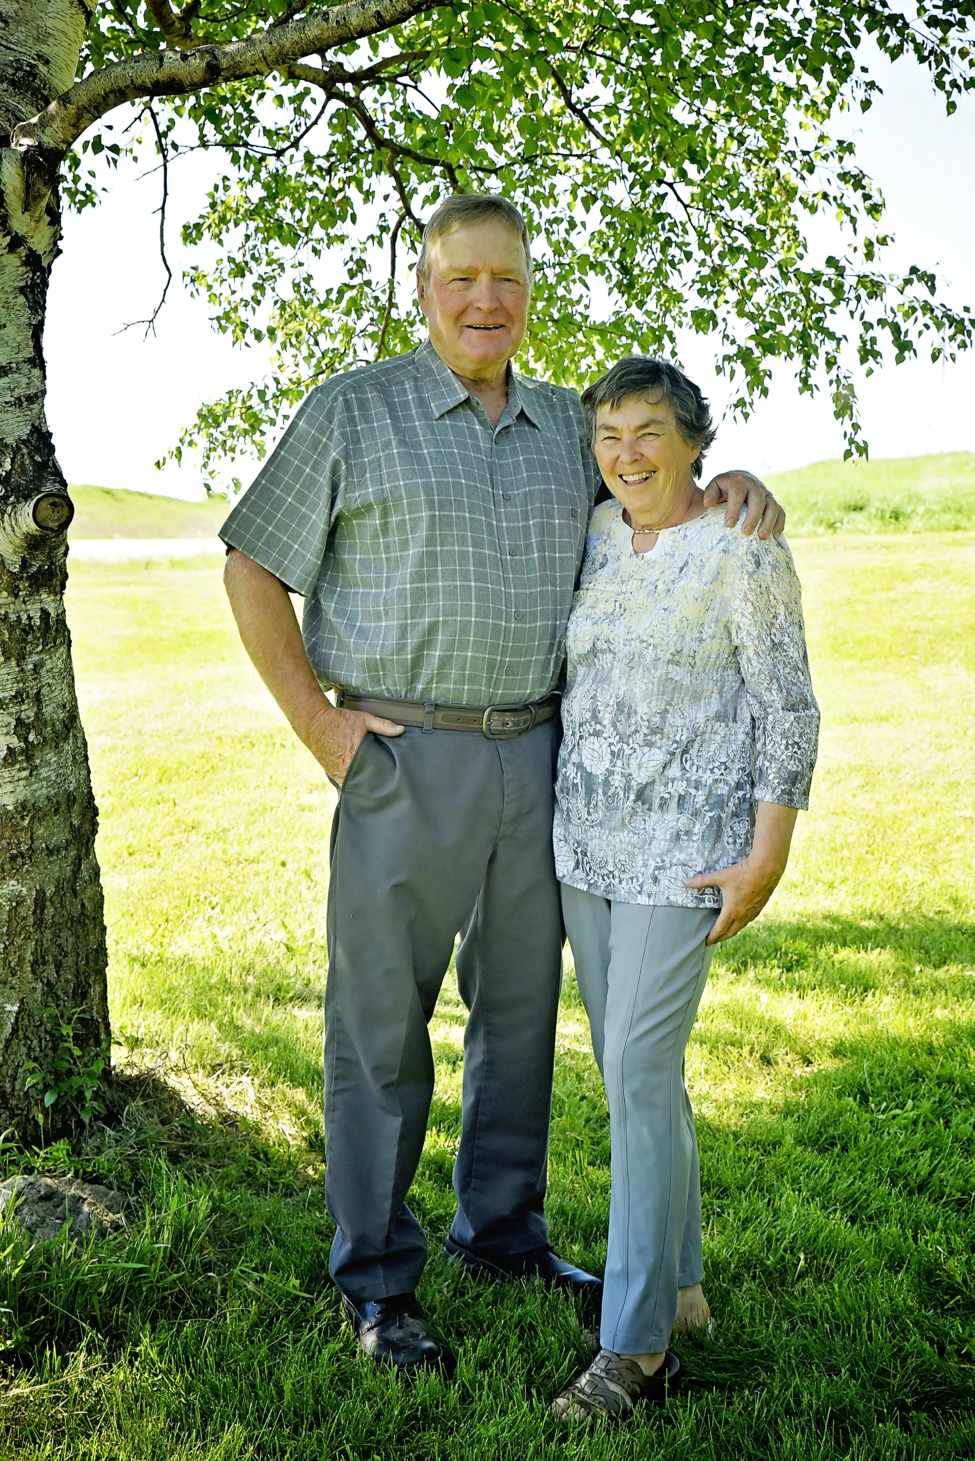 |  | Larson Angus Annual Bull/Heifer Sale  Sale Location: 4747 240th Ave Webb, IA 51366
  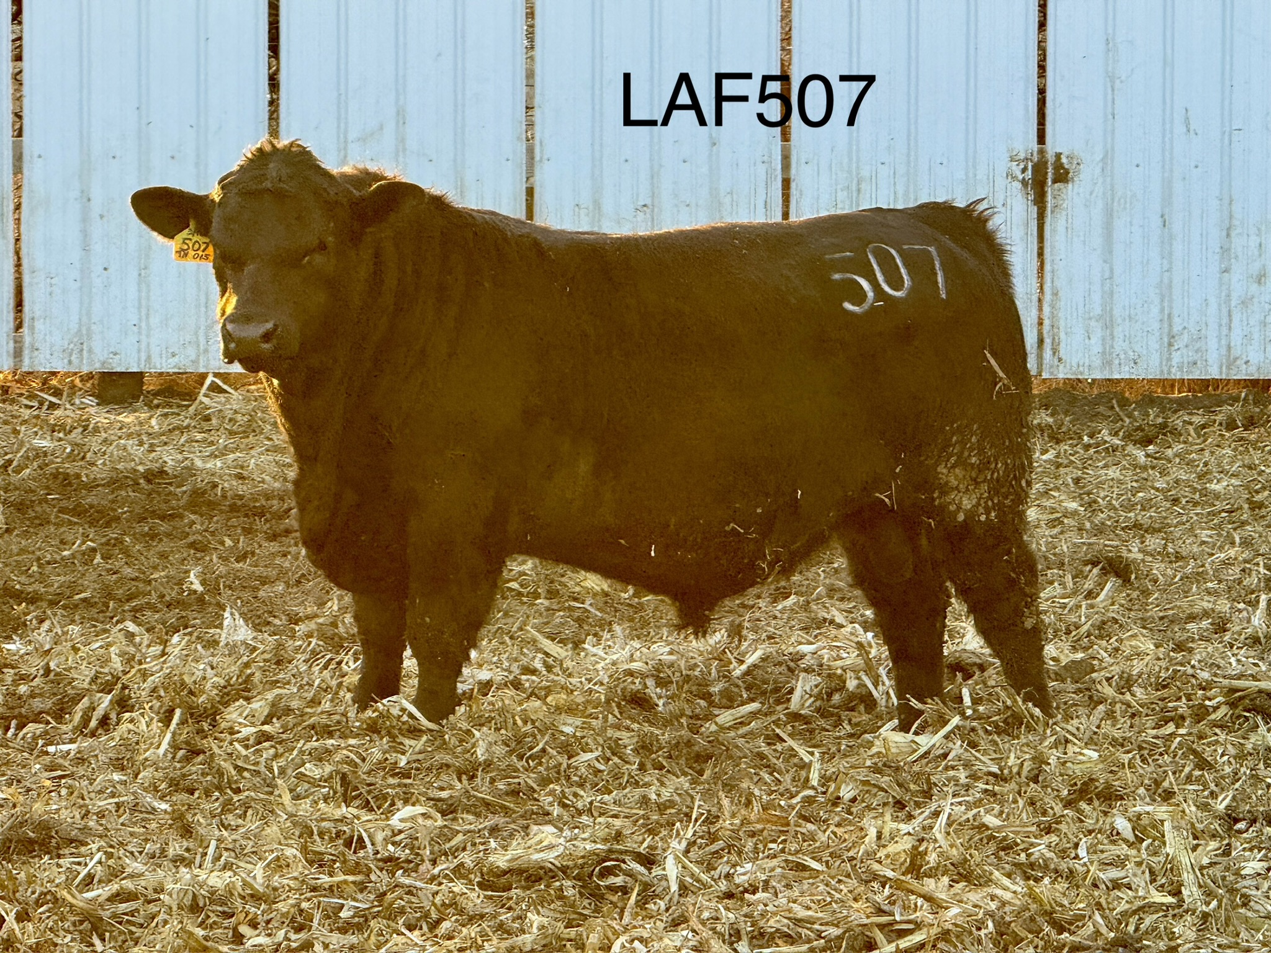
  LAF507(True North) from a Stellar Dam
  Larson Angus Annual Bull/Heifer Sale
    - Saturday March 28, 2026, at 1pm

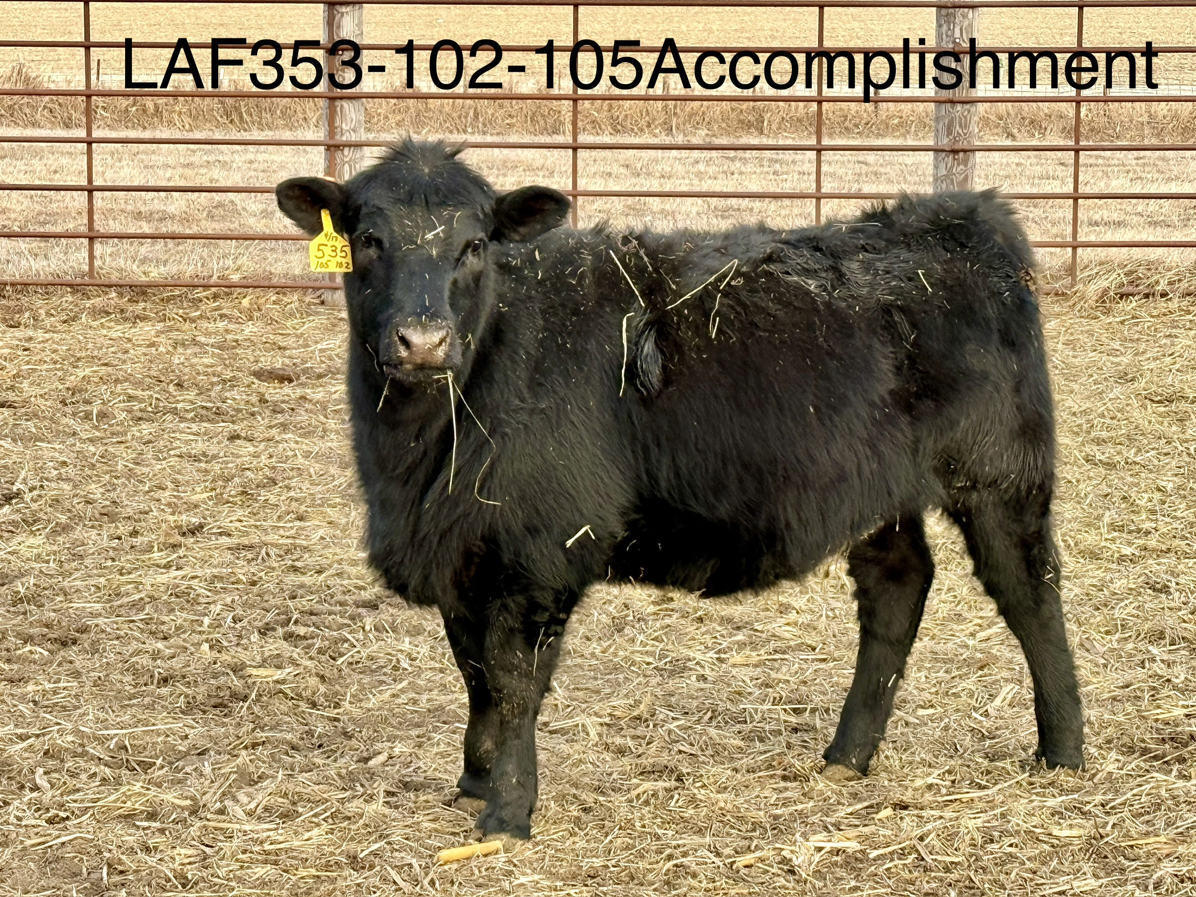  LAF535 is a LAF105(Accomplishment) heifer out of a Substantial cow.  Heifers  The yearling heifers are being developed with our own keeper heifers. We have used over 50 years of AI to develop our herd and breed for maternal traits. A good cow will make you good calves. We value docility, calving ease, and look for good udder/teats and milk. These heifers should offer functional longevity to your herd. We look for cows that will last and the dams of these heifers have several productive daughters in our herd. True North and LAF105 (Accomplishment) have strong maternal traits. |  |  | Auction will be on March 28th at 1pm with bulls to start and heifers to follow.  Come early to view the bulls/heifers. They will be sorted and ready for viewing by 10am. Lunch will be available prior to the sale  We encourage you to take time to semen test your bulls before spring to ensure you are set for the season. We are testing ours for you and guarantee them for their first breeding season.  You are welcome to view the animals prior to the sale.  The sale is a month away. Feel free to schedule a visit or give us a call. In addition to Jim, Marc Hinners and the Hermstad brothers can also be contacted to arrange a time to view the bulls.  Marc Hinners: (712)299-7911 and David Hermstad: (712)334-0217 |  |  | 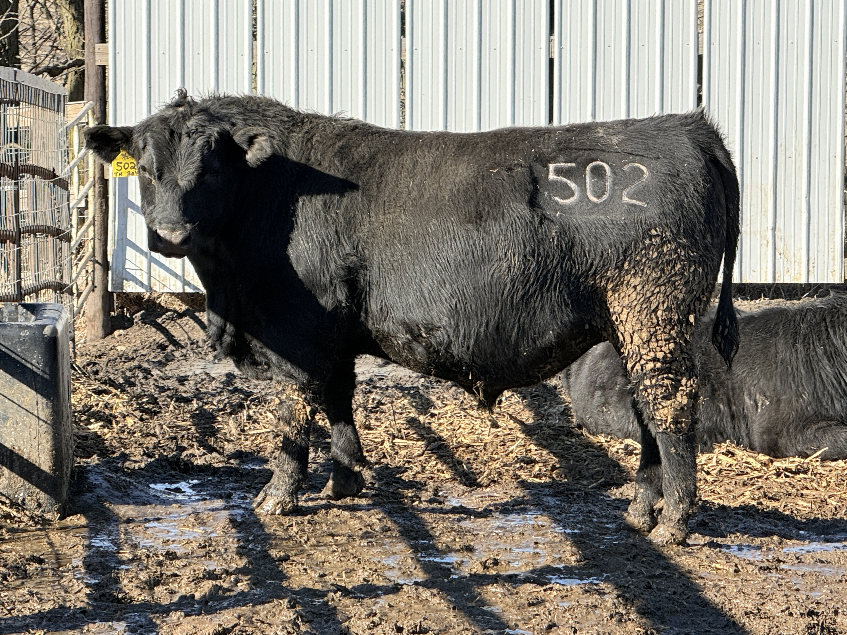  LAF502 is a True North Bull out of a Patriarch first calf heifer  Bulls  In mid-March we will weigh again and semen test the bulls. We use Shawn Nicholson at Stuart Vet Clinic for testing and scans. Our goal is to ensure there are no issues for you when you need them to get to work. We will guarantee that our bulls are functional to breed your cows. All of the data will be updated right before the sale and we will establish the sale order from that. Check out our Facebook page for updates as well as the sale page on the website. We are happy to answer any questions you might have and encourage you to come visit before the sale, please call ahead. See you in March!  Jim & Marcia Larson Family

