Application to Purchase A Puppy
C M Hunt Kennels
Carrah & Mark Whitaker
55 Elm Ridge Loop
Crawfordville, Fl 32327
Phone: 850-294-7316
SCRCarrah@gmail.com
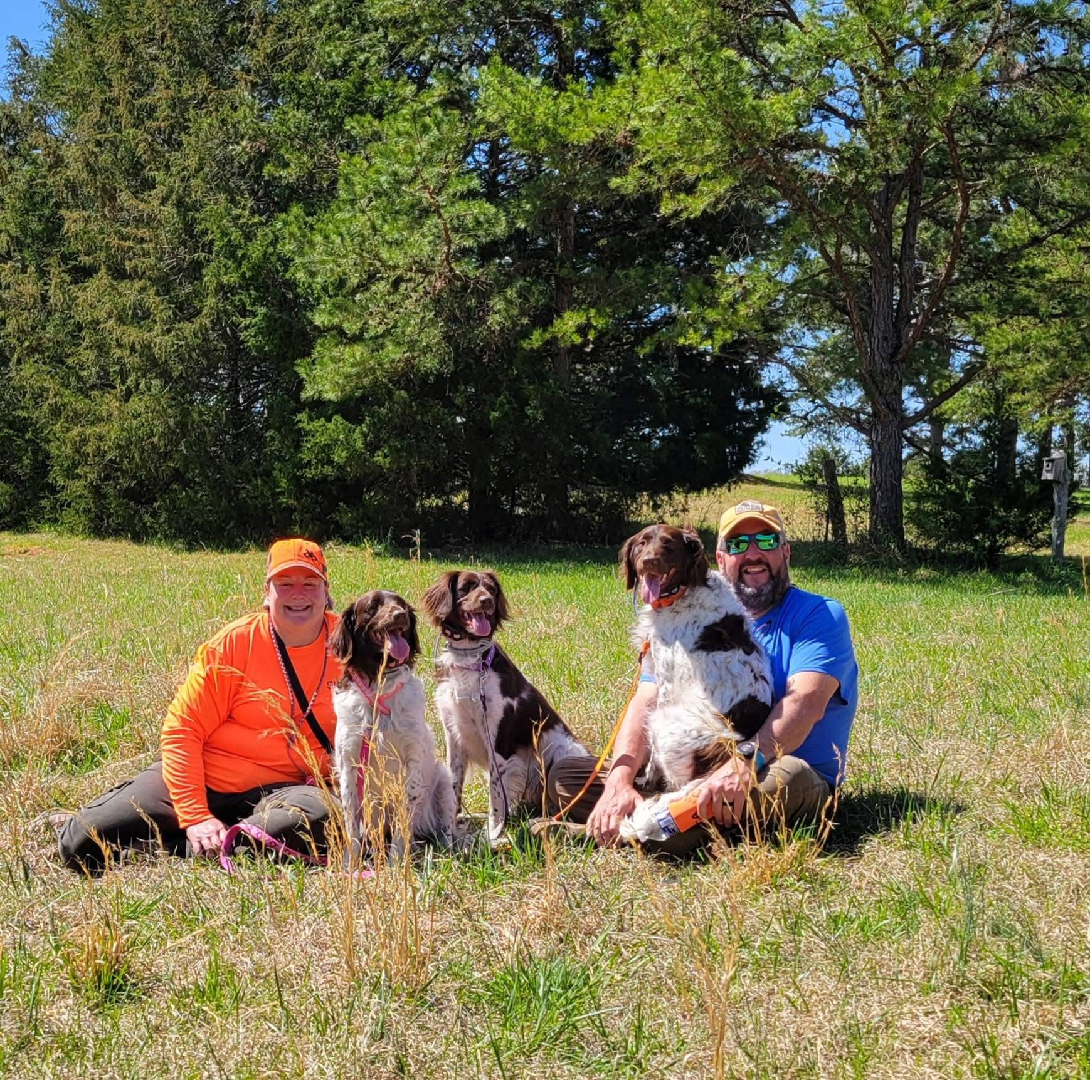
Name(s):
Address:
Phone:
Email:
Today’s Date:

We value our dogs and their wellbeing enough to warrant careful consideration of who we select to get a puppy from our kennel. If you are a new Small Munsterlander (SM) owner(s) we also want to ensure that you have the information necessary to make an informed decision before purchasing a puppy from us. We do our best to select a puppy for you that will match your hunting style and your preferences.

What is your primary interest in purchasing a Small Munsterlander?

Have you owned a Small Munsterlander previously? Yes No

How did you hear about C M Hunt Kennels?

What type of hunting do you plan to use your SM for?

How many days a year do you estimate you bird hunt?

What breed or breeds of dogs do you currently own?

What breeds have you previously owned?

Have you hunt tested in NAVHDA, AKC, HRC, NSTRA, etc? Yes No

If yes, what type and what levels have you tested?

Will your dog be kept in the house or outside or both? Do you have a fenced yard?

How will you exercise your dog?

Do you have children that will participate in the raising of this puppy? (Yes/No) How old are they?

Do you have other pets? (Yes/No) Type of pet(s)?

Veterinarian or other reference: Name and phone #

Do you plan to spay or neuter (circle one)? Yes/No/Undecided Buyer will accept either sex: Yes/No/Maybe

Preferred Litter Buyers preference in sex of the puppy is: Male/Female

Do you plan on breeding? (Yes/No/Undecided) Buyer agrees to test the puppy in the NAVHDA NA Test: Yes No

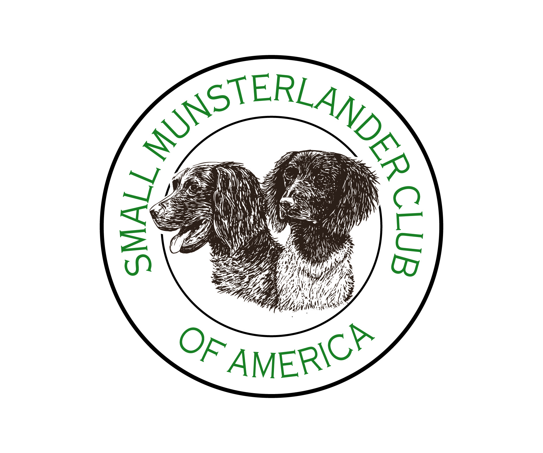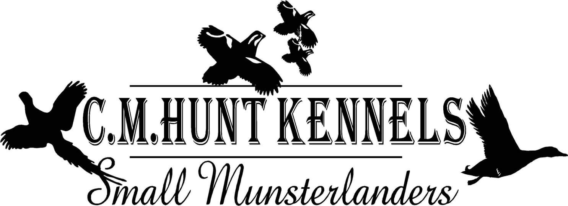
We only sell puppies to hunting homes with preference given to people wanting a dog for breeding stock and who agree to follow the guidelines of SMCA. Our puppy buyers must agree to evaluate their puppy using the NAVHDA system of testing before the puppy is 16 months old. CM Hunt Kennels accepts a limited number of applications for each litter and we help the puppy buyer select the puppy that best fits their lifestyle and personal preferences.
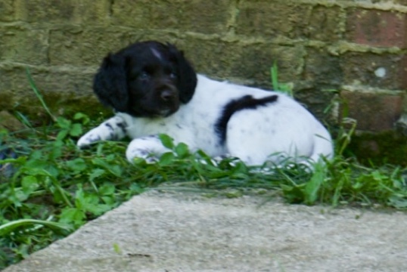

Once an application is accepted we contact prospective buyers regarding the progress of the planned breeding and we have our fertility vet do an ultrasound to confirm the female is pregnant 30 days after she is bred. Upon confirmation of breeding a deposit of $500 will reserve your puppy. Regular updates are put on CM Hunt Kennels Facebook/Instagram or sent text to prospective buyers during the pregnancy and during the time we have the puppies at our home. All of our puppies are micro-chipped, have their first shots and worming. They are also evaluated for conformation and temperament by us and an independent AKC evaluator before they are released to their new owners.

We pay to register the puppy with NAVHDA, the AKC as well as offer a three (3) year health guarantee regarding genetic defects that would prevent the puppy from functioning as a family/hunting dog. Our puppy buyers receive a free year’s membership to the SMCA, the parent breed club. Puppies we sell will go to their new homes having already been exposed to people of all ages, other dogs, and pets, water, dog crates, gunfire, birds, etc. We release our puppies to their new owner(s) at 9-10 weeks of age. Each of our litters is planned and genetically calculated in advance for the improvement of the breed and our breeding program. We sell to only responsible owners and utilize the “Breeding Restriction” registration offered by NAVHDA and the AKC registries. All of our puppies are sold with the understanding that CM Hunt Kennels retains the first right of refusal should the new owner not be able to provide their dog with a home at any age. Refunds for puppies or dogs returned to us are at the discretion of CM Hunt Kennels and refunds are based on the age and condition of the dog when it is returned to us. The price of our puppies of is $2500-3000(including your $500 deposit) based on the proven hunting ability and pairing, cost of breeding (A.I. or cover breeding) and the cost of stud fees/importing semen. We charge the same amount for a male or female puppy. Our purchase price includes the health guarantee and training advice from us for the life of the dog. The puppy must be paid for before or when the puppy is picked up OR before we will ship you a puppy. The Buyer is responsible for the additional cost of shipping which includes the health certificate, crate, other supplies and any additional costs.
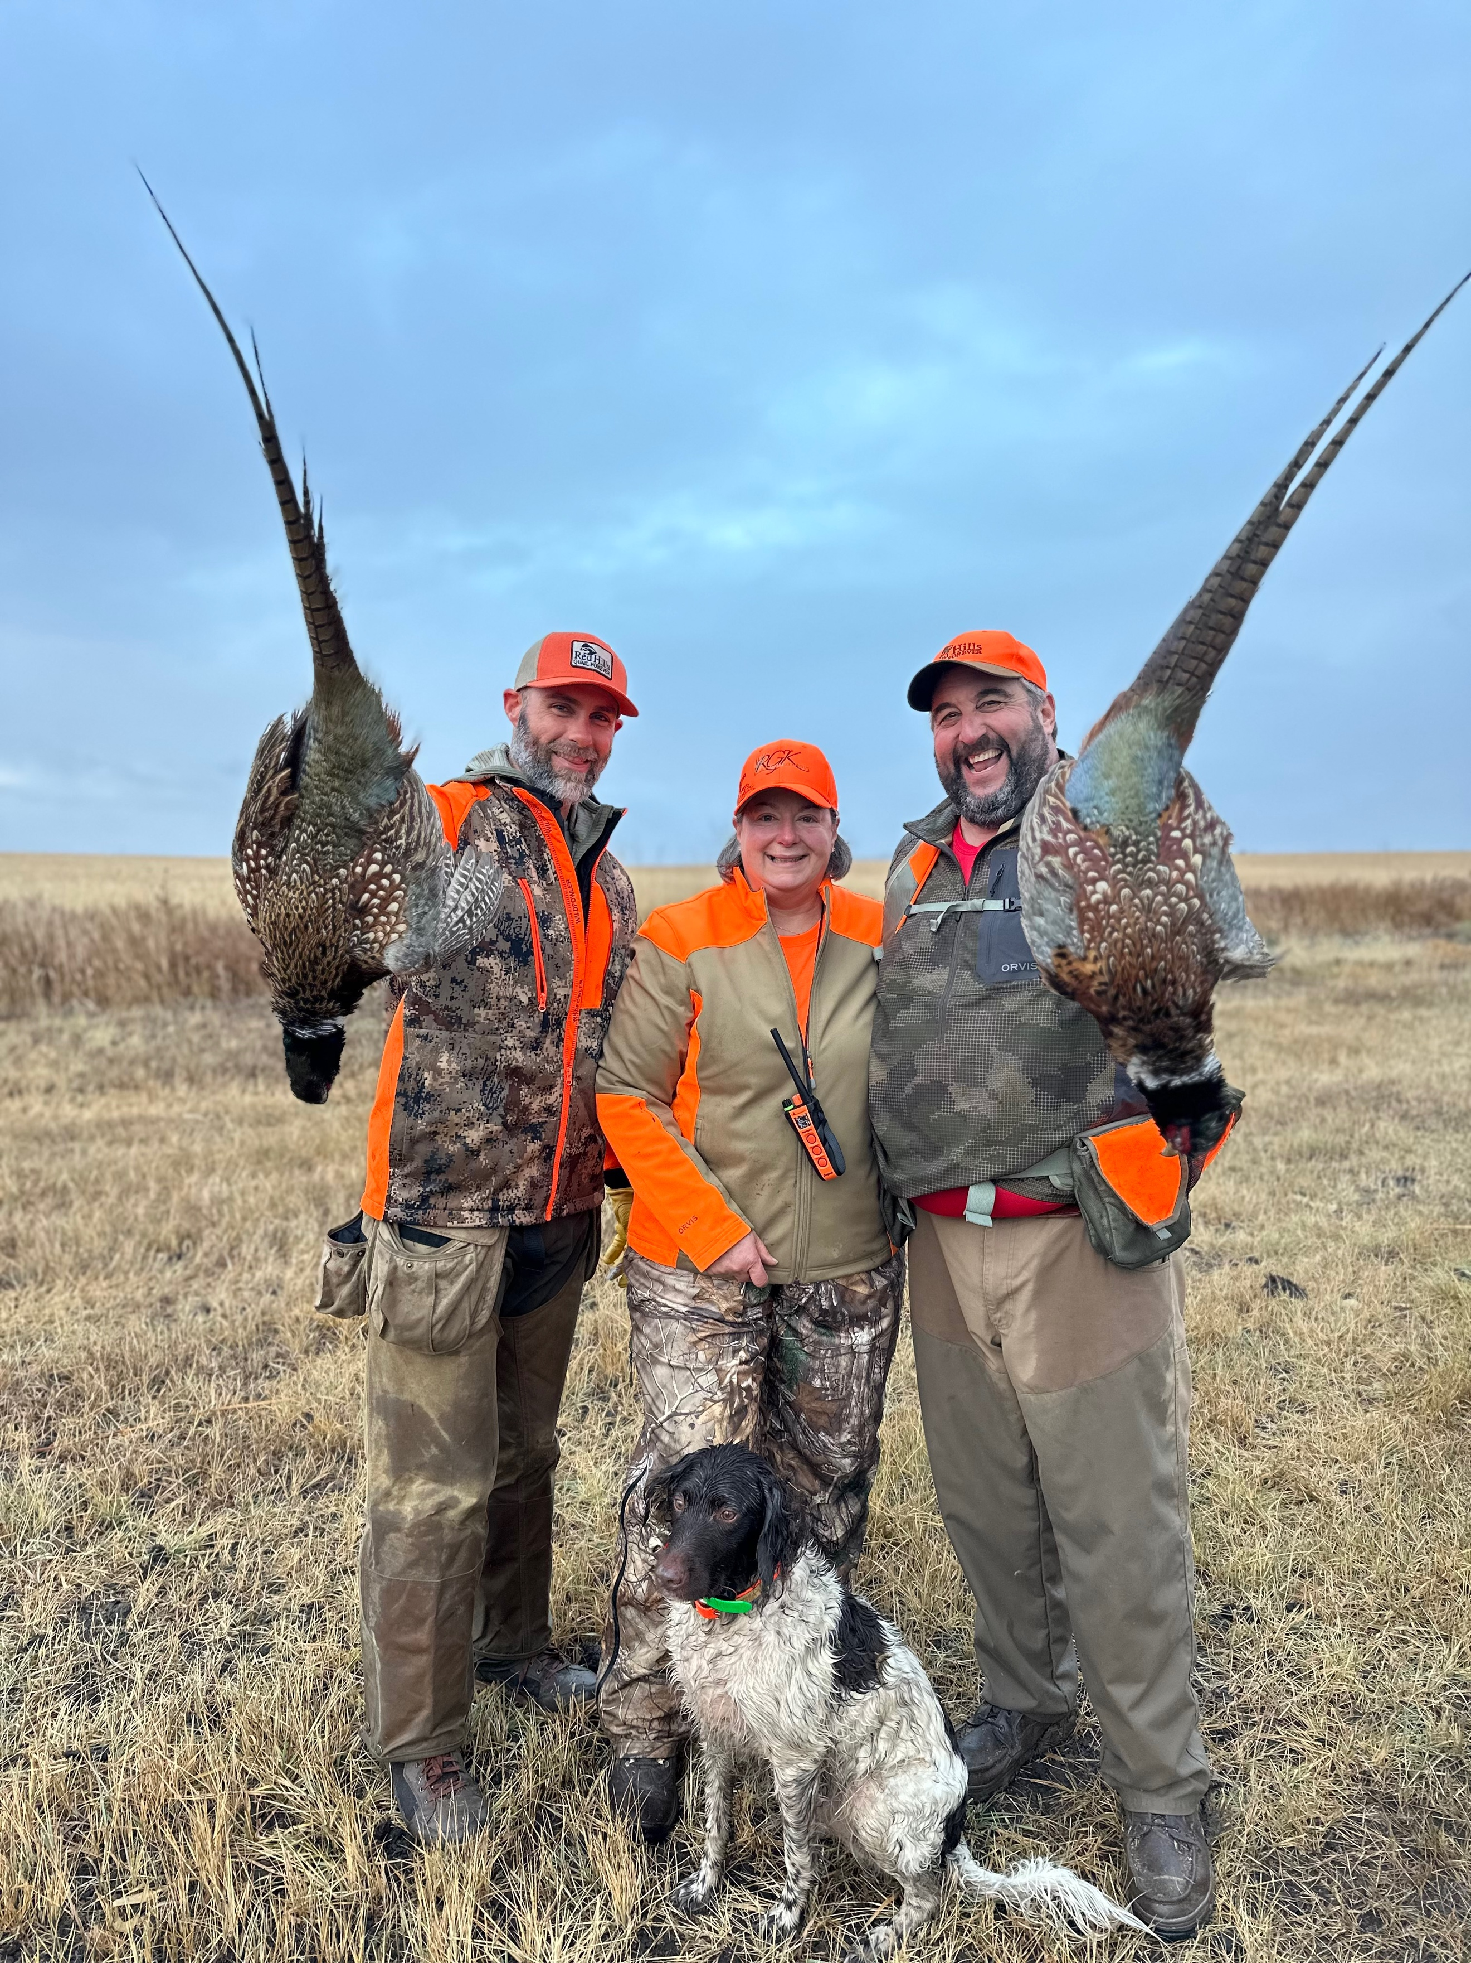

We look forward to working with you and your puppy from CM Hunt Kennels.
