**Lil Red Express MDH Tag Request Form:**

**\*\*When ordering a MDH, a photo of your original tag with dimensions is best. Every tag is slightly different on the placement of the text, so if no photo is available, the text will be centered and aligned horizontally in each box. If original tag is not legible, you must provide information you would like in each box. MPS will also try to also reproduce any Mopar MDH tag with a photo and dimensions provided.**

 Please fill information for the boxes highlighted in red, if not legible from your photos taken of your original MDH tag. (your VIN information will be safe and not provided to others)

Date of MFGR.-_______________________

Vehicle Number-____________________________________________

MDH-_______________________

****If possible take close-up photos of every 1/3rd of the tag (example photo below, MDH box).

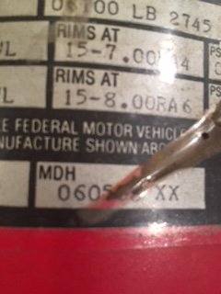

Customer Information:

Name:_____________________

Address:___________________________________________________________________

Email:______________________________________

Phone:________________________________________