Dear trusted health care provider,

I have recently discovered a group of Canadian doctors who have formed CANADA HEALTH ALLIANCE (https://www.canadahealthalliance.org). They have produced an informative and educational video about COVID-19 called “Top Reasons to Not be Afraid of Covid”. I found the information to be very credible and am urging you to please take the time to watch it as well.
This Canadian healthcare alliance is a non-profit collaboration of medical doctors, nurses, chiropractors, naturapaths, pharmacists, and other healthcare practitioners from across Canada whose common goal is to protect the rights of their patients, and their first task is stopping the COVID-19 public health policy damage.
Their goal is to counter the misinformation, censorship, and coercion that is being used by Canadian public health “experts”, government agencies and our elected government representatives to target Canadians during the COVID crisis. If you have any questions about this alliance, you can contact them at info@canadahealthalliance.org. Please consider joining them yourself.
You can view the video in this link https://www.bitchute.com/video/nQgq0BxXfZ4f/. It is only 11:44 minutes long. You can also read all of the reference to support their claims in this video, as it is available as a PDF for download.
The information in this video is life changing for me, my family and where I live. I refuse to live in fear any longer and it is due in great part to the wonderful doctors who are openly speaking out about this virus.
A full transcript of the video is presented below, as an alternative or in addition to watching the video.

Sincerely,

Your Name (if you are sending by Canada Post Mail, please sign your letter)
Your Email Address and/or Your Civic Address
Your trusting health care recipient

CANADA HEALTH ALLIANCE.org

Canadian Doctors Speak Out
Top Reasons Not to be Afraid of CoviD

Transcript of their 11:44 mins video produced March 2021

Dr. Stephen Malthouse, MD – British Columbia
Introduction
00:05 – Welcome to Canadian Doctors Speak Out, where we are going to give you the top reasons not to be afraid of Covid
- When we hear the word Covid or coronavirus we now instinctively reach for a mask or look around to see how we can protect ourselves and our families
- No place really seems safe
- But, as Canadian medical doctors, we’re going to tell you what the best science now has to say, and we think you’ll be pleasantly surprised

SPEAKS about the latest science
00:28 – On the TV, we hear “cases cases cases” which would frighten anyone
- But “cases” are not necessarily symptomatic people
- And the vast majority have few or really no symptoms of being sick
- They just have a positive PCR swab test
00:39 – Research now shows that the PCR test is practically worthless
- Only 3% of patients with a positive test have the Covid virus
- People have died, yes, that’s true
- But using “case numbers” gives a false picture of what is really going on
00:55 – Here is a graph showing the Covid cases each week in Canada [blue line]
- Even I get frightened looking at this graph
- But now, let’s put the weekly deaths on the same chart [red line]

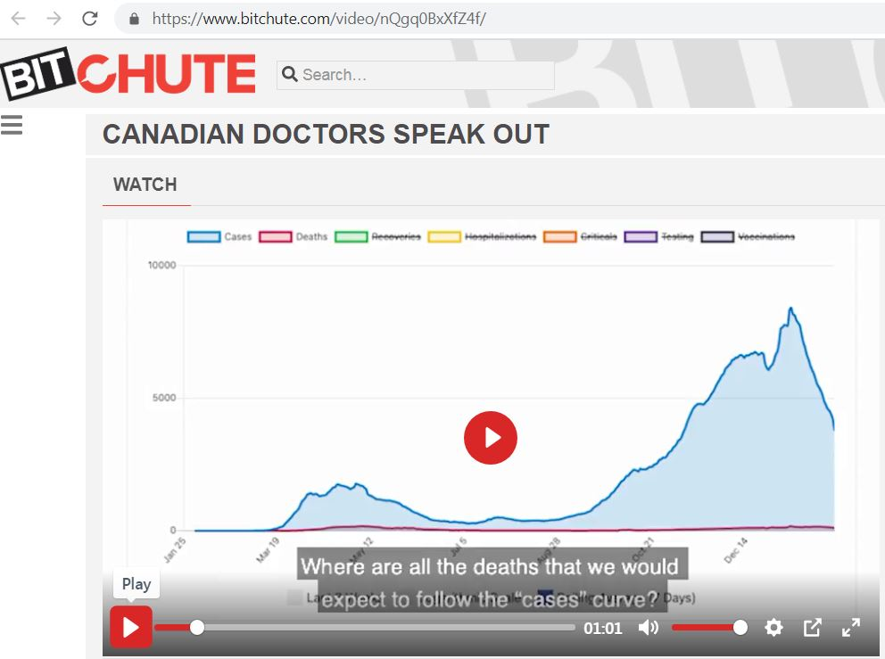
- Where are all the deaths that we would expect to follow the “cases” curve?
- Something is really fishy here!

1:05 – Let’s look at yearly deaths in Canada from 2001 [until 2020]

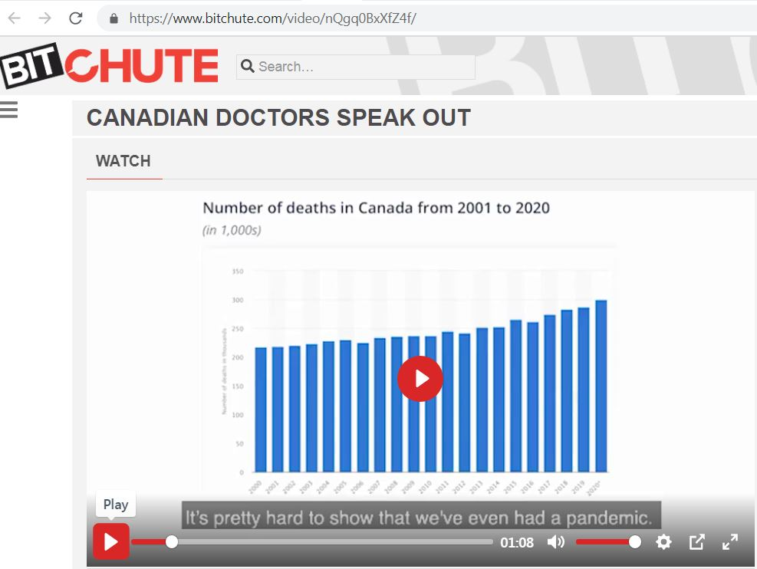
- It’s pretty hard to show that we’ve even had a pandemic
- The slight increase in 2020 was probably due to an aging population
1:15 – But aren’t hospital Intensive Care Units overloaded with COVID patients?
- If we look at the Ontario Intensive Care Unit data
Time Period | 2017  (1-16 Dec) | 2018  (1-16 Dec) | 2019  (1-16 Dec) | 2020  (1-16 Dec)
ICU Occupancy | 86.66% | 91.21% | 83.51% | 80.84%

- There were fewer patients in the ICU in 2020 than in each of the previous 3 years
- The CDC’s own data compares Covid to the seasonal flu

1:27 – In children, Covid illness is so mild their death rate is statistically zero
- [ages 0-19: 99.997%; ages 20-49: 99.98%; ages 50-69: 99.5%; ages 70+: 94.6%]
- For people under 50, the infection survival rate is greater than 99.98%
- For those over 70, it is 94.6%
- And that is without any early treatment whatsoever, like vitamin D or vitamin C
- So, if you’re young, you really don’t have anything to worry about
- If you’re older, we are going to give you some really great ideas on how to protect your health
- That do not include getting a shot with a vaccine

Dr. Patrick Phillips, MD – Ontario
SPEAKS about Asymptomatic Transfer
2:01 – So back in April [2020] we knew so little about Covid – and this led us to take a lot of extra precautions, including adopting the idea that healthy people can spread disease
- This is known as “asymptomatic spread” – and that’s a very scary thought
2:17 – Now however, over 10 million cases have been studied and evidence is rapidly emerging, both from Wuhan [China] and the University of Florida showing that asymptomatic and presymptomatic spread are negligible to non-existent
- This is a game changer!
- This means we can take our lives back – and go back to the time-tested advice I’ve always given my patients when they have a virus
- If you’re sick stay home
- And the rest of us can be free to live our lives

Dr. Caroline Turek, MD – Ontario
SPEAKS about T-Cells Immunity
2:48 – We have great news! Do you know that many of us are already immune to SARS CoV-2 due to cross reactive T-cells?
- A T-cell is just another immune cell that helps our body fight infection
- At the beginning of the pandemic, SARS CoV-2 was considered a novel corona virus
- Meaning that none of us were immune to it and all of us were still at risk for infection
- However, immunologists and virologists worldwide have studied and found that 30-50% of people already have pre-existing immunity to SARS-CoV-2 from pre-existing circulating T-cells
- This pre-existing immunity is due to prior exposure from other corona viruses, such as the common cold
- So, the problem is with testing for COVID immunity is most of the tests are serum antibody tests
- BUT this doesn’t look at our T-cell response
- And antibody levels decline over time, but we still have our T-cells to protect us
- Many, many of us are more protected than we realize from COVID, from our T-cells
- This is exciting news because we are closer to herd immunity than we realize

Dr. Neda Amani, MD – Ontario
SPEAKS about Kids and COVID-19
4:12 – We have heard a lot about how children are COVID ‘super-spreaders’
- Terrified, we have shut down our schools
- Covered our children’s beautiful faces with masks
- And stopped them from playing with one another
- Many teachers are too scared to even step foot into a classroom
- BUT the science shows that none of this is warranted
- If children do get COVID-19, they might not even show any symptoms, and if they do, they’re usually mild
- And they’re not the drivers of the pandemic
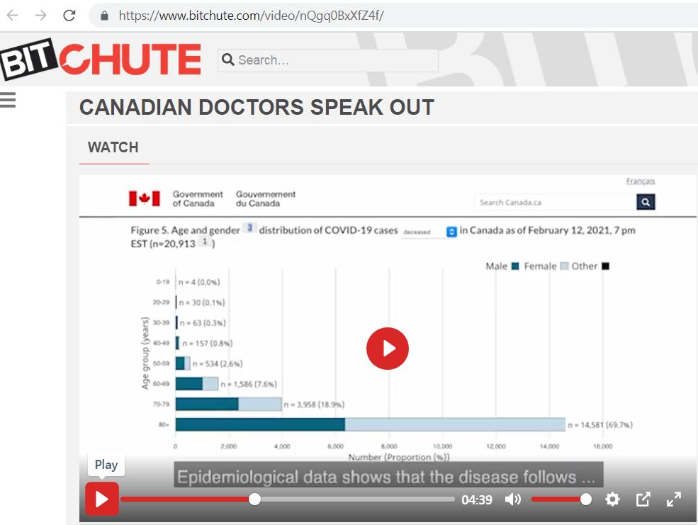
- Epidemiological data shows that the disease follows a much milder course in kids compared to adults
- Since the pandemic began, only 4 people under the age of 19 have died with COVID in all of Canada
- That’s 4 out of 8 million children and teenagers
- By comparison, 10 children died of influenza in the 2018-2019 flu season
- Influenza has killed more children annually than COVID-19
- An overwhelming number of peer reviewed studies now show children, especially those under the age of 10 are not a significant factor in the transmission of COVID
- Studies in the UK, Australia, Switzerland, France and Norway have shown that there is minimal child to child and child to adult transmissions in schools
- A study in The Lancet also showed that closing schools was never medically warranted
- A German study of parents and their children showed that parents are way more likely to infect their children, rather than the other way around
- When we look at the large and growing body of scientific evidence, we can put the fear behind us and let our children be children again
- They can go to school, play with their friends and do the things they love
- Its time to give our children, their life and childhood back

Dr. Dorle Kneifel, MD – British Columbia
SPEAKS about Prevention
6:10 – I am not afraid of this Corona Virus and you do not need to be afraid either
- We’ve evolved with these respiratory viruses over thousands and thousands of years and we’ve developed a highly intelligent and very sophisticated immune system
- We support and strengthen our immune system when we nutritious food, when we engage in physical activity, when we spend time in nature and feel supported by life
- Vitamin D is a critical nutrient for our immune system
- When we supplement with vitamin C, zinc and magnesium our immune system is primed and ready to go
- In spite of suboptimal diets and widespread vitamin D deficiencies, most people who encounter the coronavirus do not require hospitalization, but are able to manage their symptoms at home
- I myself had Covid-19 eleven months ago and I responded to the early viral symptoms the way I always do
- I took Vitamin D – 60,000 international units each day, until the symptoms were gone – it took two days
- The fact that I am here, talking to you is proof that our bodies know what to do

Dr Bill Code, MD – British Columbia
SPEAKS about Treatments
7:32 – I have more than 40 years of practicing medicine in Canada, and at least 30 of those has been as a specialty anesthesiologist with the FRCPC [Fellow of the Royal College of Physicians of Canada]
- Anesthesiologists are well accepted as clinical pharmacologists by other physicians because we know the risk / benefit ratio about drugs
- In addition, safe and long, experienced use of older drugs can be very useful in combating a new problem, such as Covid
- With this in mind and reviewing the literature, I treat my patients with early Covid-19 with Quercetin, zinc, vitamin C and vitamin D
- If you’re able to get a prescription, Hydroxychloroquine (400 mg/day for 5 days) and Azithromycin (500 mg/day for 5 days)
- In addition, I have used Ivermectin (0.2 mg per kg on days 1 and 3; so, if 60 kg, then 12 mg) for post Covid symptoms with some success
- If needed, oxygen supplementation with nasal specs often based on what your personal oximeter, which I recommend, says for you
- In all of the patients I have treated, this regimen has worked for them and they have not needed hospitalization
- I myself had Covid-19 in November last year [2020]
- Taking these agents, as I’ve listed, was incredibly helpful for me and I recovered within 7 to 10 days
- In summary, I would like to have you let go of the fear – it does not serve us
- There are many things we can do for ourselves and then we’ve got the hospital as backup

Dr. Stephen Malthouse, MD – British Columbia
SPEAKS about “Variants”
9:15 - Many of us have heard about something that is designed to scare the living daylights out of you. Its something we’re hearing 24/7 pumped through your television set – and that’s the possibility of dangerous “variants”. Now here’s something that will surprise you!
- One slight variant was artificially created after a lot of hard work, in a mouse study
- The so-called variants had never been found in humans
- This was followed by some papers with mathematical modelling and coding – not real-life observation
- This was simply guesswork about spread and severity – not real research with human beings
- That is the sole foundation of all you’re hearing about on the TV
- Viruses naturally change over time and new strains emerge
- Since a virus cannot live alone but depends on human cells to live, it makes evolutionary sense that it will become less dangerous, not more so, over time
- If it becomes more easily spread, but less likely to make you really sick, then that is a good natural progression toward herd immunity
- The Covid virus is no different
- Over all the time we have studied viruses that is what they’ve always done – adapt to humans as humans adapt to them
- We can all relax since viruses always become less likely to cause harm as time goes on

SPEAKs about “A way out for everyone”
10:24 – When you put it all together, there are so many reasons not to be afraid of COVID
- When we honestly evaluate the COVID evidence and stop being fearful, we can start living life fully and becoming a joyful member of our family and community again
- Hiding inside of your home and avoiding people is not necessary
- Humans are social creatures and do not do well in isolation
- For one thing, both solitary confinement and fear are harmful to your immune system
- Four hugs a day are indeed the minimum!
- So, make sure your nutrition is good and don’t forget to take Vitamin D in the wintertime to optimize your immune system
- 4,000 International Units is a good daily amount for Canadian adults – followed by a blood test in about a month to make sure that’s the right amount for you
- Vitamin D is safe, its inexpensive and has been shown to boost resistance to viral respiratory infections, including COVID
- And remember – the real virus is FEAR
- It stops a person from thinking clearly
- Now is the time to turn off your TV set and learn how to do some reasoning for yourself
- It doesn’t take a doctor, or a rocket scientist to figure it out
- Just look out your own front door and see what is really happening
- The evidence is clear – you do NOT need to be afraid of a little COVID virus

