Course Title: Train the Trainer Presentations
Topic/Module: Tying a Half-Windsor knot
Duration of Training: 10 minutes
Prepared by and Date Prepared: WLC 09.20.21, updated 03.15.22
Instructional Methodology:
Conference Method, Hands-on
Performance Objectives:
Using a supplied necktie, the student will tie a Half-Windsor knot so that when the small end is pulled out the knot stays tied.
After successfully tying the Half-Windsor knot the student will state when they might use this knot in the future, giving at least 1 reason.
Required Materials/Equipment
Necktie
Handout
Evaluation/Check for learning (based on objectives):
students will tie a tie that matches the example in the lesson plan and handout and the knot stays tied when the smaller end is pulled out.
References:
Dress for Success
How to Dress Like $1,000,000
How to Tie a Necktie, the Half Windsor Knot - YouTube
Connections to Other Topics:
How to make an impression on the stand
Safety Plan:
Do not allow students to pull on other student’s ties once tied around the neck, as this may cause injury.
Reviewed By: Agent Wm. Steinkirk, 03.25.22
Approved By: Chief Jesse Langsdorf, 03.30.22

Course Content | Delivery Notes
Anticipatory Set:  How many of you have found yourself in the position of having to decide which way to, or even how to tie a necktie?  How many of you know how to tie a necktie?  For those that do, what is the name of the knot you use?  Half-Windsor, 3/4 Winsor, Full Windsor  Four-in-Hand  Eldridge Knot  Kelvin Knot  Pratt Knot  Excellent!  Well, today we’re going to talk about how to tie the ever popular, and approved for court attire by our agency, half-Windsor knot.  Does anyone already know how to tie a half-Windsor knot?  Assessment/Check for Learning  Students will engage in answering the questions.  Instructional Content/Guided Practice:  Start by picking out the tie you would like to wear today. We have this collection of lovely “vintage” ties for you to pick from.  Now everyone place your tie around your neck. The back, seamed side of the tie should be against your body with the wide side of the tie on your right. Have the wide side of the tie extend about six to eight inches below your belt line. This will put the end of the tie near your belt once you have tied your knot. Depending on the length of the tie the narrow end may be longer or shorter.  All ‘movement’ to make this knot will be with the wide or long end of the tie. You will want to tie the knot as close to your neck as is comfortable so that the finished lengths will be correct when you’re done.  The first step in the knot is to take the long end of the tie and lay it over the short end. The seam should still be against your body, but now the long end is on your left side. Keep the short end straight along where the buttons of your shirt would sit.  Now fold it horizontally underneath the short end so the long end is on the right side again but now with the seamed side facing out. Remember to keep the knot close to your neck.  Now take the long end and bring it up and over the top of the knot and then down behind the short end of the tie. The seamed side of the tie should be away from your body still. The part of the long end that is folded over the top should be up against the right side of the now forming knot.  Pull the long end of the tie out to the left side of your body, hold it horizontal with the long end near your shoulder level.  Bring the long end straight across the knot, with the top edge flat across the top of the knot.  Wrap the long end around to the back of the knot and push it up through the loop around your neck.  Let the long end lay over the knot and straight down to your waist. Check this end for correct length by pinching the knot and raising it up to your neck, where it will sit when tightened.  If you need to make adjustments to your tie, now is the time. To undo the knot, just pull out the short end of the tie by pulling on the left side of the loop around your neck. The knot will fall out and you can make adjustments to the length of the long end and start over.  If your tie is the correct length, lift the long end and pull some slack into the last horizontal layer of the knot. Then push the long end of the tie through that layer and out the bottom.  Gently pull on the long end of the tie to snug the knot, making sure that all layers of the cloth lay flat and stay inside the knot. The front most horizontal layer of the knot, especially, should lay flat from edge to edge of the fabric.  Hold the short end of the tie and push up on the knot to raise the knot to your neck.  When the tie is completely tied, the narrow part of the tie should be completely hidden behind the wide part of the tie. The lowest point of the wide part of the tie should land near the belt line.  If the long end is the correct length, but the short end hangs out below the long end, tuck that end into your shirt just below the knot. This is an indication that the tie is too long for you. If the long end of the tie doesn’t reach your belt line, and the short end is less than an inch or two below the knot then the tie is too short for you. In either case, consider a different tie from the collection.  Look at your neighbor’s tie. How great does that look! Since we don’t have mirrors here, consider helping out your tablemate by assisting with any adjustments to the lay of the knot.  Assessment/Check for Learning  Every student will have tied a tie. Every student’s knot will remain tied when the small part of the tie is pulled out to remove the tie from around their neck.  Independent Practice/Evaluation:  We’ve worked through this together, now it’s your turn! Tie the tie at least one more time following all these steps.  Ok. That looks like a good tie! Go ahead and pull the short end out of the knot by pulling on the loop around your neck right next to the left side of the knot. If you pull that length out of the knot, the knot should stay tied if you did it correctly.  Assessment/Check for Learning  Every student will have tied a tie by themselves. Every student’s knot will remain tied when the small part of the tie is pulled out to remove the tie from around their neck.  Closing:  How many of you would consider using this knot in the future?  Great work everyone. All of you are now able to tie the agency approved knot in your tie so you can look awesome at court! | If you have a personal story about tying or wearing a necktie, you can add it here…  Do this quickly. No need to write them down.  If nobody can name any other knots, skip to “Well, today…”  Hip pocket: If one student knows how to tie this correctly, invite that student to show everyone else how. Make sure all the described steps are completed correctly.  Allow students to quickly pick a tie from those provided in the box. If anyone takes more than about 5 seconds, pick one for them.  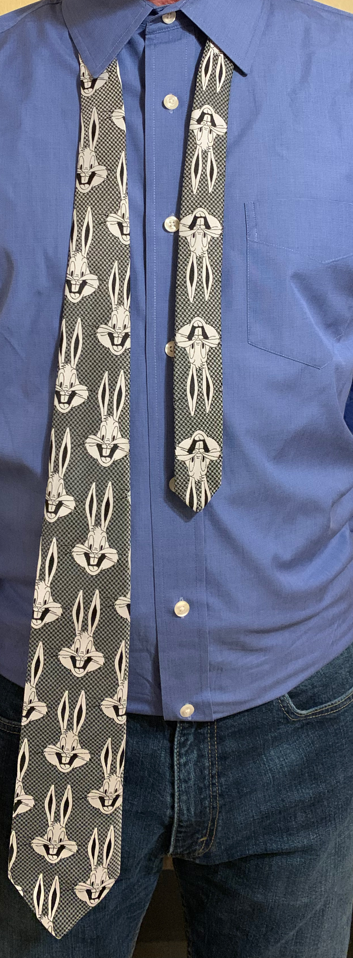  Set up the tie  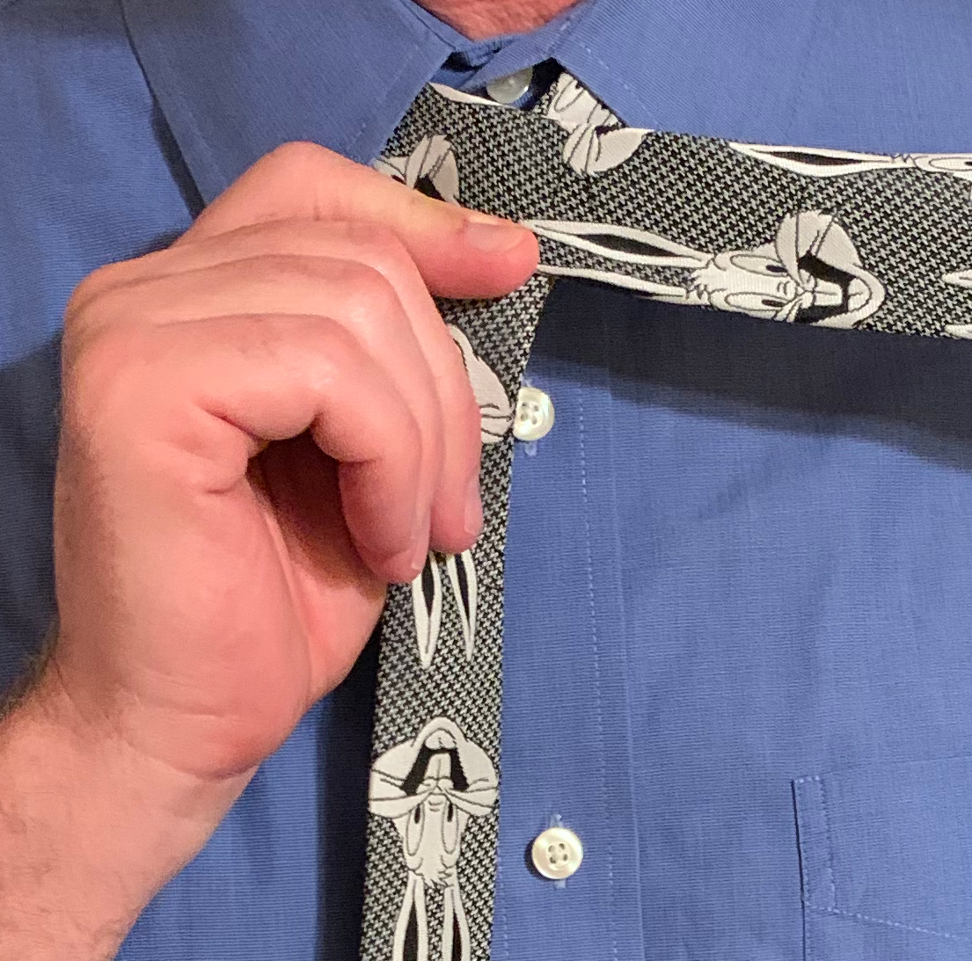  Step 1  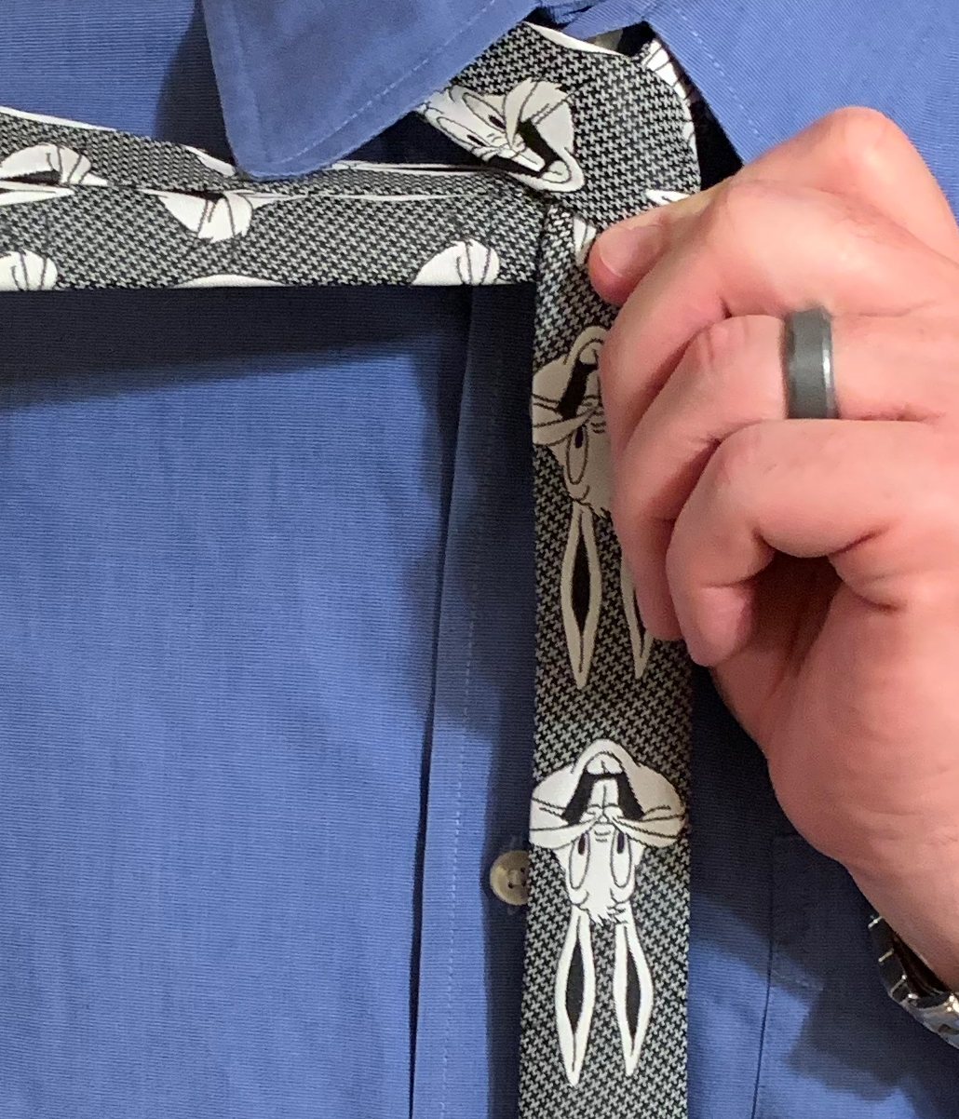  Step 2  Step 3  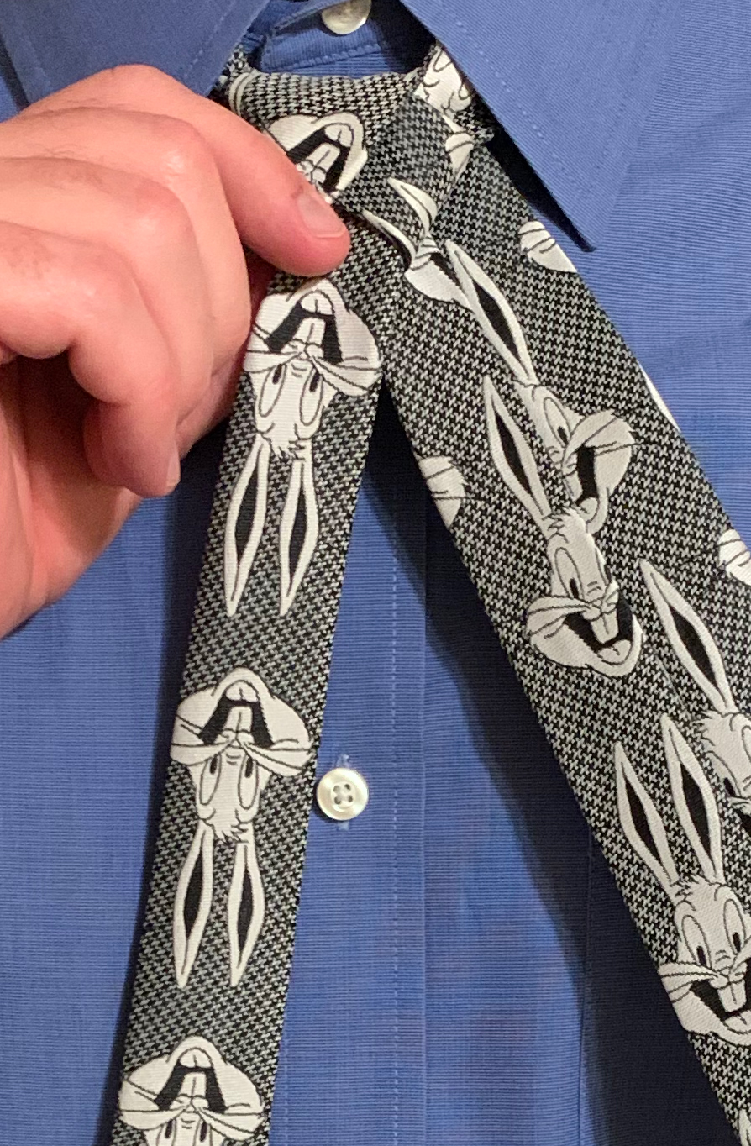  Step 4  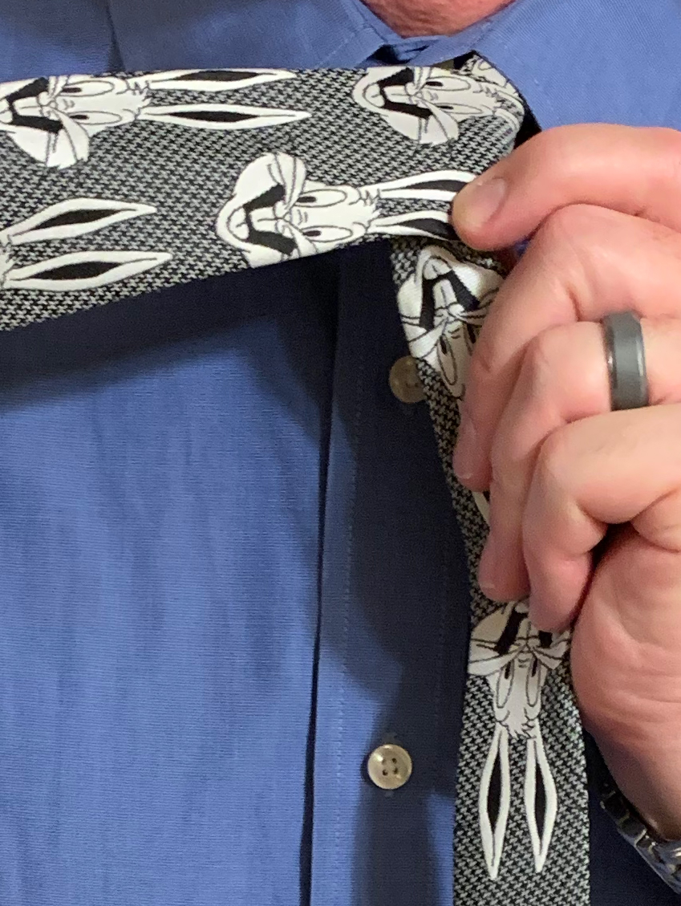  Step 5  Step 6  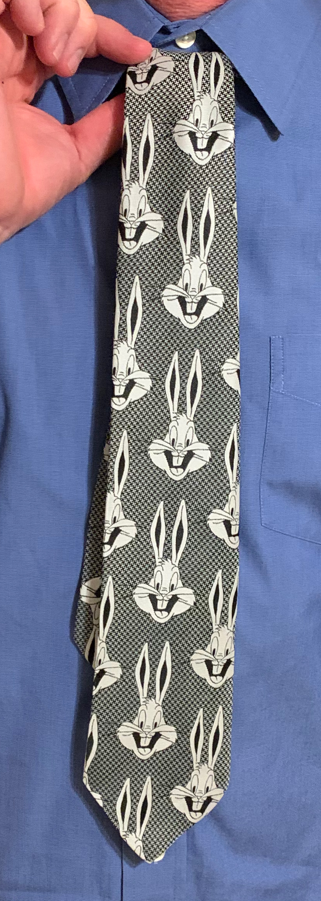  Step 7  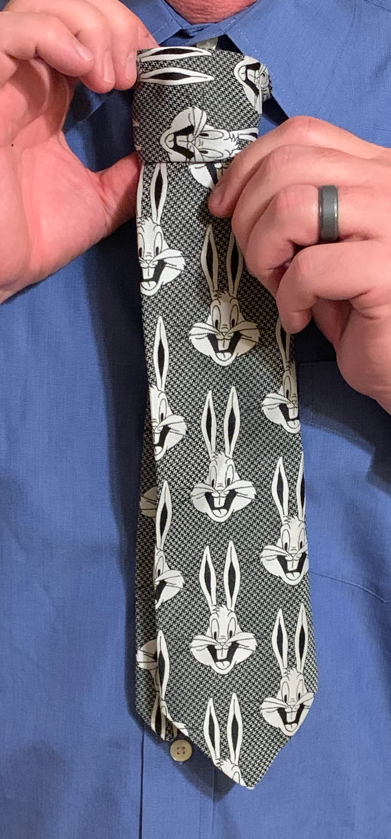  Finish the knot  Dress the knot  Adjustments for tall or short persons (relative to tie length).  Do not intervene or coach during this time!  Make sure all students do all the steps correctly and no students violate any of the safety requirements.  PO #1 (Cognitive)  PO #2 (Affective)  Please make sure that all ties are returned when the training is over. Thanks!

