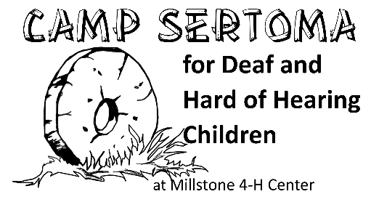
2019 Counselor in Training Application
An Equal Opportunity Employer
June 23-28, 2019 @ Millstone 4-H Center  1296 Mallard Dr  Ellerbe, NC, 28338
www.facebook.com/SertomaDeafCamp
Submit all applications to: campsertomanccoordinator@gmail.com
All applicants must be 17 years of age.
**NOTE: This a NEW Counselor in Training application for 2019.**
**Application deadline: April 1, 2019**
APPLICANT
Full Name__________________________________________________ Name you prefer_________________________
School__________________________________________________ Grade _________________________
HOME ADDRESS
Street_______________________________________ City_____________________ State______ Zip__________
Phone Number (include area code)______________________________ E-mail Address__________________________
EMPLOYMENT INFORMATION
I am applying for:

- Counselor in Training

Have you ever attended Sertoma Deaf Camp?  No  Yes - When?___________________

PAST CAMP EXPERIENCE
Please list any past experiences at any types of camp. Camp experience is not required for this position.
Camp |  | Years |  | Type of Camp

EDUCATION
List any education you have obtained.
Diploma/GED | Institution | Year Obtained | Area
High School

CERTIFICATIONS
List any certificates that pertain to camp life. For example, CPR training, life guard, etc.
Certification |  | Date of Training |  | Expiration Date |  | Copy Provided  (Attach to application)

As a staff member at this one-week camp, you will be giving up a great deal of privacy and comfort, working long and demanding hours, adhering to camp policies which may be limiting (curfews, time on, time off, lack of privacy, putting the needs of campers first, etc.) Do you anticipate any problem complying with this type of lifestyle?  Yes  No

ADDITIONAL APPLICANT INFORMATION (Please use additional paper if necessary.)
Why do you want to be a CIT?

What kinds of leadership and/or camping experiences have you had, if any?

List any extracurricular activities (i.e. school, church, volunteer organizations):

Please share any additional information about yourself that illustrates how you would be an ideal candidate for a camp staffing position:

ASL EXPERIENCE
ASL Skills. Please rank your ability to use American Sign Language.
____ Basic Communication—This is the equivalent of ASL 1. You have a basic vocabulary, you have basic understanding of fingerspelling, signs, and culture. You could carry on conversation related to school, family, and hobbies, but would not feel comfortable translating or facilitating between a signer and a non-signer. You are still nervous about signing in front of deaf ASL users.
_____ Conversational Communication—You can easily carry a conversation on familiar topics between adult sign language users, but would have difficulty if asked to voice for a non-signer. Your vocabulary is extensive, but not advanced and technical vocabulary is not advanced. This is the equivalent of ASL 2-3 course work. You are nervous, but can put those nerves aside to converse with deaf people.
____ Advanced Communication—You can easily carry on a conversation with native users with ease. You easily translate between ASL users and SEE users. You could comfortably sign or voice for a Deaf user, with minimal error. Communicating with deaf people is natural.
___ Native Language—You are a Deaf person or CODA who uses ASL as a primary home language. If growing up as a CODA, your ASL could easily be mistaken for Deaf rather than hearing.

REFERENCES
Please list 3 references, individuals who can make a statement regarding your work experience, character and ability. Please do not include relatives or fellow students. We must have complete information on each reference including street, zip code and phone number(s).
Name | Address/City/Zip | Phone (including area code)

ADDITIONAL INFORMATION
These positions require that applicants be age 17.
Are you 17 years of age:  Yes  No

I affirm that all information given is correct to the best of my knowledge.

_________________________________________________________________ _________________________
Signature of Applicant Date

_________________________________________________________________ _________________________
Signature of Parent/Guardian Date

