

Mercedes Benz O405

AUSTRALASIAN BUS MARKET
DIAGRAMS AND MANUAL INSERTS

FAMILIARISATION

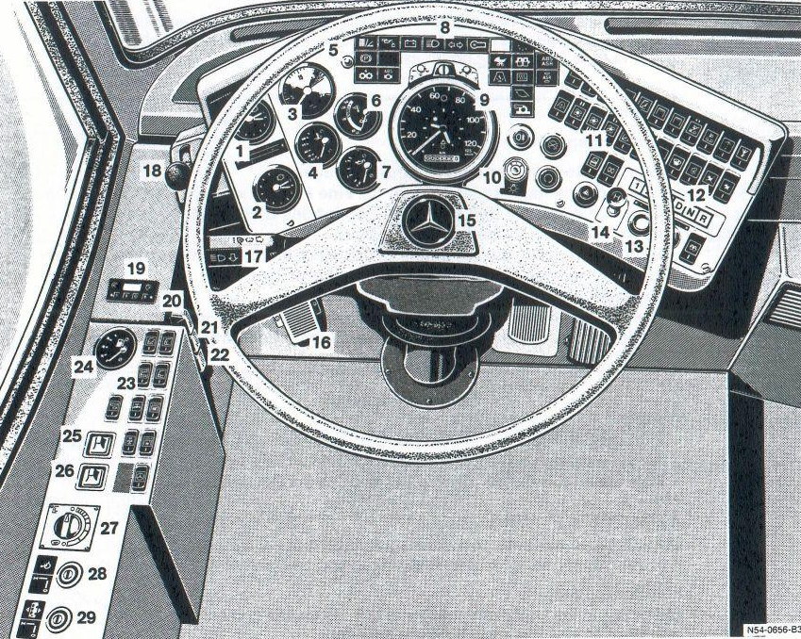

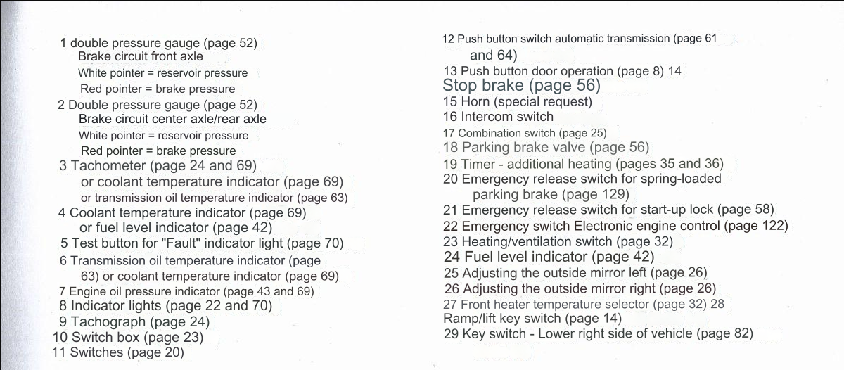

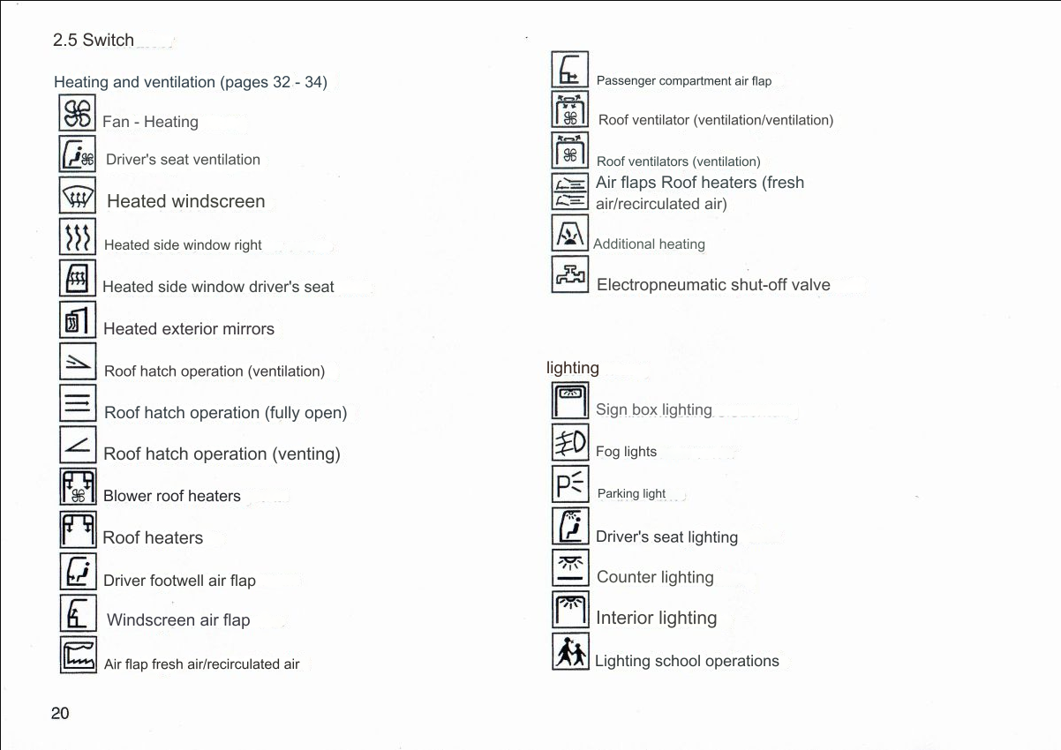

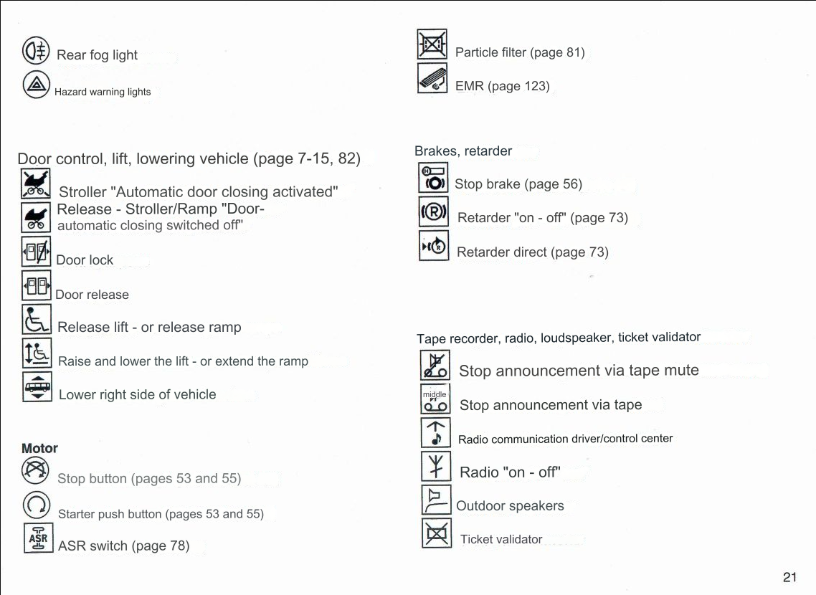

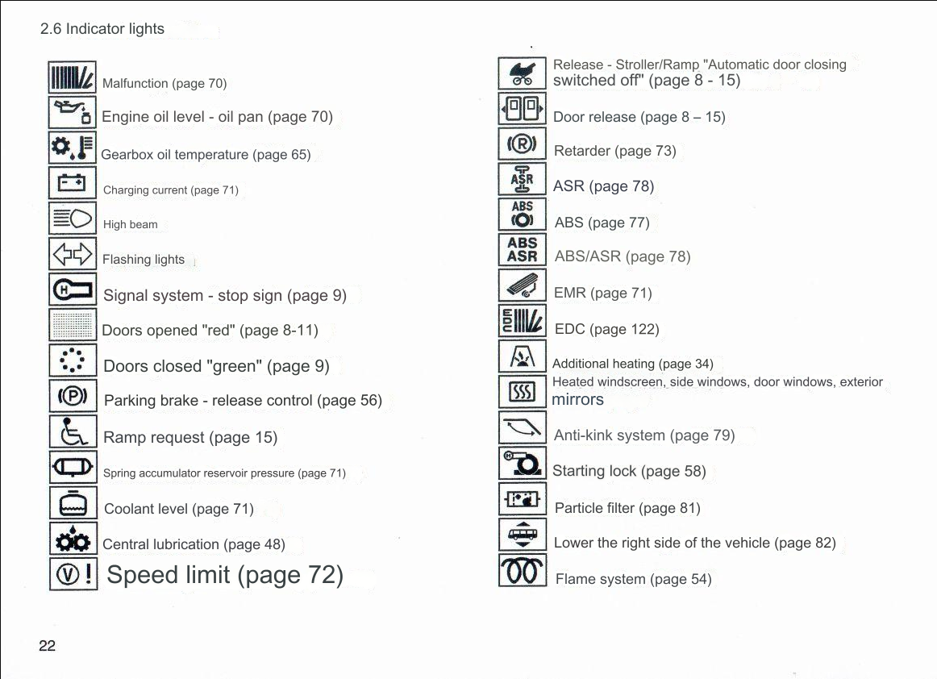

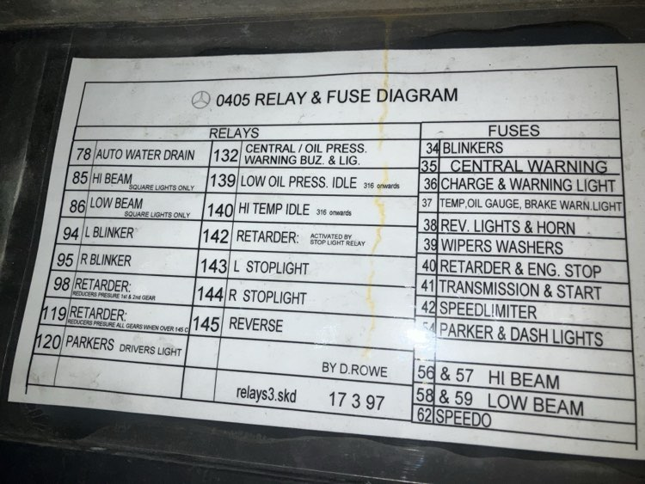

Mercedes Benz O405 Chassis Troubleshooting
Problem | Root Cause | Examples of the failure | Solution
Flat battery  ENSURE BATTERYS CONTAIN ENOUGH CRANKING AMPS / VOLTAGE FOR BUS TO POWER ON SUCCESS-FULLY | Battery’s have lost cell/s and do not hold enough power to start bus. Due to appliances drawing constant power off battery when bus off. | - Staggered, jittery start attempt  - No start-up from starter motor at all  - Dash cluster lights dull or intermittently powered  - Interior saloon lights dull | - As a temporary fix, fit isolator to battery and let batteries charge while isolator engaged. See if any cells are restored in the battery.  - Inspect electrical cabinet for any circuit breakers or fuses tripped.  - Inspect contact on terminals, you may only just have a dirty contact.
Starter motor | A drivers safety system is preventing start up  Or  Starter motor is faulty | - No start up at all  - Ignition power only  - Accessories powered | - Inspect first if a driver safety system is preventing the start up. This could be body hatches open which contain a sensor when if hatch open the bus will not start, or components disconnected in engine bay.  - Engine hatch has a flip arm which when open it prevents engine from starting. Either close hatch/es or engage sensor for start up to occur.  - Contacts on starter motor unit could be defective/dirty. Clean with electrical contact spray.  - Inspect electrical cabinet for any circuit breakers or fuses tripped.  - Temporarily, you can start the bus by using a two ended cable, and bridge the positive terminal with the ignition sense plug on starter motor (tiny plug in between + and – terminal), with key and ignition power on, this will jumpstart the bus.  - Some O405s (O405N and O405NH) contain a starter relay. Sometimes it can be a faulty starter relay module.
Brake circuit air  DO NOT DRIVE BUS WITH NO AIR BUILT UP THROUGH-  OUT CHASSIS | Brake circuit front and rear axle/s may have insufficient air or builds air slowly. | - Gauge inaccurate  - Gauge needle unsteady or violently shaking  - Water in air reservoir tanks  - Leak in air line under chassis | - Temporary fix, you can drain and dump all pressure in reservoir tanks. Front axle tank located directly under driver seat under chassis. Rear axle reservoir tank mid way along chassis. There is a ring on both tanks you can pull to dump excess water and air deposits.  - If air builds slowly, giving a few revs can speed up the process, as long as not excessive revs.  - Contact air specialist, a tank, fitting, valve or air line may need replacing.
Kneel and level  DO NOT DRIVE BUS WHILE KNEEL ENGAGED  DO NOT DRIVE BUS WITH NO AIR BUILT UP THROUGH-  OUT CHASSIS | Bus not raising to drive level / kneel not working / off centred | - Must wait for brake circuit gauge to build up first  - Air could be leaking from a levelling valve / kneeling system  - Some buses have units that take 10-20 minutes to properly raise up air bags to drive level. | - Allow 10-20 minutes for air to fully build up throughout entire chassis  - Air line or tank could be leaking  - Levelling valve or kneeling system may be faulty  - Shut down bus, let sit for 1 min and restart.
Air Conditioning | Air conditioner unit may be overdue for a service from an external contractor or manufacturer of air conditioning system onboard. | - Check to see if air conditioner circuit breaker has tripped  - Air is not conditioned; not cold nor hot  - Blower is very minimal  - No air presently blowing out at all  - Drivers console to have fault code or fault light present | - Contact air conditioner servicing company or the manufacturer

