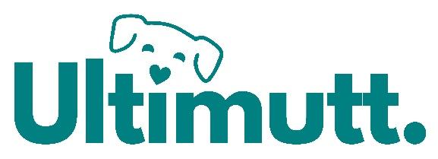
Ultimutt Doggy Daycare – Privacy Policy
Modified 26/06/2026

At Ultimutt Doggy Daycare, we are committed to protecting the privacy and security of our clients and their dogs. This policy outlines how we collect, use, store and protect your personal information, in compliance with the Australian Privacy Act 1988 (Cth).

- What information we collect
We may collect the following types of information from you:
Personal information:
- Your full name, contact number, email address and residential address
- Emergency contact details
- Payment details (processed via Square or other secure platforms)

Animal information:
- Dog’s name, breed, age, medical history, vaccination records and behavioural assessment
- Photos/videos of your dog while in our care

Other information:
- Correspondence, service preferences or feedback shared with us

- How we collect your information
We collect personal and pet information when you:
- Fill out enrolment forms (online or in person)
- Submit vaccination records or behavioural notes
- Communicate with us via email, SMS, social media or over the phone
- Sign waivers or agreements
- Use our website, or social media pages

- Why we collect your information
We collect this information to:
- Provide safe and tailored daycare services for your dog
- Match your dog with suitable playgroups (‘ice-cream flavours’)
- Ensure all dogs are healthy, vaccinated and appropriately placed
- Contact you in case of emergencies or service updates
- Improve our services and client experience
- Comply with legal and insurance requirements

- How we store & protect your information
We take reasonable precautions to keep your information secure. This includes:
- Password protected systems and software
- Secure payment processing (via Square)
- Limiting access to staff on a need-to-know basis
- Storing paper forms (if/when used) in a locked, secure location
We will retain your data only for as long as necessary for business or legal purposes, after which it will be securely deleted or destroyed.

- Sharing your information
We will never sell your information.
We may share limited data only when:
- Required by law or for insurance claims
- Emergency situations involving your dog’s welfare (e.g. with vets or emergency services)
- Payment processing (via secure third-party platforms like Square)

- Photos & Social Media
We love showcasing our Ultimutt family! We may take photos/videos of your dog while they’re with us. These may be used for:
- Social media posts
- Website galleries or promotional material
You can opt out anytime, just contact us.

- Accessing or updating your information
You have the right to:
- Request a copy of your stored information
- Ask us to correct or update your personal details
- Withdraw consent at any time

- Policy updates
We may update this policy to reflect changes in legislation or our services. The most current version will always be available on our website or by request.

- Contact us
If you have questions about your privacy, please reach out:

Sam – Manager, Ultimutt Doggy Daycare

0478 039 979
hello@ultimutt.net.au

Stacey – Owner, Ultimutt Doggy Daycare
0488 049 055

