The Port Fairy Historical Society on the River Moyne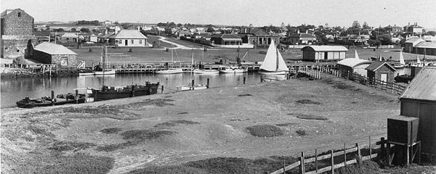

**Becoming a member of The Port Fairy Historical Society [PFHS] is an opportunity to be part of a community of members that are committed to preserving and sharing the history and heritage of Port Fairy and the District.**

Membership Benefits

* Free admission to General Meetings and presentations by Guest Speakers.
* Free admission to the Accredited PFHS Museum and Exhibitions
* Access to the extensive archives and comprehensive research library.
* Advice with personal research from our Library and Research staff.
* Subscription to the PFHS Society Newsletter providing news of monthly meetings, upcoming exhibitions and offering well researched articles on the local history of Port Fairy and District.
* Opportunity to participate in excursions to historic locations.

Membership Subscriptions Options

Single Membership :

$20 per annum or $50 per 3 years

Family Membership :

$25 per annum or $60 per 3 years

Newsletter Subscription only :

$10 (6 copies per annum)

PFHS Membership Application

|  |  |
| --- | --- |
| First name |  |
| Surname |  |
| Street Address  Town/State  Post Code |  |
| Phone no. |  |
| Email Address |  |

Select Membership Option

|  |  |  |  |
| --- | --- | --- | --- |
|  | 1 year | 3 Year | New  Or  Renewal |
| Single Membership |  |  |  |
| Family Membership |  |  |  |
| Newsletter Only |  |  |  |

Payment Options

Direct Debit :

Please pay to Account :

Port Fairy Historical Society

BSB 013 760

A/C 283606079

REF: PFHS Membership

& Name of Membership

OR cheque

OR EFTPOS /Cash at Museum

Museum Opening Hours:

Saturdays & Wednesdays   2.00 pm. until 5.00 pm.

Last entry at 4.30pm.

Sundays

10.30am - 12.30pm.

Last entry at 12 noon.

Winter Hours :

Saturdays Only

2pm - 4pm.

Last entry at 3.30 pm.

Winter School Holidays :

Saturdays & Wednesdays

2.00 pm. until 4.00 pm.

Last entry at 3.30 pm.

Sundays - 10.30 am 12.30 pm

Contact Us:

30 Gipps Street Port Fairy

Port Fairy 3284

Ph. 03 5568 2263

pfhsmuseumandarchives@gmail.com