AMBIGUITY

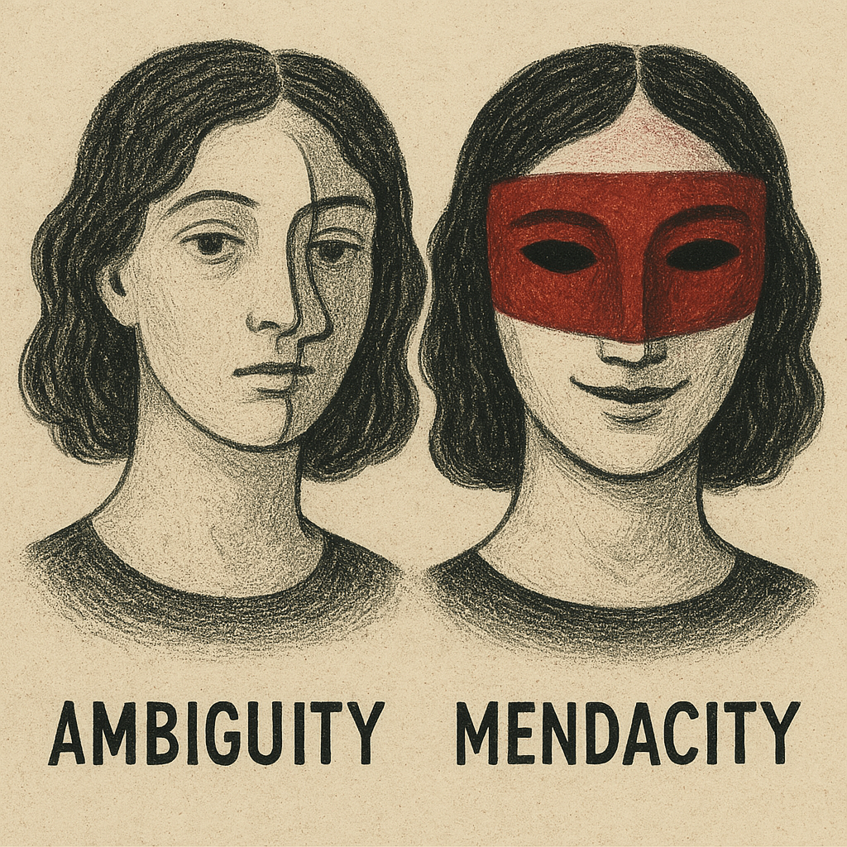

This and mendacity are two of my favorite words. Ambiguity is defined as open to more than one interpretation. Mendacity is a tendency to lie or a habit of being untruthful. I’ve been thinking of them and my past this morning. As a recovering addict of thirty-nine years, I can still remember that morning when confronted by several of my oldest friends about some of my dubious behavior, and wanting to lie about it. Fortunately, I pled guilty as charged. That was a freeing moment as I was no longer a prisoner to my attempts at deception. People you grew up with can spot you from a hundred yards away, and they had no doubt about my comings and goings. At thirty-three years of age, it was time to move on.

##

What I remember most about my Army basic training was the observation from our drill Sergeant, and what we had to repeat back to him, “Only the strong survive, drill Sergeant!” It gave me a sense of cohesion and a factor for performance. I had been a good athlete in high school and otherwise, and had an IQ measured at above average; I hadn’t needed to focus on them, but this was an added value. Perhaps it’s why I survived the next eleven years of full-blown street junkie, and saw so many die during that time, and as I’ve lived in recovery. I had certain principles and a limit on how far I would go to get my stuff. But, as referred to above, I still pushed the boundaries too far.

##

So now, at seventy-two years of age, I can measure the present state of my affairs as a human being. Again, one word will suffice, balance, and a poem I wrote many years ago. As an aside, I had just smoked some of the best weed ever!

‘The few-leafed oak, in a rainy wind wet, its tall, thinning frame, the top of which suggests a leaning, too far this way, too far that way, that as I look and wonder whether, I too would bend too far, in a rainy wind, on an autumn twilight, not yet dark, but having been light.’

© 2025 George H. Clowers, Jr.