“Guilty, your honor. The cover was done by AI after I described what I needed. Everything inside, however, is all natural intelligence from my wife and I.” “Excellent.”

RECOVER

David entered the small chapel and didn’t turn the light on in the anteroom. He entered the worship area and sat on a bench. He thought to go kneel up front but didn’t want to feel too formal. His mother had died six weeks ago, and he just wanted to be with his thoughts. The grandeur of the moss-dripped old oak trees outside made him feel reverent, the quiet of the marsh brush and waterways had soothed the disquiet he was experiencing. He was enjoying his work as a writer yet was feeling alone for the first time in his life. He remembered how she pushed him, rarely praising his work, yet acknowledging “It’s like the others.” She knew he operated from a lofty perch and always compared him thusly; she expected greatness from him. Even in the darker moments of his life, understanding his drives and needs, she took his confidences to the grave. She knew he would have to be alone with them one day, but she listened and prayed, prayed that he would handle them successfully.

Twenty minutes into his reflection David returned to the present moment and looked around, noticing the stained-glass figures in the windows, the Jesus statue atop the altar, then, again, the quiet stillness.

\*

His spirit life was honed in prison, the twenty-four hours aware of danger, the brief moments of insight given by his fellow, older inmates, his sense of isolation from the younger ones, the seeming wall of protection around him, provided a surety about his purpose on earth, yet he still wasn’t clear about what happened that night, but he remembers the gunshots, the bullets going past, the aroused tension in the air. And his hands would tremble a bit, the pain in his right wrist would increase, and he could almost hear, “David, David, David,” being shouted, no, screamed behind his right ear, he could remember lights, and darkness, dogs barking, running, thumps, then the quiet again.

He thought to go kneel before the altar again because, “Isn’t that what you’re supposed to do?” but he resisted, took a good breath, then left the small chapel, relieved.

\*

Slow dust roads in the fall capture the mist of morning love.

An old horse gamely comes to the fence,

slow and sure friends are near.

Since the church knows its place,

an hour too soon carries the magic,

of a return to spiritual awe,

de Christo mountains,

a fresh rushing stream.

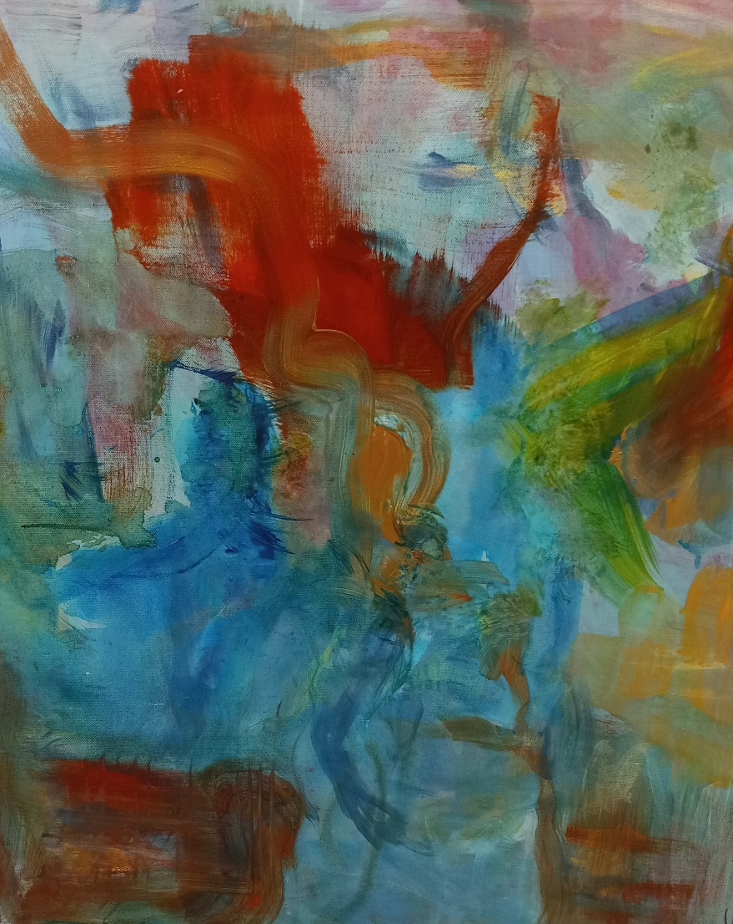

Distant memories, like seeing the Blood Moon and Mars overnight,

late July, a jealous cool and just enough breeze

to grade a toughened patch of life.

Our younger cat then joined us

when up the window went,

she took a seat and looked straight up

to view the timeless scene.

She seemed to know from our response

the beauty we gathered for,

awakened by

the depths of how

the human mind must search.

Thank you for visiting my gallery of art and perception.

I am truly grateful for the opportunity to share these with you.

Deborah Clowers

deborahmusic@comcast.net

www.georgeclowers.com