EMBRACING THE SPIRIT OF CHANGE
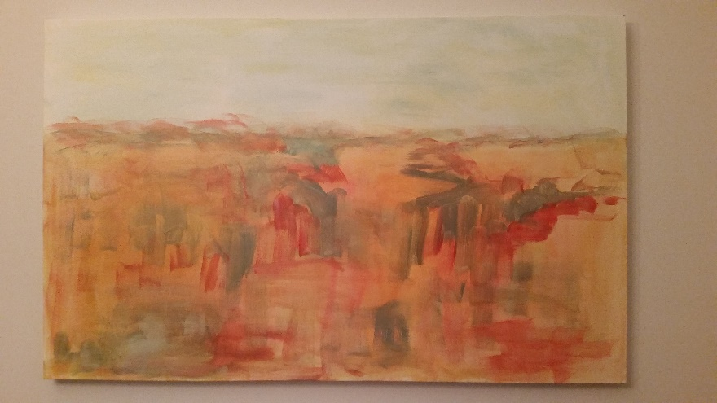
Desert Mourning I
Acrylic on Canvas by Deborah Clowers
Story by George Clowers
PLEASE DON’T BURY ME IN THE RAIN
© 1990 by George H. Clowers, Jr.
ALL RIGHTS RESERVED
THIS IS A WORK OF FICTION
I should have just taken the nine iron out of the bag and called Judy back. She was my ex-wife, after all. I was on the eighteenth hole, leading Franklin by a stroke. I had one hundred and twenty yards to the pin, an even lie, and no wind for my second shot. I took the call anyway. He looked at me like I was weird for stopping play.
“Judy, how are you?” I asked.
“Not good. Can you talk now?” she asked.
“Sure, sure,” I said, and motioned for Franklin to go ahead and take his shot. He did and came within one foot of the pin.
“I’m dying, and I would like to see them again.”
“What?” I asked.
“The paintings, the Desert Mourning paintings. Do you still have the first one?” she asked me.
“No,” I answered. “I sold it a few years after we divorced.”
I could hear her start to sob.
“Charlie, what happened to us?”
I didn’t have an answer for that one.
“Do you know if Harvey Sanders is still around?” she asked me.
“No, I don’t.”
“He would know where they are. He liked them as well. He’d know who owned them now.
“How much time do you have?” I asked, feeling impolite.
“Three months, they say.”
*
I hadn’t thought of those paintings in years, though I thought of her often. It had been twenty-five years since we separated. I thought to tell Carla about the call, but not today. I’ll tell her in a week or so. I would have to think through what this meant, and what I should do. Yes, Harvey was still around somewhere, and yes, he had acquired the other painting and sold them both. I’m not sure what they would be worth now, especially since they were probably in a private home, maybe not even in this country. They were beautiful, exquisite even, together or featured alone. I would have to call people I had not talked to in years, and spend some money of course, but she was worth it, up to a point. I would find them for her.
*
Jackson Wheeler would be my starting point. He still lived in Memphis and attended all the art shows around the country. He knew people who knew people, and plus he was a good breakfast companion. I could fly up late, or early one morning. He usually only needed a couple of days’ notice if he was in town. His number was still in my phone.
“Jackson Wheeler,” he answered.
“Yes sir, Charlie Bivans here, how are you?” I start.
“Well I’ll be, Charlie Bivans, when did you get out?”
“A day after you!” I say, and we both laugh, thinking back.
“How’s Carla?” he asks.
“Good, good, good. And how’s Jean?”
“Great, great. She’s around here somewhere,” he says, and we both laugh again. “What’s up?”
“I need to find something, and I thought you might be able to help?”
“Sure, what do you need?”
“Do you remember some paintings Judy did for the Recovery Center years ago, there were two, desert themed, powerful, based on feelings she expressed when Tommy died?”
“Awh man, that goes way back! Wow. Man, you’ll have to buy me breakfast for this.”
“I know, I’ll be up Saturday.”

When I hung up the phone I paused, and asked myself, “What are you doing?” I didn’t have an answer. I hadn’t talked to Judy in over 25 years, and I didn’t know what happened to those paintings. I do remember how striking they were, and Tommy’s death. I didn’t owe her anything, I thought, until Carla arrived.
“Hey darling, what’s new?” she greeted me.
“Not much. I won the dollar today, and Franklin wants a rematch next Tuesday.”
“That’s great. What’s for dinner?”
“Chops? I picked up a special today. Full bone, half an inch.”
“Yummy. Potatoes?”
“You know, the usual. How about you?”
“Rough day, Tina’s father died last night. She’s a mess. They hadn’t talked in years. He called her last week, and she didn’t return the call. She’s messed up, blaming herself for his death.”
“Is she alone?”
“Yes, as a matter of fact, I’m going back over to stay with her, probably overnight.”
“Oh sure, that’s fine. Her brother?”
“She doesn’t know, out west somewhere. I told her I’d help find him. The whole thing’s a mess.”
“Boy, I’d say. How can I help?”
“This may stretch out a bit since I’m her best friend,” she says.
“Sure, just let me know. Oh, I heard from Judy today.”
“Your ex?”
“Yeah, you talk about a story.”
“What did she want?”
“I guess it comes in waves. Do you want to hear it now, or later?”
“Later would be better. I need to grab some things and get back to Tina. I’ll eat over there; save the pork chops. Is that okay?”
“Sure. Give her my love and keep me informed.”
“Thanks darling, I will.”
2
We were out there for eight days, but the experience left us both with a new sense of freedom, a further commitment to our art forms, and a feeling that we had been fed a new food that would produce a new kind of energy that only comes from exploration of the desert, especially in northern New Mexico.
Tommy’s house was standard adobe stucco, with modern upgrades in and outside. It’s tan colored exterior, with a red front door and rock garden that extended around to the sides of the house, produced a special aura to me the first time I saw it. The expanse of sky and land, spotted by brush and cacti allowed me to get closer to why he left the east coast.
He was tall and rugged and spoke on all subjects with delight and depth. He had been a track man in high school, and he would go for a jog each morning we were there. Judy joined him twice, and I thought about it every day. I had golf, however, to soothe my passions.
They were close and talked of art and literature and films for hours sometimes. She would critique his essays, and he would judge her acrylic abstract images on canvas. I would have input, but their laughter and jokes were usually from a place of early intimacy only gained in families where support and comfort were easily practiced. Their parents had been intense businesspeople, but home was sacrosanct, and business stopped at the front door.
Judy had studied with a group of free lancers and developed into a fine painter using watercolor first, a brief stint in oils, and then on to acrylics. The Desert Paintings were in acrylic, and the soft beige and blue tints were layered by a red and dark turquoise brush stroke that put faces and stories all about the first 36”x 40” canvas. It was dynamic and angry. The second one was moody, with orange and eager yellow rooms of tears browned and washed down with space and time by a curious type of green sky. It was elegant and soothing. They had adorned the living and dining rooms of our home and were a testament to the love she had for her brother, but also of the pain she felt when he died at the age of twenty-six. When we divorced, three years later, we chose our favorite. She chose number two. Once her fame as an artist peaked I sold mine for forty-four thousand dollars. Hers was given to a friend the year she went to France to live for safe keeping.
*
Desert Mourning II

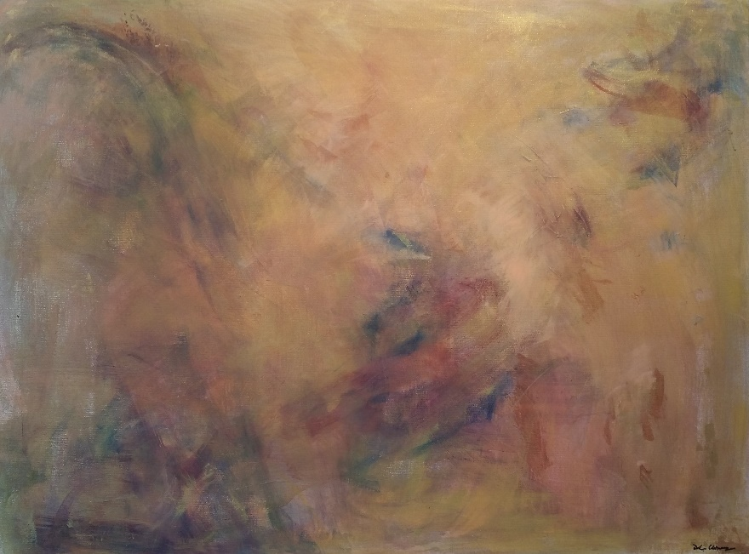

END OF SAMPLE

