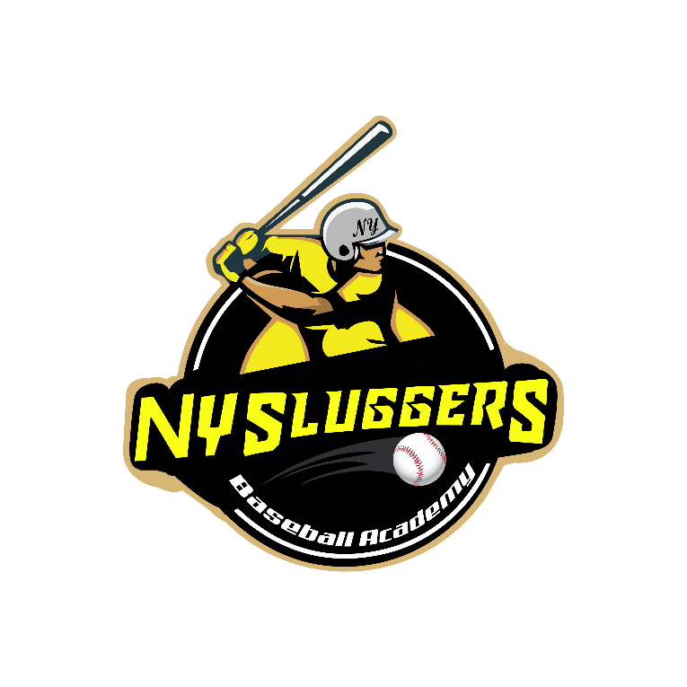
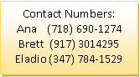

Please Complete this form and Email or send with payment:
NY Sluggers Baseball Academy
728 E. 136th Street, Bronx, NY 10454
Tel: (718)292-1234
Email: Nycsluggers@gmail.com
Web: NYCSluggers.com
Dates: | Days and Time: | Where: | Cost:
Spring Season  March 31st -June 14th  Including Memorial Day Weekend Tournament  Games either Saturdays or Sundays | Practice days:  Tues. 4:30-6:30 pm Batting  9U and 10U  Fridays 3:30-5:30 p.m.  Fielding Practice at Central Park North Meadow Field #7 and #8  ** Batting Practice Day can be adjusted to your schedule if necessary | *Batting Practice will be at NY Sluggers Baseball Academy in the Bronx  *Fielding practice will be at Central Park North Meadow fields #7 and #8  Pickups and Drop offs for batting practice during the week  *Pick up locations:  East side 86th street and Park Ave. and Westside 86th street and Central Park West by the Park from 3:30 to 3:45 P.M.  *Drop offs at home | $1,925  Price includes uniform (Game Jersey, hat with #, two dry fits with #, belt, socks and pants)
Training for Every Position and Skill
Depending on your position, here are just some of the skills you will learn from our expert coaches:
Hitting
Approach, pitch recognition/strike zone discipline, situational hitting and bunting
Catching
Receiving, blocking, throwing, footwork & exchange and game calling
Base Running
Primary/secondary leads, proper reads, base stealing and sliding
Infield
Pre-pitch preparation, fielding mechanics, throwing footwork, range, double play turns and positioning
Outfield
Pre-pitch preparation, fly ball and ground ball technique, jumps and reads, throwing and positioning
Pitching Mechanics/delivery, arm care, off-speed development, PFP practice
SLUGGERS BASEBALL ACADEMY SPRING 2020 9U and 10U

Personal Information:
Child’s Name (first, last):……………………………………………………………………… DOB:…………………………………
Street Address:……………………………………………………………………………… City:………… State:……… Zip………
Parent #1 Name: ………………………………………………………………………………………………………………………………….
Home Phone: ………………………………………………………….. Cell Phone: ……………………………………………………
Email:……………………………………………………………………………………………………………………………………………………
Parent #2 Name: …………………………………………………………………………………………………………………………………
Cell Phone: ……………………………………………………………….
Email: …………………………………………………………………………………………………………………………………………………

Payment Information: Full payment due with registration
Total cost ($1,925.00 per player)
If payment by credit card: Name on Card: ……………………………………………………….........
Credit Card #: .............................................................................Expiration................... Date: ................ Security Code: …………………………
Signature: .................................................................................................................................
If payment by check, make payable to: Sluggers Baseball Academy

Parental Consent
Cancellation Policy: Please note that a $50.00 processing fee will be charged for any cancellation of registration prior to the start date. There will be NO REFUNDS FOR TRAVEL BASEBALL, only for Sluggers camps or pre and post season workouts. Also, once your child has attended three sessions or more of a program, NO REFUNDS will be given unless due to injury, in which case a doctor’s note is required. If your child has only attended one or two sessions and decides he or she does not like the program, a prorated credit will be applied to be used towards Slugger Academy private Lessons minus a $50.00 processing fee.
As parent or legal guardian of the above applicant, I hereby consent to his/her participation in any and all activities in Sluggers Academy and agree to abide by all rules and regulations of the institution. In consideration of Sluggers Academy accepting this registration and permitting the participation of above applicant, which I believe would be of educational, physical and other benefits, I assume all risks and hazards incidental in participation in all activities. I hereby release, discharge, indemnify and hold harmless Sluggers Academy, its officials, coaches, representatives and all persons transporting my child/dependent to and from activities from any and all claims, actions and liability arising out of or in connection with my child’s participation in any aspect of Sluggers Academy, whether or not such injury is caused by the negligence, willful conduct or other inaction of the indemnities. I certify that he/she is in good health and able to participate in all activities and in the case of emergency affecting my child, I hereby give permission for a physician or hospital designated by Sluggers Academy to administer treatment to my child. I also understand that Sluggers Academy has a no refund, ONLY a credit policy towards lessons to be used at the Sluggers Baseball Academy
Signature: X______________________________________________ Date:____________

