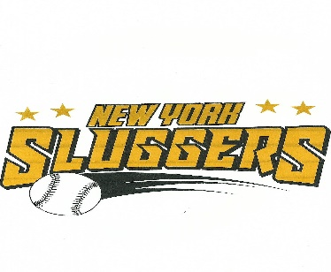
UNIFORM ORDER FORM
UNIFORM CONSISTS OF:
1 GAME JERSEY (BLACK W/ GOLD W/#)
2 DRI FIT GAME/PRACTICE SHIRT-BLACK (1 LONG SLEEVE,1 SHORT SLEEVE W/# )
1 BASEBALL PANTS (GRAY)
1 HAT (BLACK W/ GOLD LOGO & PLAYERS # ON BACK)
1 PAIR OF SOCKS (BLACK)
1 BELT (BLACK)

Athletes Name: ____________________________________
Please indicate your sons sizes below:

UNIFORM # CHOICE 1_____, 2_____, 3_____

JERSEYS: YS, YM, YL, YXL, AS, AM, AL

SHIRTS: YS, YM, YL, YXL, AS, AM, AL

PANTS: YS, YM, YL, YXL, AS, AM, AL (NOTE PANTS MIGHT RUN BIG)

FITTED HAT: (3 SIZES) XS/S, S/M, L/XL

Total cost: $125.00-INCLUDED W/SEASON FEE

PLEASE EMAIL FORM BACK TO:
NYCSLUGGERS@GMAIL.COM

