Putting Prayers Yo Acñon, Inc,

l33fi Solway Meeting Road, Big Clifty, Kenmcky 42712-8870 Phone 270-735-3155

E-Mail: praverstoaction ;gmail.com Web site:
EIN 45-3571879
Z Z Z S X WK W L Q J S U D \ H U V W R D F W L R

Date:
Donor:
Address:

Dear
We thank you mar your generous donation of lhe following iiems in support of’Putting Prayers to Action. We couldn't accomplish what u e do without donors like you assisting us. Ttiank you for being His Obedient Vessel in assisting us.
Thank you for your donation of:

We are so grate‘lu1 to you ior supporting our rommitmenl to the underprivileged. Thanks to you, God has allowed us to iouch and change the lives of thousands — whether they faced an urgent need, devastating hunger or sought to improve their spiritual life by asking Jesus into their hear. Puttñig Prayers to Action is your Hands and Feet in this hurting world. We exist to serve God and to Change the world one life at a time with Mercy, Love and Grace through CA ist Jesus, our Lord.
Together, we are making a Difference!
Putting Prayers to Action, Inc. is a 50l(c)3 non-profil Drganizalion under the Internal Revenue Code and certiiies that there were no goods or services provided to you for this donation.

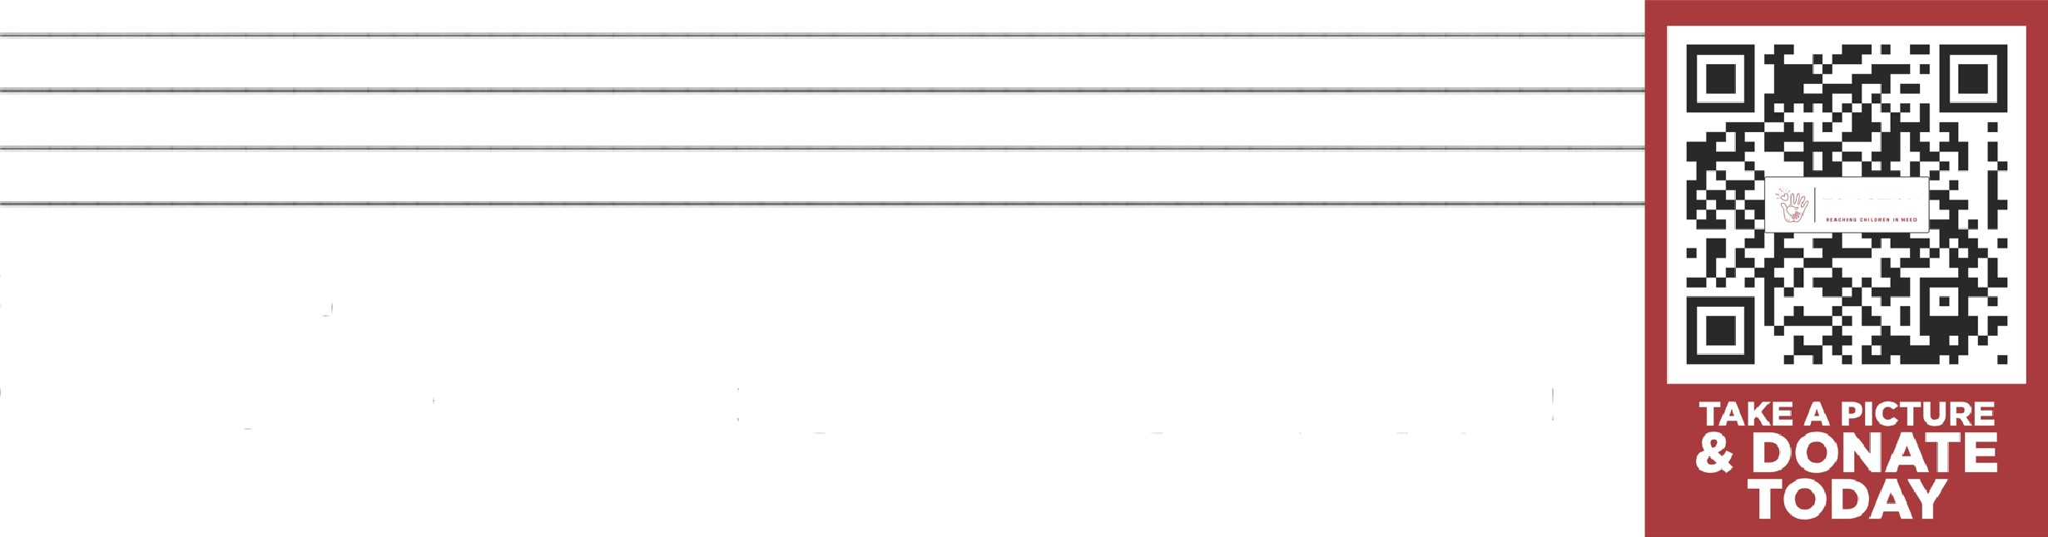
TO ACTION
In Christ's Love,
T⁷in^{L}a^{Q}D^{D}ecke’ r^{H}, F^{F}o^{N}un^{H}de^{U}r
Keep ront bsue to keep us ii yoar prayers!

The Spirit of the Lord is upon me. because he hath anointed me to preach the gnspel to the poor
he hath sent me to heal the brokenhearled. Luke 4: i g

