**Chapter 1**

Innovation

**Chapter 1: Innovation**

“*Innovation is change that unlocks new value*.” – Jamie Notter0F[1].

**Learning Objectives**

Upon completing this chapter on Lean innovation you will be able to:

* Explain Lean Kaizen, Lean Kaikaku and Lean Kakushin.
* Recognize the parallels between the rise of the internet and the emergence of Web3.0.
* Understand the concepts of ‘Transformative change’ and ‘Radical change.’’
* Be clear on why blockchain technology requires system *thinking* and *design thinking*.
* Follow the evolution of Organisational Structures over the past 100 years.

**Introduction**

In this chapter we explore Lean Kaizen, Lean Kaikaku and Lean Kakushin to understand their pivotal roles in driving transformative change.

.

We will use as an example the transformative change that occurred in business and society as a result of the ‘World-Wide-Web’ internet during the 1990’s and early 2000’s.

A similar transformation is possible with the use of Web3 and Blockchain technology in the 2020’s and beyond.

Lean Kaizen, Kaikaku and Kakushin strategies are presented as valuable tools for organisations that want to embrace the innovative potential of Web3 and Blockchain technology.

The benefits of transitioning to Web3.0, the integration of Lean thinking with blockchain, and the role of Lean innovation in the shift from ego-centred to eco-infrastructure organisations are key themes explored in this transformative journey.

**Lean Transformation: Kaizen, Kaikaku, and Kakushin**

Lean provides three distinct approaches to improvement which have been named by the Japanese as Kaizen, Kaikaku, and Kakushin.

These three Japanese words represent the following:

* Kaizen: small and regular changes for improvement, incremental improvement often in an iterative way.
* Kaikaku: radical change that replaces a previous design / process / business model with a new design / process / business model.
* Kakushin: use of innovation for transformational change, disruption of the status-quo. Involves a paradigm shift, a new way of thinking and behaving.

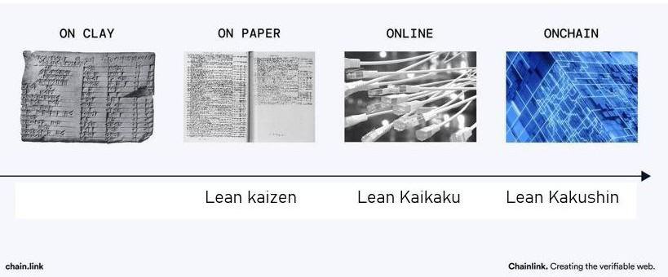

**Lean Kaizen**

The term "Kaizen" is understood in Japanese as "Change for the Good in small incremental steps". In the context of Lean manufacturing, Lean Kaizen represents a culture and mindset with organisations for ‘Everybody, Everywhere, Every Day’ to be identifying and making small improvements to the way in which work is being done.

**Lean Kaikaku**

The term "Kaikaku" translates to "radical change" or "revolution" in Japanese. In the context of Lean manufacturing, Lean Kaikaku represents a deliberate and strategic effort to bring about substantial and transformative changes within a process, system, or organisation. Its goal is to swiftly enhance efficiency, quality, and overall performance. The methodology behind Lean Kaikaku involves a meticulous process of identifying bottlenecks, eliminating non-value-added activities, and re-engineering processes to achieve breakthrough results. This approach becomes valuable when incremental improvements (Kaizen) prove insufficient to overcome existing challenges, necessitating a more profound and sweeping transformation.

**Lean Kakushin**

"Kakushin" translates to "innovation" or "reform" in Japanese. Lean Kakushin centres around fostering a culture of innovation within an organisation. It encourages employees at all levels to cultivate innovative ideas, experiment with diverse approaches, and actively contribute to the evolution of processes and products. Lean Kakushin places a strong emphasis on creating an environment that nurtures creativity, experimentation, and views failures as opportunities for learning. This approach is an organisation's key to adapting to ever-changing market conditions and shifting customer needs while maintaining a competitive edge.

All three approaches, Lean Kaizen, Lean Kaikaku and Lean Kakushin hold integral positions within Lean thinking, concepts which have been used to their fullest effect by Toyota in their Toyota Production System (TPS). These principles have gained universal acceptance across various industries to enhance operational efficiency, reduce waste, improve quality and ultimately create more value for all stakeholders.

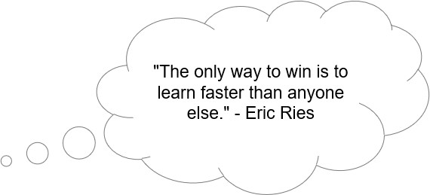

**Learning to see what is not there yet**

Blockchain technology and decentralized systems stand at the forefront of a transformative change, poised to revolutionise how we structure organisations and organise value transfers in processes. To grasp the profound implications of this shift, we think it helps to draw parallels with something we have experienced before: the advent of the internet. While these changes may have been challenging to foresee in advance, they appear highly logical when viewed in retrospect.

**A comparative analysis**

We can compare and contrast the rise of Web3 and blockchain technology to the rise of the internet and Web2 e-commerce.

**Innovation and evolution**

With the internet we created new ways of communication, entertainment, socialisation and business transactions. With Web3.0 powered by blockchain technology, we have created a decentralized record keeping platform for value transfer and messaging. This innovation facilitates secure value transfers, digital assets management and application development.

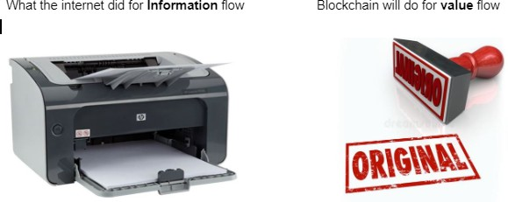

"The internet is programmable information, the blockchain is programmable security." - Balaji Srinivasan

**Decentralisation or disintermediation**

Initially, the internet was dominated by centralised systems with a few major players. Blockchain and Web3.0 aim to shift this paradigm by leveraging decentralized networks to reduce reliance on central authorities and empower individual users. This move from centralised control to decentralized control is often referred to as disintermediation because it removes the *intermediaries* in transactions.

**Value transfer**

While the internet transformed information communications, digital payments and value transfers continued to rely on traditional *legacy* financial systems. Web3.0 leverages blockchain and cryptocurrencies to enable direct peer-to-peer value transfer, facilitating fast and cost-effective cross-border transactions.

**Privacy and identity**

Concerns over online privacy and data security have become prominent. Web3.0 addresses these concerns through decentralized identity systems and encrypted communication, offering users greater control over their personal information.

**Innovation and applications**

Just as the internet sparked countless innovations, such as e-commerce and social networks, Web3.0 opens the door to new functionality, including decentralized finance (DeFi), non-fungible tokens (NFTs), decentralized apps (dApps)and *smart contracts (more about these new functionalities later in the book )*

**Adoption and challenges**

Just as the internet faced challenges in its early days, Web3.0 grapples with issues like scalability, user-friendliness, and legal and regulatory hurdles. Web3.0 is expected to evolve gradually, offering both new opportunities and challenges.

In summary, Web3.0 has the potential to revolutionise how we transfer value, conduct transactions, and engage in digital interactions, like how the internet reshaped information sharing and communication. As the internet gradually evolved, Web3.0 is poised to follow a similar trajectory, bringing many new opportunities as well as challenges.

**Transformative innovation is here!**

Lean Kaikaku and Lean Kakushin offer invaluable strategies for organisations seeking transformative improvements. Embracing these lean principles can elevate efficiency, enhance quality, and foster innovation. As we continue this transformative journey, staying adaptable and innovative is key to thriving in this dynamic digital age.



*Article clipped from The Signal, Santa Clarita California, Fri, apr 19, 1996*

**Key benefits of transformation for Lean practitioners**

The transformation to blockchain based transactional systems (Web3.0) brings many benefits compared to traditional internet (Web2.0) based systems.

P299#yIS1 Proof of ownership P299#yIS2 Proof of provenance

P300#yIS1 Trust and transparency P300#yIS2 Enhanced privacy

P301#yIS1 New incentive models

P302#yIS1 New governance models P302#yIS2 Interoperability

P303#yIS1 Censorship resistance

P304#yIS1 Reduced middlemen and costs P304#yIS2 Global accessibility

P305#yIS1 Immutable content

P306#yIS1 Reduced data monopolies P306#yIS2 Control by design

P307#yIS1 Security by design

DYOR is an acronym for **Do Your Own Research**. DYOR is advice generally given to anyone getting involved in the cryptocurrency markets with real money, advising them to research topics on their own instead of simply believing some random Twitter account or Facebook article or YouTube influencer.

**Lean Thinking: value, value streams, flow, pull, perfection, trust and respect**

Lean thinking encompasses the principles of value, value streams, flow, pull, perfection and trust and respect. It places a strong emphasis on delivering value to customers, streamlining processes, maintaining smooth workflow, producing based on demand, and striving for perfection by eliminating waste and improving quality. This comprehensive methodology has found widespread application across industries, resulting in increased productivity, cost reduction, enhanced quality and a more engaged workforce that works with mutual trust and respect.

**Lean system thinking: collaborative technology**

One reason we refer to *blockchain* as a *lean system technology* is because the technology facilitates collaboration and removal of *silos*. Power and control are decentralized and not in the hands of a single or small group of entities.

Blockchain technology is at its best when multiple diverse parties must cooperate, trust cannot be assumed, and transactions or data require transparency, tamper-proofing, and validation by all participants.

Blockchain's greatest advantage over more traditional data systems lies in its ability to track transaction statuses across a network of diverse stakeholders, making this information accessible and verifiable by all participants. In this decentralized network, the time and occurrence of transactions become irrefutably documented. This capacity to verify transactions without intermediaries opens the door to groundbreaking opportunities for establishing trust on the internet. In a manner like the internet itself, blockchain is ushering in new organisational models, revenue structures, persuasive strategies, products, and customer interactions.

Blockchain technology, also called Distributed Ledger Technology ( DLT ), means “not controlled by a single or small group of entities”

We are still in the early stages of this transformative journey. At the time of writing this chapter, blockchain technology is at a similar stage to the internet of the 1990s—not an easy solution for rapid change. Mainstream adoption will take some time (perhaps 5 to 10 more years) ... Just as the owner of a record store in 1985 could not envision music's digital accessibility, the adoption of blockchain hinges on gradual evolution rather than immediate revolution.

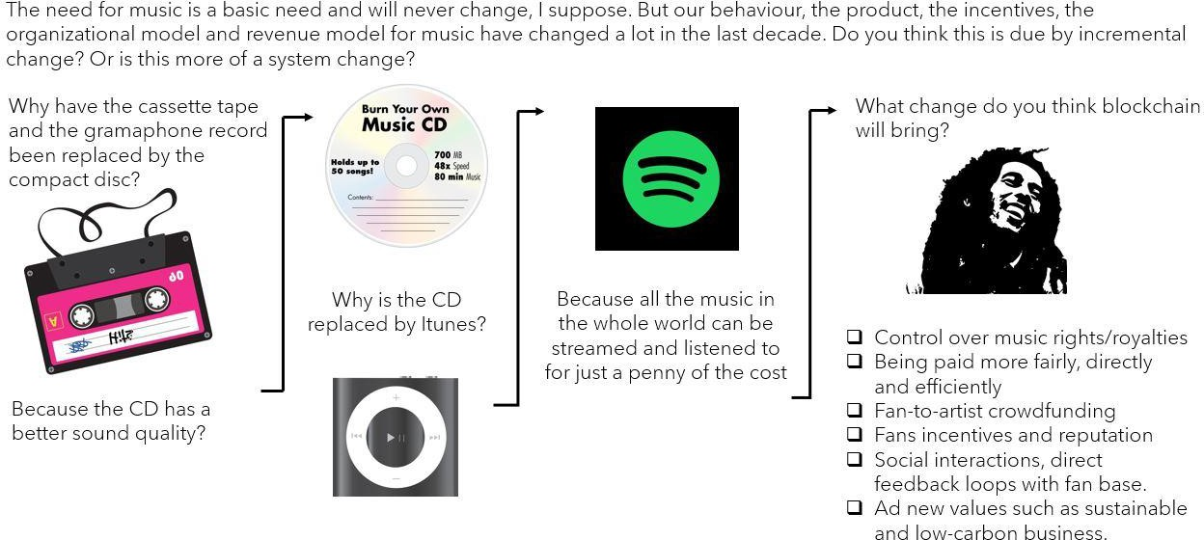

**Paradigm Shift**

Numerous processes withhold information from Stakeholders, based on distinct interests and objectives. Non-disclosure can be a deliberate strategic choice, integral to business models. Moreover, companies often compartmentalise into departments, functions, systems, or roles, further fragmenting information and internal power dynamics. This fragmentation through "silo thinking" and "silo organising" obstructs the smooth flow of product, payment, and information streams, rendering processes less predictable. This unpredictability yields problems and challenges, which provides opportunities for Lean practitioners and consultants to introduce the concepts and technology of blockchain and Web3.

The adverse effects of information fragmentation, characterised by fluctuating demand downstream, are referred to as the "Bullwhip" effect or whip-lash effect within the supply chain.

This phenomenon occurs when information arrives late, leading to automatic inventory fluctuations. Imagine the transformation if we shared critical information with our chain partners, such as customers providing real-time product feedback. This could dramatically impact lead times, quality, and customer satisfaction, as we will explore later. One can envision a "supermarket model" where all stakeholders gain insight into the "who, what, where, and when" of a process. The implications for the Bullwhip effect are profound.

**’Blockchain technology provides a solution to the problem of information fragmentation and information silos, characterised for example by fluctuating demand downstream in a supply-chain creating the "Bullwhip" effect.**

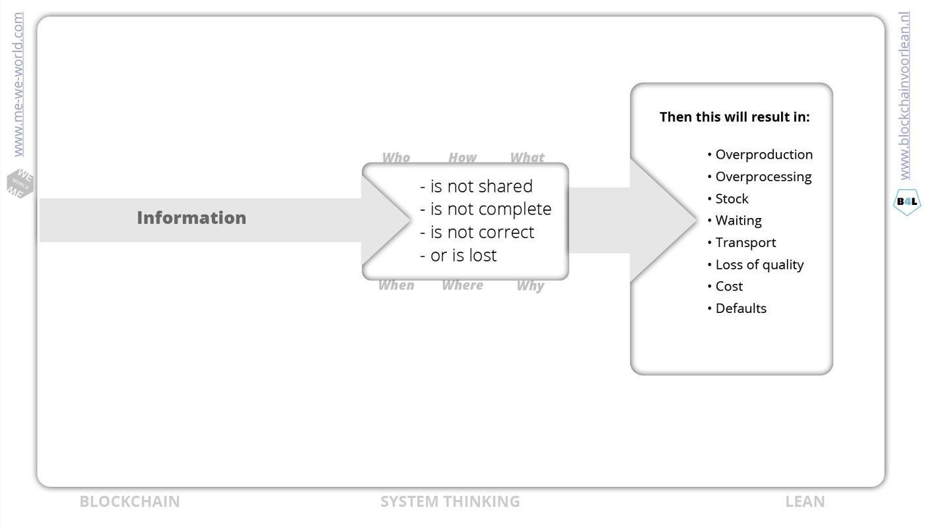**Imagine the reduction in waste and gains in sustainability if we shared critical information in real-time with supply-chain stakeholders, partners, suppliers and customers who need it to make decisions.**

**Lean drivers behind blockchain**

The elegance of this decentralized organisational model built on blockchain technology lies in transparency, standardisation, visualisation, and accountability. Blockchain technology serves as the foundation, offering all process participants real-time insights into the flow of goods and work. This new insight into their processes and supply chains empowers every stakeholder involved to stay informed about the current status of their products or services.

For example, outsourced maintenance jointly overseen by a company and an external service provider. Imagine if not only these two parties but also the customer could collaboratively monitor the entire process. This collaborative approach has the potential to yield positive results in terms of reduced lead times, enhanced quality, heightened customer satisfaction, and a lowered overall carbon footprint—all achievable by getting it right the first time and delivering just-in-time. It paves the way for great efficiency and effectiveness of ‘Just-in-Time’ using ‘Kanban’ leading to improved flow with reduced waste.

This transformation is more about process design and organisational evolution than a mere technological challenge. Understanding this fundamental concept enables rapid assessment and adaptation, fostering progress and enhancements across various industries.

**The Digital Transformation: Lean Innovation**

Blockchain technology is transforming the ‘back office’ of the internet. Blockchain digitises registers of value, enabling value transactions to flow from one register to another in a seamless manner. (The precise definition of "value" will be elaborated later).

Blockchain is the enabler for entirely new forms of value streams. This evolution aligns closely with the lean philosophy of frictionless flow of value streams.

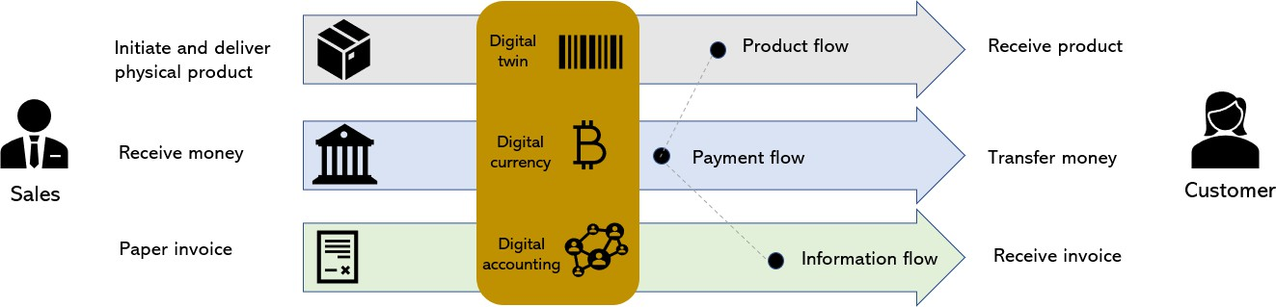

Much like the internet, this transformation is progressing incrementally.The trend is unmistakable. This book explains these changes and their consequences for business and society. This book highlights the intersection of lean thinking and blockchain technology. We draw parallels with the rise of the internet and we see that blockchain technology is the foundation for comparable radical transformation.

**The trend is your friend: from dot.com to block.com bubbles.**

The Dot-com crash of 2001 mirrors the crypto crash of 2018 and 2022. In 2001, the internet's potential was initially overestimated, resulting in an initial price bubble. In hindsight, this bubble was the opportune moment to invest in stocks like Amazon, Google, or Facebook. Like the rise of the internet, blockchain technology has experienced fluctuations in perceived potential and certainly price movements.

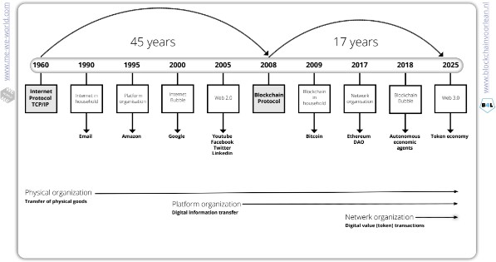

The rise of the internet started with the internet protocol TCP/IP, then the first use case (email) and 10 years later a stock market crash. How is this different with blockchain/crypto?

**Learn about Lean system design thinking.**

Just as you can explain the function of a car as a means of transportation, soon you'll be able to explain blockchain’s function in terms of a superhighway for value flows, an enabler for collaboration, a foundation for trust and collab an IT platform with built-in security by design that is superior to any existing network security models. While lean principles are currently applied to centrally coordinated organisational structures, we aim to inspire decentralized organisation through this book—for a leaner and more sustainable future.

We are entering an era where the ceaseless pursuit of more ( ‘’The acquisitive society’’ ) is losing its appeal to many. We are entering an era where ‘Fake News’ is being exposed and people are demanding evidence and have a thirst for the truth. We will not trust the

free-range egg based on packaging, or Nike sneakers based on the ‘Swoosh’ mark. We are transitioning from Ego-centred organisations to Eco-centred organisations where contribution and collaboration leads to value and reward, creating a leaner, fairer and more inclusive society. This is what Lean-Kakushin and blockchain innovation can do for us.

We'll also assist in preventing you from getting FOMO.!

FOMO is an acronym for **fear of missing out:** fear of not being included in something (such as an interesting or enjoyable activity) that others are experiencing.

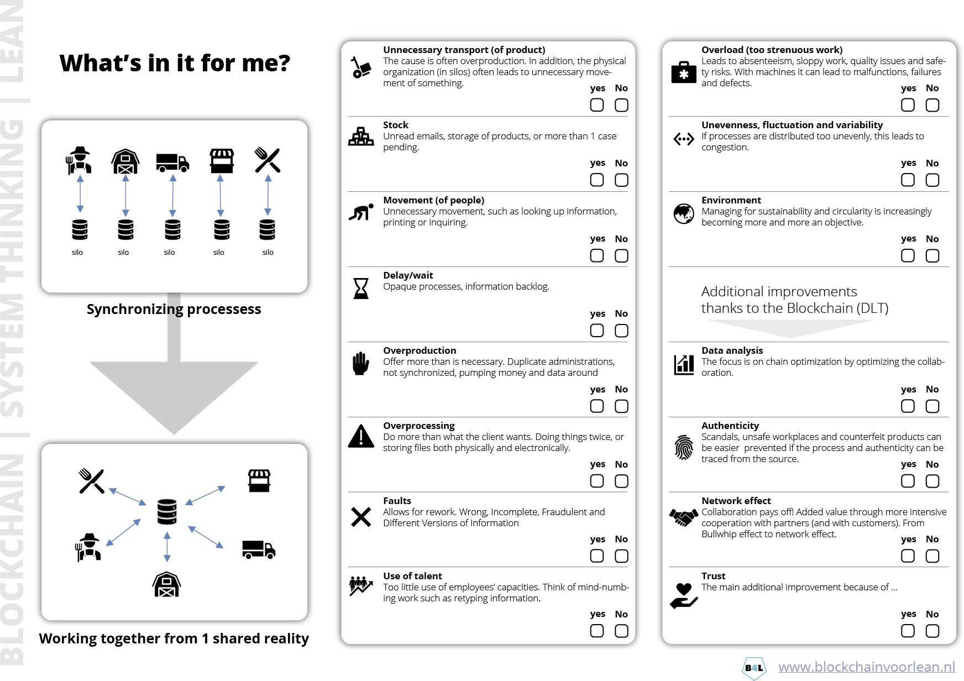

* **Customer friendly:**

Say goodbye to cumbersome paperwork and endless queues. With digital identity, accessing essential services becomes as simple as a few clicks on your smartphone.

* **Control by design:**

Personal information is protected against identity theft and fraud. Give only the part of the identity that is needed. For example, to enter a bar or nightclub you can prove your age without also needing to provide your name and address.9

* **Privacy:**

Take control of your digital footprint and decide who has access to your personal information. With digital identity, privacy is not just a promise, it's a fundamental right.

* **Empowerment without waste (of time):**

With the ability to assert your identity across domains, wasted time is removed from the process. Lead times for processing documents and applications can be reduced by orders of magnitude.

**Summary**

Lean goes beyond only continuous improvement, Lean Kaizen. Lean also encourages radical change and innovation through Lean Kaikaku and Lean Kakushin.

Comparing the Internet and Web 2.0 revolution with the Blockchain and Web 3.0 revolution helps with our understanding. Also, by applying the concept of decentralized organisations, we obtain an insight into the future of Lean organisational structures.

Significant Lean benefits from moving to Web 3.0 include proof of ownership, improved privacy, new incentive and governance models, fewer handovers (middlemen: constraints in value flow) and global accessibility to information to those who need it and have permissions.

We also recognize that the complexity of this concept does not allow for a simple and concise ‘elevator pitch’. The same applied to explaining the internet. when it first appeared. To fully understand these concepts, extensive reading, questioning and individual research (DYOR) is needed.

Within our traditional organisational framework (TRAD-ORG), inefficiencies and waste persist as a result of information fragmentation, siloed behaviours and push models. By embracing Blockchain as a lean system concept, the focus shifts from a competitive organisational model towards a collaborative model. Transparency and cooperation will become the new norm.

The future state, as suggested in this chapter, involves the transition from a self-centred competitive organisation to an eco-infrastructure organisation (ECO-ORG). In this new model rewards and incentives are given for behaviours which benefit the entire system. This helps to promote a more inclusive and fairer society which is in alignment with SDG and other sustainability goals.

WAGMI is an acronym for the phrase “**We're All Gonna Make It**.” It is a slang term used on social media platforms among traders and investors to convey a sense of optimism or encouragement.

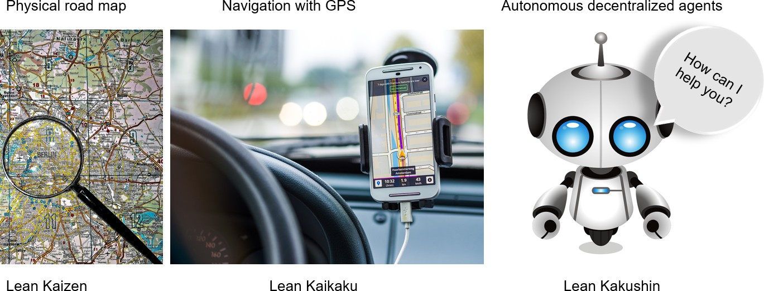

1. Jamie Notter:<https://www.forbes.com/sites/forbescoachescouncil/2021/01/12/how-to-build-a-culture-of-innovation>