A Letter to My Younger Self
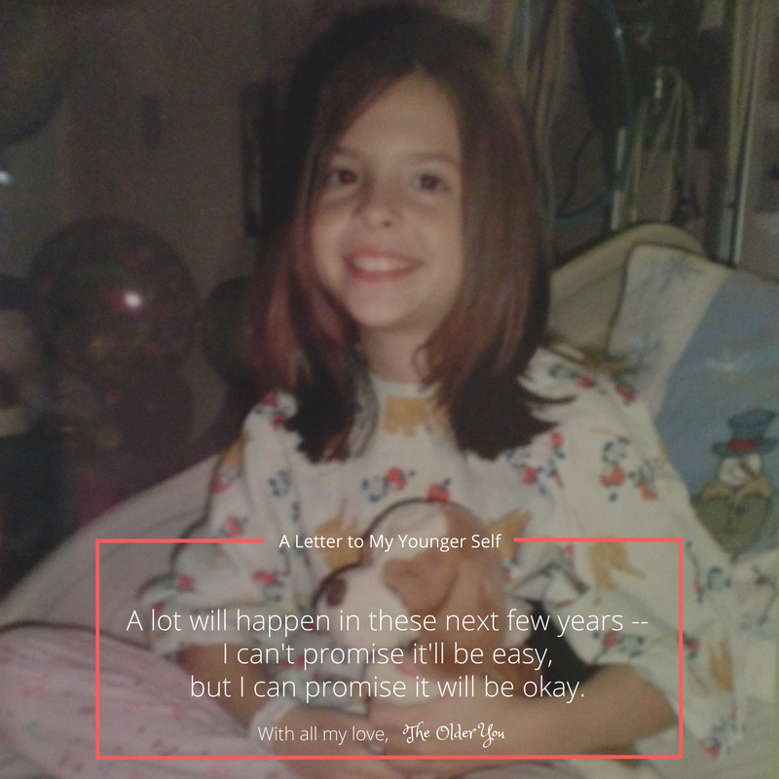
Dear Younger Me,
I know you're scared and this past week in the hospital has not been all that great. All the tests and doctors are so new to you. The doctors said you have Crohn’s disease. It’s going to be okay,
I promise.
I wish I could tell you these next few years will be easy, but they won't. You're going to go through some pretty tough stuff that many kids your age will have a hard time relating to. Most won't even understand it and that's okay.
You will go through a lot of ups and downs--mostly downs, but you'll handle it all with grace. You will spend a lot of time at the hospital, but you will spend even more time in the bathroom. There will be times you feel like the pain is never going to stop, but it will.
You will have a couple surgeries. I know this is the one thing you are wishing will never have to happen, but when the time comes you will know it's for the best. You'll be so desperate to feel better and I promise these surgeries will help you feel better (and, of course, give you a couple kick-butt scars).
You will hate yourself sometimes. You will cry sometimes. You will be angry sometimes. Often times you will find yourself asking "why me?" Just know you did nothing wrong to cause this.
You will learn a lot. You will learn how to take really good naps. You'll learn how to lay completely still for over two hours while stuck in an MRI machine. You will learn to swallow pills. But more importantly, you will learn to live life to the fullest despite your body going crazy on you. You’ll also learn to be a great friend and amazing person.
You will meet some extraordinary people who will change your life. Some will be friends, others medical professionals, and sometimes they’ll be both. These people will teach you some pretty great things. They’ll help shape you into an amazingly strong and resilient person as you grow up and many will be there for you through thick and thin.
There’s so much more I wish I could tell you and warn you about, but I don’t want to spoil everything for you. I want to remind you to stay strong, keep on smiling, and never take your family, friends, or good health for granted.
A lot will happen in these next few years -- I can't promise it'll be easy, but I can promise it will be okay. You will be okay. Your life will never be the same, but I promise it's all worth it.
With all my love,
The Older You
YOU ARE NOT ALONE IN THIS
WITH YOU EVERY STEP OF YOUR JOURNEY – Crohn’s & Colitis Foundation
http://www.crohnscolitisfoundation.org/chapters/southwest
LIKE US to stay in touch
https://www.facebook.com/CCFASouthwest
CALENDAR OF EVENTS
http://www.crohnscolitisfoundation.org/events/events-index-page.html?chapter=334310357&_ga=2.179890596.1243172970.1531874510-71997882.1509747656
FAMILY SUPPORT GROUP
http://www.crohnscolitisfoundation.org/chapters/southwest/support-groups/3crohns-and-ulcerative.html
YOUNG PROFESSIONALS NETWORKING GROUP
http://www.crohnscolitisfoundation.org/chapters/southwest/support-groups/6ccfa-young-professionals.html
PLUG IN TO THE IBD FAMILY, GET INVOLVED
http://www.crohnscolitisfoundation.org/chapters/southwest/get-involved/
IMPROVE CARE NOW
https://www.improvecarenow.org/
ImproveCareNow is a collaborative community where patients, parents, clinicians, and researchers work together to improve the health and care of children and youth. We invite everyone interested in getting kids with Crohn’s disease and ulcerative colitis better right now to join!
PARENT RESOURCES
Crohn’s Disease & Ulcerative Colitis: A Guide for Parents - http://www.crohnscolitisfoundation.org/resources/guide-for-parents.html
Psychosocial Issues and Kids with IBD –
http://www.crohnscolitisfoundation.org/resources/psychosocial-issues-kids.html
I Have to Swallow That? Pill Swallowing Techniques for Kids and Teens - http://www.crohnscolitisfoundation.org/resources/pill-swallowing-techniques.html
Crohn’s Disease and Ulcerative Colitis: Emotional Factors Q & A - http://www.crohnscolitisfoundation.org/resources/emotional-factors.html
Doing Our Homework: A Parent’s Guide to Educational Equity - http://www.crohnscolitisfoundation.org/resources/parents-guide-educational-equity.html
Treating Children and Adolescents -
http://www.crohnscolitisfoundation.org/resources/treating-children.html
Finding the Funds for College -
http://www.crohnscolitisfoundation.org/resources/funds-for-college.html

MEDICATIONS
Co-Pay Assistance Programs -
Appeal letter sample: Pediatric Adalimumab Therapy - http://www.crohnscolitisfoundation.org/resources/pediatric-adalimumab-therapy.html

TIPS FOR SCHOOL SUCCESS
Template Section 504 Plan for Children with Inflammatory Bowel Disease - http://www.crohnscolitisfoundation.org/resources/template-section-504-plan.html
Crohn’s Disease & Ulcerative Colitis: A guide for teachers and other school personnel - http://www.crohnscolitisfoundation.org/resources/guide-for-teachers.html
School Accommodations Letter -
http://www.crohnscolitisfoundation.org/resources/school-accommodations-letter.html
School is Back in Session! -
http://www.crohnscolitisfoundation.org/resources/school-is-back-in-session.html
Taking IBD to School -
http://www.crohnscolitisfoundation.org/resources/taking-ibd-to-school.html
Teen Guide: Dealing with Crohn’s & Colitis -
http://www.crohnscolitisfoundation.org/resources/teen-guide.html
HIGH SCHOOL & COLLEGE
More Than Just My Diagnosis - A Letter from a Young Adult
http://www.crohnscolitisfoundation.org/resources/more-than-my-diagnosis-youth-and-ibd.html
JUST LIKE ME! -- Teens with IBD
www.justlikemeibd.org
Teens with IBD have a lot on their minds. Upcoming exams, sports, activities, friends, social media -- and they might also have worries about their disease, such as bathroom urgency, and how to get through the day with symptoms. If you are a parent of a teen with Crohn's disease or ulcerative colitis, here are a few quick tips to help your teen feel supported and confident as they learn to live with their disease:
• Set up a plan with your child's school to give them the support and accommodations they need
• Have your child keep a journal of their symptoms
• Encourage your teen to speak up during visits with their doctor

CAMPUS CONNECTION -- For college students with Crohn’s disease or ulcerative colitis
www.crohnscolitisfoundation.org/campus-connection
Students can find and connect with other IBD patients on campus as well as receive helpful tips on:
• Navigating college life with IBD
• Coping with their disease
• Preparing for adult care

Appeal letter sample- Private Dorm and Bathroom
http://www.crohnscolitisfoundation.org/resources/private-dorm-and-bathroom.html
Finding the funds for college -
http://www.crohnscolitisfoundation.org/resources/funds-for-college.html
Managing Inflammatory Bowel Diseases as a Young Adult -
http://www.crohnscolitisfoundation.org/resources/managing-ibd-young-adult.html

YOU HAVE “A SAY” IN THE FUTURE
IBD PATIENT-POWERED RESEARCH NETWORK- IBD Partners
https://ccfa.med.unc.edu//
Patients understand their own body and disease best and have valuable information to share. We provide a way for researchers to hear from patients on their experiences with IBD. IBD Partners is an online research network that brings together inflammatory bowel disease (IBD) patients and researchers in a revolutionary partnership aimed at optimizing treatment of IBD. By completing a simple survey twice a year, YOU drive research that leads us to cures.
CLINICAL TRIALS COMMUNITY -
http://www.crohnscolitisfoundation.org/research/clinical-trials-community/
While joining a clinical trial may sound a bit scary, it is important to realize that all IBD treatments currently in use were first proved effective and safe to use through clinical trials. Visit this site for answers to all your questions on clinical trials, to hear what participating patients have to say, and to learn more of the trials taking place in your very own community.

