What to know about the Ashby high-rise and The Langley, a new luxury tower coming in its place

[Marissa Luck](https://www.houstonchronicle.com/author/marissa-luck/)

May 2, 2022Updated: May 2, 2022 5:58 p.m.

[Comments](https://www.houstonchronicle.com/business/real-estate/articleComments/The-Langley-Ashby-high-rise-what-to-know-17142229.php)

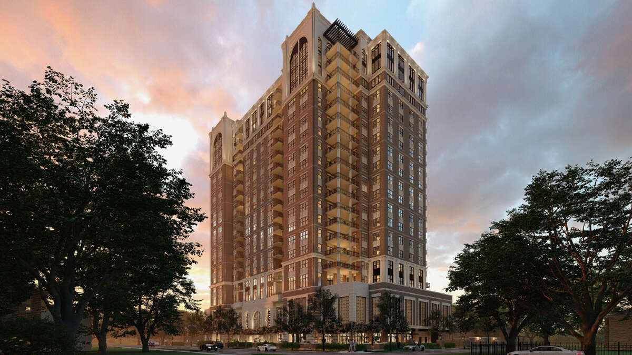1of6

The 20-story tower, The Langley, would feature a fitness center, a pool with covered cabanas, concierge and valet services and other luxurious perks aiming to appeal to affluent empty nesters.

StreetLights Residential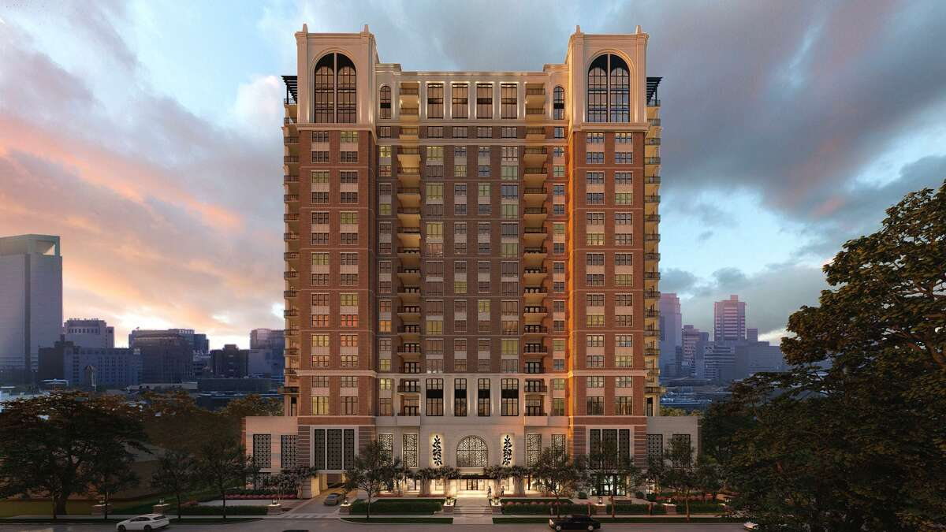



Houston is famous for having virtually no formal zoning, but there was one major project that put Houston's lax zoning to the test -  the so-called Ashby high-rise proposed near Rice University. The proposal [unleashed a wave of protests a](https://www.chron.com/life/gray/article/Gray-Development-gets-personal-3549587.php#photo-2921006)nd lawsuits unfolding over the course of nine years between 2007 to 2016. The site has sat mostly untouched over the past six years, but [there is a new proposal](https://www.houstonchronicle.com/business/real-estate/article/Exclusive-Six-years-after-Ashby-high-rise-17139055.php)from a new development team aiming to build a lower density project at the same location.

Here's a look at the background of the contentious former project and what to expect for the new project, The Langley.

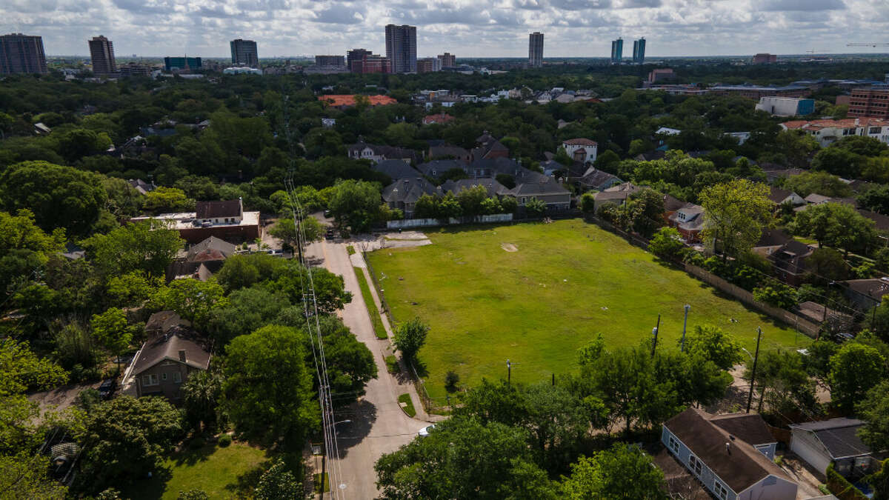

Towers along Main Street and Fannin Street can be seen to the east of the vacant property at 1717 Bissonnet Street at Ashby Street in the Boulevard Oaks neighborhood, Friday, April 29, 2022, in Houston.

Mark Mulligan / Houston Chronicle

What is The Langley?

The Langley is [a proposed 20-story luxury apartment tower](https://www.houstonchronicle.com/business/real-estate/article/Exclusive-Six-years-after-Ashby-high-rise-17139055.php)with 134 residential units planned by Dallas-based StreetLights Residential in partnership with El Paso-based Hunt Companies at 1717 Bissonnet in Houston near Rice University and Rice Village. The luxury apartment tower will feature spacious units with an average size at 2,850 square feet, much larger than standard Houston apartments. The classic, timeless design plus the high-end amenities are expected to attract affluent empty nesters who want to downsize but stay within the neighborhood.

What was the Ashby high-rise project?

The Langley is proposed in the site of a famously contentious land-use battle Houston at the corner of Ashby and Bissonnet in the wealthy Southampton/ Boulevard Oaks neighborhood near Rice Village and Rice University. Although the project never had a formal name, The Ashby was the name that residents gave to proposal. The earlier project was proposed by Houston-based Buckhead Investments in partnership with El Paso-based Hunt Companies.

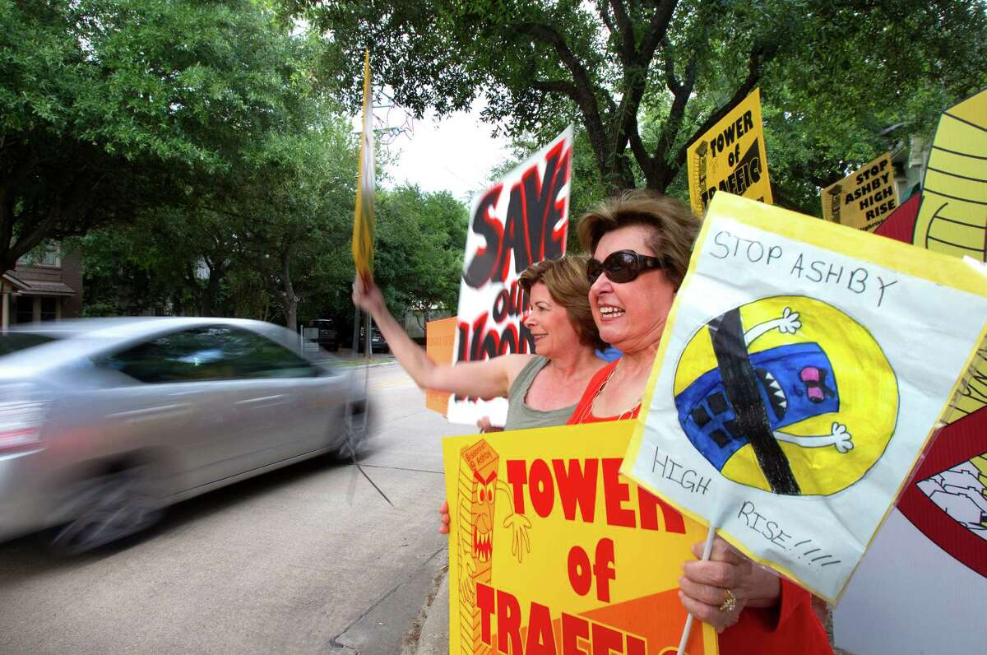

Protestors Nancy Proler, left, and Carol Barndollar, right, stood in front of Maryland Manor Apartments as they protest the construction of the Ashby High Rise Wednesday, May 2, 2012, in Houston. Residents opposed the high-rise building in the leafy Southhampton and Boulevard Oaks neighborhood of two-story houses. "I'm not against development," Barndollar said in 2012. "But it just changes the whole makeup of the neighborhood."  (Cody Duty / Houston Chronicle)

Cody Duty

Why was the Ashby so controversial?

Buckhead’s original project – [pitched in 2007](https://www.chron.com/business/sarnoff/article/Southampton-group-up-in-arms-over-high-rise-1797528.php)at 23 stories – was certainly not the tallest structure in Houston. However, residents worried that a high-rise would be out of place for the low-rise buildings surrounding the site. They also worried that an apartment project would lead to heavy traffic clogging the two-lane streets surrounding the property. They argued the project would be a nuisance that could lower their property values.

For some, The Ashby became[a symbol for fighting Houston’s lax zoning laws.](https://www.chron.com/life/gray/article/Gray-Development-gets-personal-3549587.php#photo-2921006)There were protests, lawsuits, websites and citizen groups formed around trying to halt the project. Opponents created bright yellow and black signs that read “Stop Ashby Highrise” featuring a menacing-looking caricature of a tower that could be seen in yard signs around the neighborhood.

The real estate community closely watched the battle as a test for whether so-called Not-In-My-Backyard (NIMBY) protests could squash a project that for appeared to follow all the city’s permitting requirements. A successful block of the project could have ate away at Houston’s pro-development reputation and had a chilling effect on new development, proponents argued.

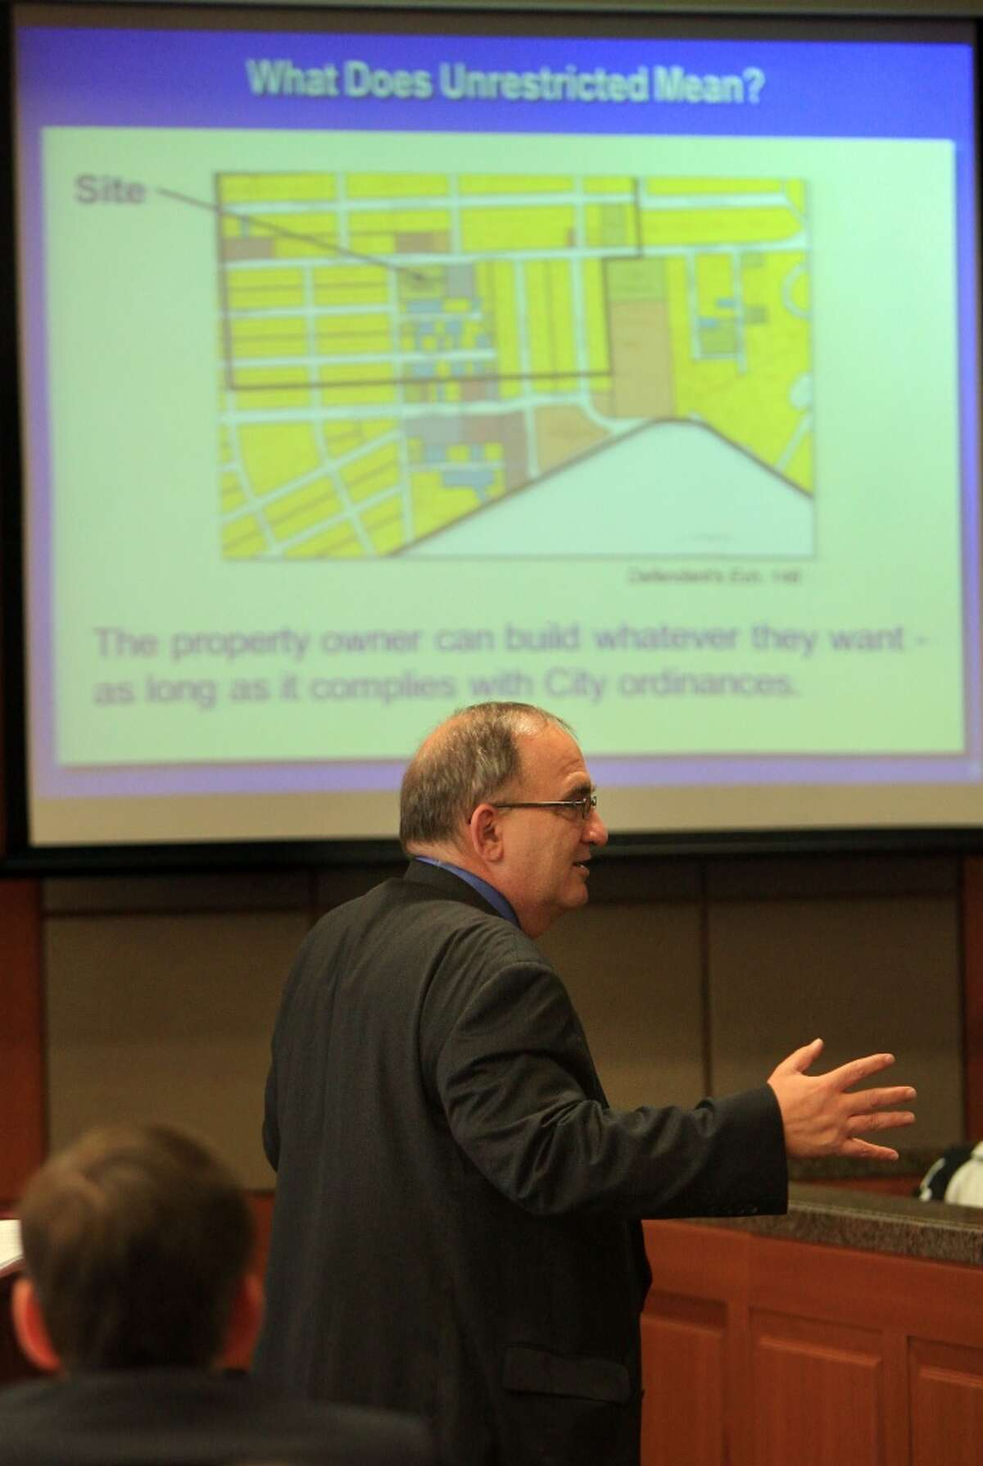Attorney Fred Cook, representing Buckhead Investment Partners, delivers his closing arguments in the Ashby Highrise Trial at the Harris County Civil Courthouse on Monday, Dec. 16, 2013, in Houston. ( Mayra Beltran / Houston Chronicle )Mayra Beltran/Houston Chronicle

What happened with the lawsuits involving the old project?

There were two major lawsuits tied to the old project. The first when Buckhead sued the city in 2010, arguing the city bowed to  neighborhood pressure and exceeded its legal authority in denying the developer's application for building permits numerous times. Eventually Buckhead and the city [reached a settlement](https://www.chron.com/news/houston-texas/article/City-reaches-deal-on-Ashby-high-rise-project-3401146.php)in 2012 to build an altered, smaller version of the project at 21 stories with 228 units, instead of the original plan for 23 stories with 231 units. The settlement resulted in the city and Buckhead forming a restrictive covenant outlining guidelines that the developers agreed to follow to mitigate traffic, noise, light and other concerns tied to the project. The city then granted the developers a permit in 2013.

Residents, unhappy with the city’s settlement, filed their own lawsuit in a state district court to try to block the project in 2013. A judge agreed with a 2014 jury verdict that neighbors were owed $1.2 million in damages, but said there was [no legal way to stop the project](https://www.houstonchronicle.com/business/real-estate/article/2-years-after-court-ruling-Ashby-high-rise-7384486.php). However, the damages contemplated were based on a building that did not yet exist, which proved to be a challenge later for the plaintiffs. In 2016, a judge in the 14th Court of Appeals [reversed the earlier ruling](https://www.houstonchronicle.com/business/columnists/sarnoff/article/Court-reverses-Ashby-high-rise-ruling-in-favor-of-8337576.php?t=a428bd61b2438d9cbb&cmpid=twitter-premium), meaning the developers no longer were required to pay damages. The 2016 ruling also cleared the way for Buckhead to build the tower.

When did the developers get their original permit?

The city approved of the project’s initial construction permits in 2013 after the city reached a settlement with the prior developers for a smaller version of the project in 2012. The owners of the real estate have kept their permits active with routine inspections since then, according to Houston Public Works.

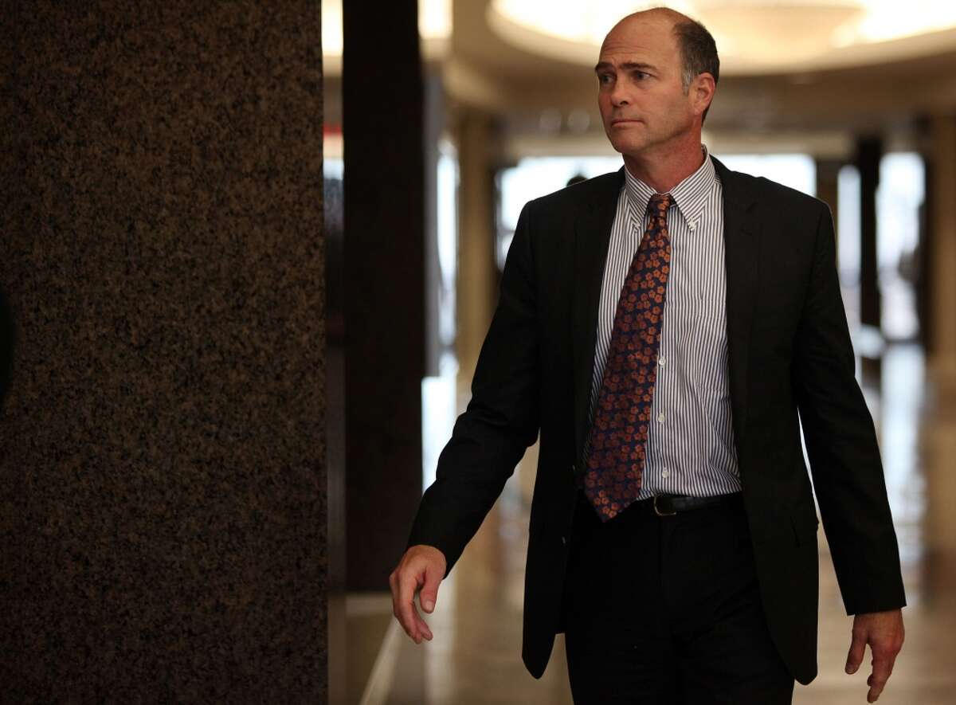Kevin Kirton, of Buckhead Investment Partners, returns to courtroom to hear closing arguments in the Ashby Highrise Trial at the Harris County Civil Courthouse on Monday, Dec. 16, 2013, in Houston. ( Mayra Beltran / Houston Chronicle )Mayra Beltran/Houston Chronicle

Do the developers need any more permits prior to building?

Because the owners of 1717 Bissonnet kept the permits active over the past nine years, it’s not clear how much more needs to be done before developers get the green light to break ground. The city’s legal team is reviewing the restrictive covenant tied to the project to see how it may impact the proposed changes. As of April 29, the Houston Permitting Center has not received a new application or updated plan for The Langley, a city spokesperson said. City officials said the developers have met with some of the key stakeholders within the community and have shared their new vision for the site, a Houston Public Works spokesperson said in a statement. Developers with StreetLights Residential said they are setting up meetings with city officials soon to review their plan.

What’s different about The Langley plan versus Buckhead’s earlier plans?

Unlike earlier iterations of a proposed high-rise at the site, The Langley will not feature any retail space, potentially cutting down on traffic. The original 2007 proposal by Buckhead Investments was for a 23-story structure with 231 units. By 2012, that was pared down to a 21-story project with 228 units. Now StreetLights Residential is again downsizing the project to 20 stories with 134 units – which means fewer residents, which developers hope will also reduce traffic concerns. The parking garage on site would also be three stories, not five, and contain 255 parking spaces.

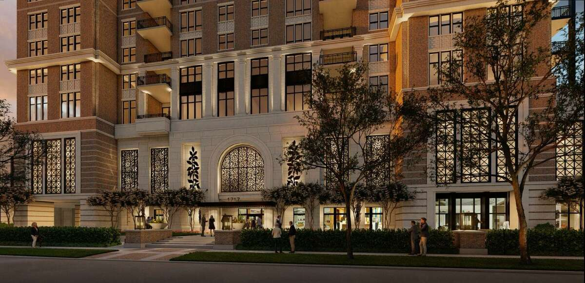

A rendering of The Langley as seen from Bissonet Street.

Peter Johnson

Who is behind The Langley?

An entity tied to Hunt Companies still owns the real estate, but this time Hunt has partnered with a new development team with Dallas-based StreetLights Residential. The former developers, Houston-based Buckhead Investments, still have a passive ownership stake in the project but they have no role in the development or decision making. StreetLights Residential said it will follow the parameters outlined in the restrictive covenant the prior developers reached with the city.

StreetLights is familiar with Houston having developed The Carter, a 305-unit apartment project in the Museum District. The developer also partnered with Dallas-based real estate firm Stonelake Capital Partners on two other luxury apartment projects in River Oaks: the 344-unit project, The James, which is connected to the 297-unit project The Ivy.

When would this project be built?

Assuming all goes according to plan for developers, the idea would be to secure construction financing and break ground by November 2022. It would take a few years to build, with some residents moving in 2024 and the final construction completing in 2025.