CULTURE MAP ONLINE

LATEST NEWS

[Hoffman on Houston's wrestling all star's power move on ESPN 97.5 FM](https://houston.culturemap.com/news/city-life/05-02-22-booker-t-hall-of-fame-wrestling-show-espn-975-925-fm-brad-gilmore-new-schedule-ken-hoffman/)

INTRODUCING THE LANGLEY

Posh new Boulevard Oaks tower replaces controversial Ashby high-rise

By [Steven Devadanam](https://houston.culturemap.com/author/steven_devadanam/articles/)

May 2, 2022, 5:25 pm

**[ENLARGE  
SLIDESHOW](https://houston.culturemap.com/news/real-estate/05-02-22-the-langley-ashby-high-rise-1717-bissonnet-for-rent-luxury-streetlights-residential-hunt-companies/slideshow/" \o "Click to see full size slideshow" \t "_blank)**

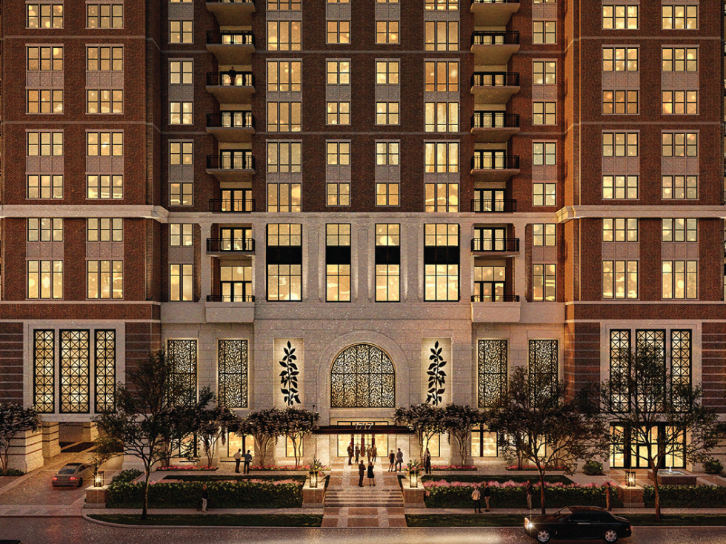

The Langley takes the place of the embattled Ashby high-rise. *Rendering courtesy of StreetLights Residential*

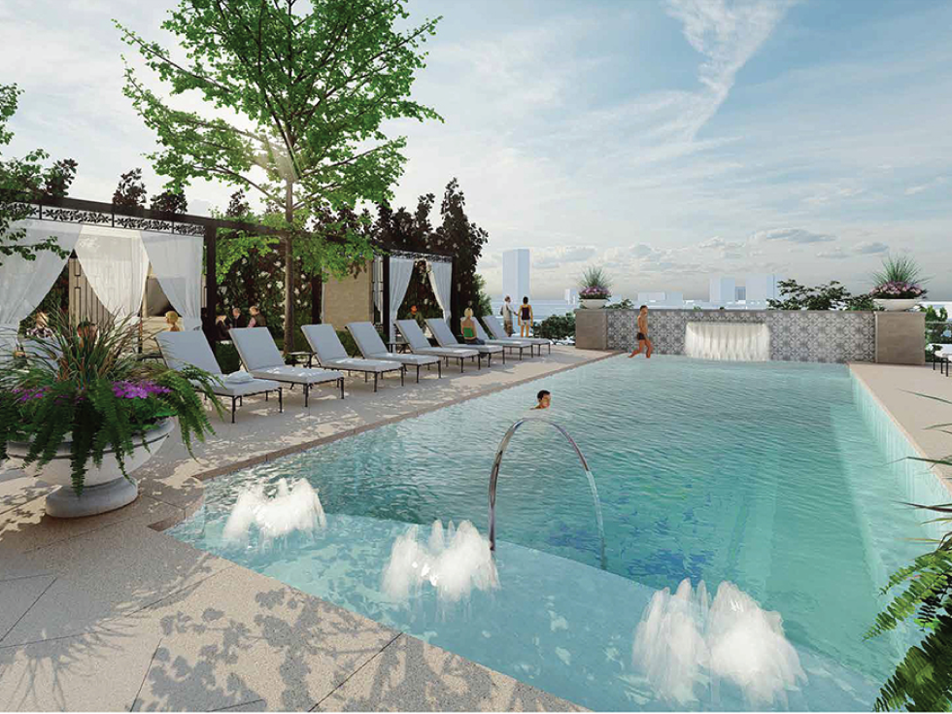

The pool and other amenities are aimed at up-market renters. *Rendering courtesy of StreetLights Residential*

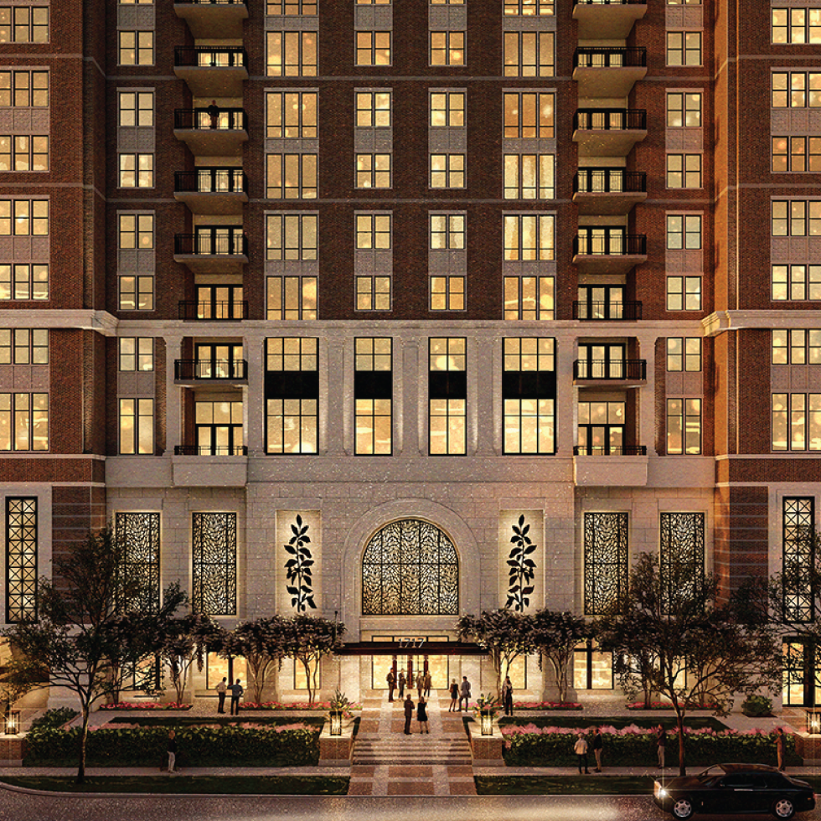

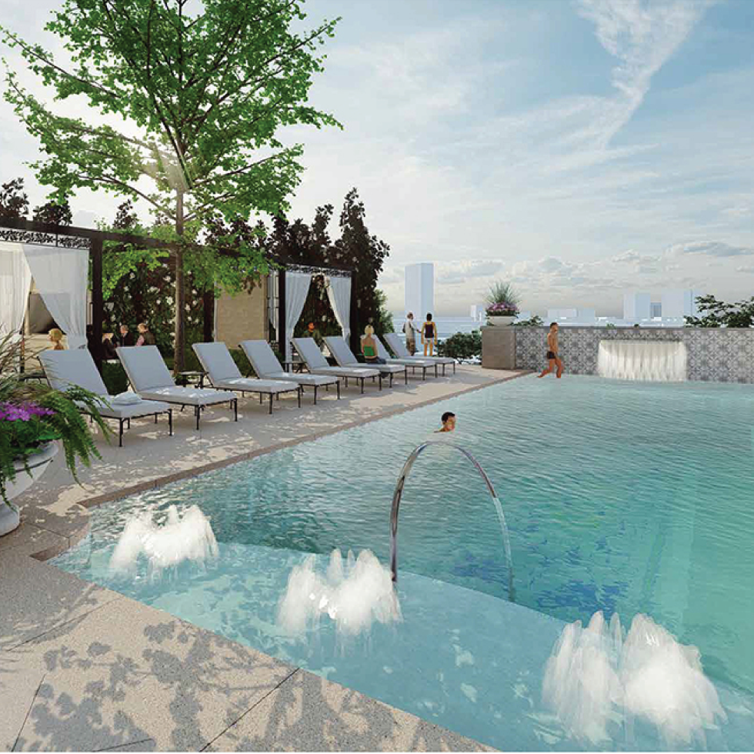

Some 15 years ago, a turf war ensued between Boulevard Oaks/Rice University-area residents and the developers of a mixed-use tower, then dubbed the Ashby high-rise.

While locals [filed a suit](https://houston.culturemap.com/news/real-estate/05-03-13-area-residents-file-suit-against-ashby-high-rise-developer/) against Buckhead Investment Partners, a judge eventually [sided with developers in 2016](https://www.houstonchronicle.com/business/columnists/sarnoff/article/Court-reverses-Ashby-high-rise-ruling-in-favor-of-8337576.php?t=a428bd61b2438d9cbb&cmpid=twitter-premium), though the embattled property at 1717 Bissonnet St. has yet to be developed.

That all may change, as national developer [StreetLights Residential](https://www.streetlightsres.com/" \t "_blank) has teamed with El Paso-based [Hunt Companies](https://www.huntcompanies.com/), Inc. to now construct [**The Langley**](http://www.thelangleyhouston.com/), a new luxury rental community. The targeted completion date is 2025, per StreetLights press materials.

The Langley will offer 134 apartment homes in two- and three-bedroom floor plans, according to a press release. Aimed at luxe renters and downsizing empty nesters and single-family-home owners, the project promises “the valet and concierge services of a five-star hotel and the craftsmanship of a custom home,” per StreetLights.

Average rental unit spaces are just under 3,000 square feet and are targeted to long-term leases. The Langley’s approach will mirror StreetLight’s other Houston properties: The James and The Ivy, neighboring projects in Highland Village, and upmarket community The Carter.

“The Langley will be a high-rise residential building with stunning views that match the surrounding community's standard of excellence,” said Stephen Meek, senior vice president of development for StreetLights Residential, in a statement. “Nestled between Rice University and the Museum District, and drawing inspiration from the historic charm of the immediate Boulevard Oaks and Southampton neighborhoods, The Langley’s location demands the highest level of detail in building design, amenities, finishes, and services.”

First proposed in 2007, the Ashby high-rise consisted of a 23-story tower with 17 floors of units. In effort to blend with the community, developers planned an aesthetic that matched that of nearby Rice University. However, the project drew widespread protests from area residents who objected to the potential influx of traffic it would create in the affluent, Inner Loop neighborhood.

At the center of a walkability/quality of life maelstrom, the Ashby space was either damaging to the neighborhood, traffic flow, and residents’ privacy, or, a boon to Inner Loop development—depending on the source.

With petitions and familiar “Stop the Ashby high-rise” signs and bumper stickers en vogue at the height of the years-long quarrel, tensions have since died down. Time will tell how area dwellers will respond to this new iteration.