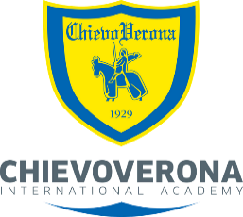
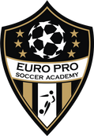
EURO PRO SOCCER ACADEMY
GOALKEEPER TRAINING
Euro Pro Soccer Academy Goalkeeper Training offers specific training for goalkeepers of all ages and skill levels.
Our Program has been designed to offer age specific training following our
Partner Club Chievo Verona's Training Curriculum/Methodology and the Long-Term Player Development (LTPD) four cornered approach of coaching:
Physical – Technical/Tactical – Social/Emotional – Psychological
Keeping with our program philosophy, the focus will be on providing the Goalkeeper with the proper fundamentals and tools to compete at all levels. Presented in a fun, but structured and Professional environment where "attention to detail" is key.

Goalkeeper Training Topics Include
- Proper Goalkeeper Specific Warm Up
- Fundamentals (Footwork – Positioning – Speed & Reaction)
- Proprioception Training (Agility - Balance – Co-Ordination)
- Handling - Catching
- Ball Distribution
- Diving
- Shot Stopping – Crosses – High Balls
- Communication - Support
- 1 v 1 (Breakaways)
Available Programs
- Multi (8/10/12) week programs (or tailored to your needs)
- Goalkeeper specific Camps & Clinics
(To Be Announced)
- Private 1 on 1 Training
- Training sessions with your team
- In-Game Goalkeeper assessments

Coaching Staff
Christian Giovannini – Former Italian Professional Player and UEFA “A” License Coach
Carlo Gambale – O.S.A. Provincial “C” License – O.S.A. Goalkeeper Coaching Diploma
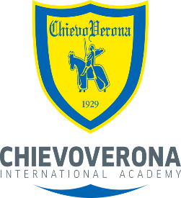
Program Fees

8 Week Winter Indoor Program (1 Hour Sessions)
$280.00 + HST per player (Includes Goalkeeper Jersey)
** Group Rates Available **

- FOR ALL OTHER PROGRAMS PLEASE INQUIRE
"Feel like a Pro at Euro Pro Soccer Academy!"
Contact us in Grimsby, Ontario at:
christiangiovannini@europrosocceracademy.com -- www.europrosocceracademy.com 905-975-3996
“BEYOND THE STANDARD!”

