**St Matthew’s**

**Family parish**

**Moving Forward in Faith**

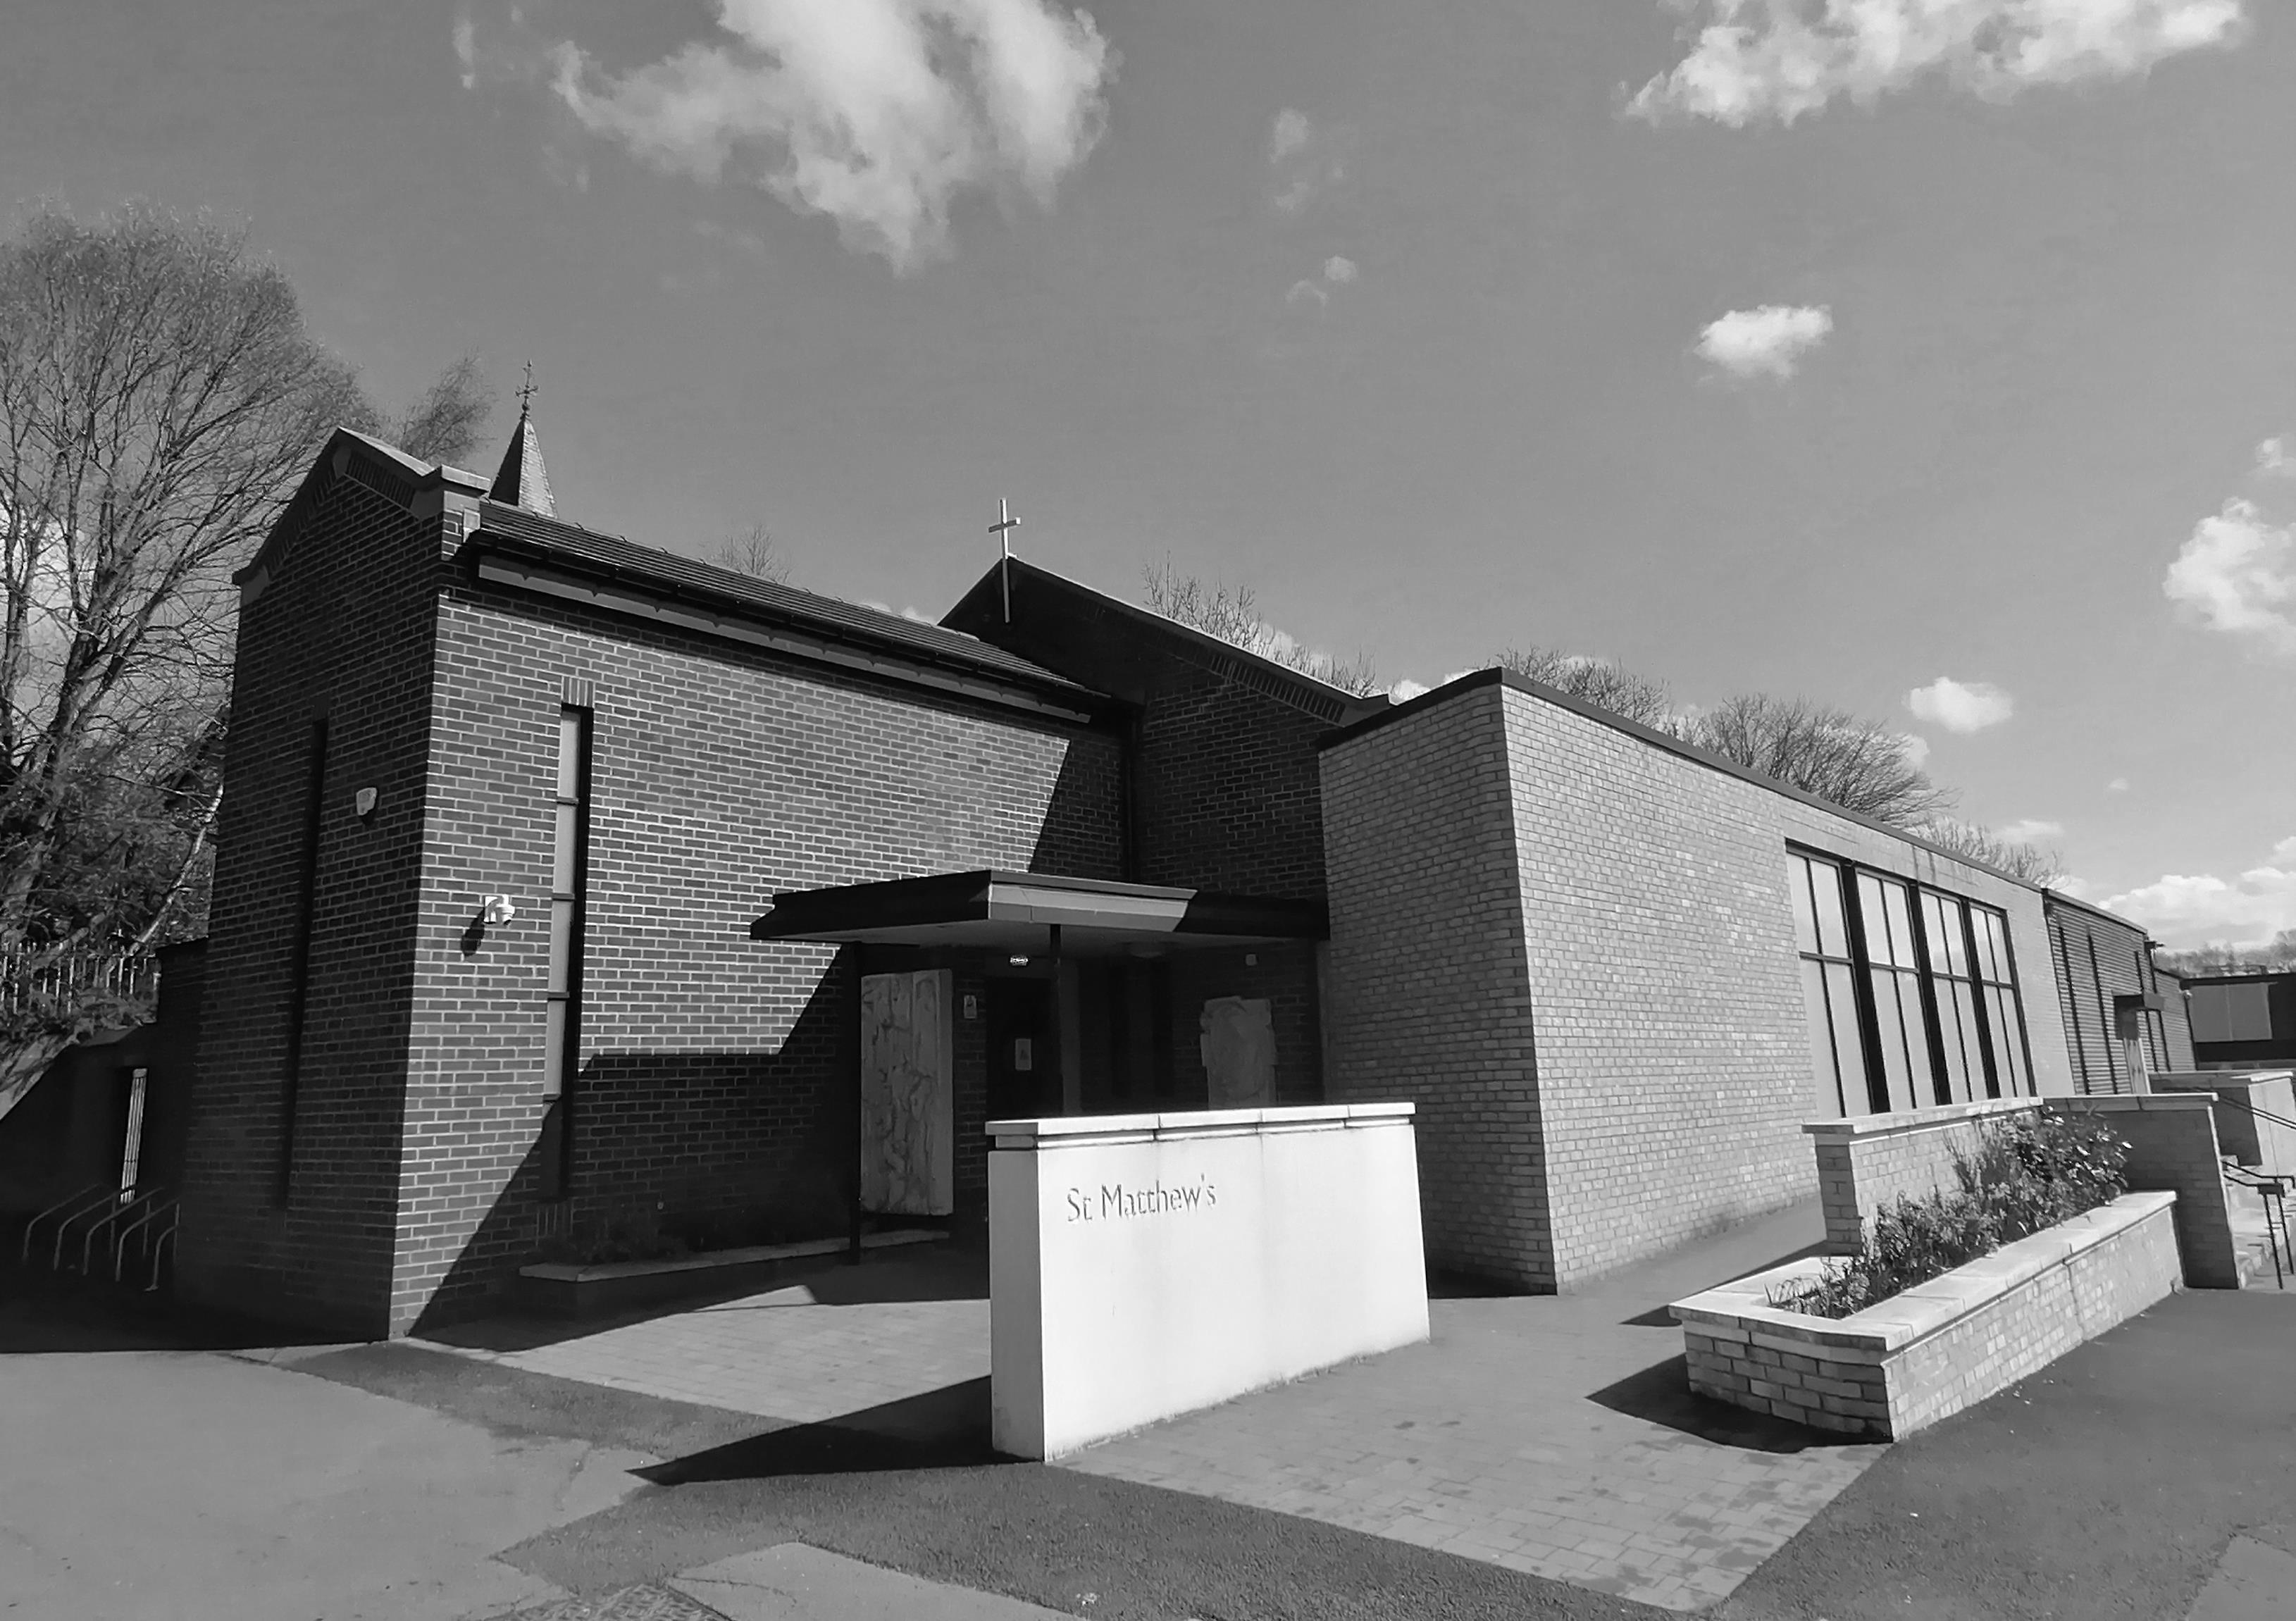

**7TH &14TH July 2024**

**14th & 15th SundayS in Ordinary Time**

**Parish Clergy:** Fr. Mpagi Alex KISASA, Parish Administrator, Rev. Deacon Anthony Murphy

**🕿** 0141 772 1619 📱07424 575827 **Email:** *stmatthew@rcag.org.uk*

**Items for inclusion in the newsletter** can be sent to: *newsletterstmatthews@gmail.com*

Items must be received **before** the Friday prior to publication.

**DETAILS OF MASS TIMES & CONFESSIONS**

**Sunday Masses : Vigil 5:30pm, 9:30 am and 11.00am.**

**Holiday of Obligation Masses : Vigil 6pm and 10.00 am.**

**Weekday Masses : Monday to Friday, 10.00am.**

**Daily Adoration : Monday to Friday 9.30 am. (Confessions on request during adoration).**

**Confessions : Friday after 10am Mass and 5:00 pm before vigil mass.**

**14th & 15th WEEKS OF THE YEAR**

|  |  |
| --- | --- |
| Monday 8th July | WEEKDAY IN ORDINARY TIME |
| Tuesday 9th July | OUR LADY OF ABERDEEN |
| Wednesday 10th July | WEEKDAY IN ORDINARY TIME |
| Thursday 11th July | FEAST OF ST BENEDICT ABBOT, CO-PATRON OF EUROPE |
| Friday 12th July | WEEKDAY IN ORDINARY TIME |
| Saturday 13th July | SATURDAY IN ORDINARY TIME |
| Monday 15th July | FEAST OF ST BONAVENTURE, BISHOP |
| Tuesday 16th July | OUR LADY OF MOUNT CARMEL |
| Wednesday 17th July | WEEKDAY IN ORDINARY TIME |
| Thursday 18th July | WEEKDAY IN ORDINARY TIME |
| Friday 19th July | WEEKDAY IN ORDINARY TIME |
| Saturday 20th July | WEEKDAY IN ORDINARY TIME |

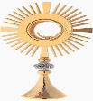**DAILY ADORATION**

This takes place prior to the weekday masses at 9.30am. Volunteers to lead Morning Prayer and/or Rosary are invited. The sacrament of confession is available at request during adoration.

**THINKING OF BECOMING A CATHOLIC?**

Do you know anyone wishing to become a Catholic or interested in the Catholic Faith? Please speak/call to Fr Alex (0141 7721619) or Michael Murphy (07789328828)

**RECENT DEAD: RIP**

Please pray for the following:

Irene Woobey,John Magill, Cathie Reily, Sarah Jeffrey, Lorraine Shannon, Brian McCann, Canon Pat Brannan, Margaret McNeil, Val Newey, Margaret Sloey, Ian Hamilton, Marie Baxter, Steve Marshall, Irene Rubey, Sadie Boyle, Eddie Murphy, William Auld, Anna Strang, Peggy Weaver & Joe Constantine.

**BURIAL OF IRENE WOOBEY**

The burial service will take place at Milgavie Co-Op funeral home at 12 and thereafter to Cadder Cementery at 1.30 on the 17th July.

**DEATH ANNIVERSARIES**

Please pray for the following:

Peter Byrne, Michael Murray, James McVey, Colin MacIntosh, Patrick Doherty, Patricia Cassidy, Mark Reilly, Helen Brennan, Mamie Grant, Matthew Diamond, Jacky Gourlay, Fred McMillan, Stella Lochran, Frank Callaghan, Maisie McConnell, Natalie Cuthew, Mary Malarkey, Greta McKenna.

**PLEASE PRAY FOR THE SICK**

Michael Cosgrove, Jodie Davidson, Beatrice Hannah & Margaret Blaney. And all our sick parishioners, friends, relatives who are in hospital and care homes!

**WELCOME TO ST. MATTHEW’S**

A warm welcome to all visitors, and especially those parishioners from St. Aloysius, Springburn and other Parishes. We are all one church.

**PARISH COLLECTIONS**

23rd June: First collection - £1,299.70; Second collection - £652.85

30th June: First collection - £1,210.41; Second collection - £650.48

Thank you for your continued generosity.

**FORTHCOMING PARISH SECOND COLLECTIONS:**

Sunday 7th July: Church Renovation Fund. Sunday 13th /14th July: Comboni Fathers

**SUNDAY CAFÉ & FRIDAY CAFÉ**

The Sunday Café will be open after 11.00am Mass in the Church Hall, and also now on every **Friday after 10 am Mass**. More volunteers are needed at both cafés. Many thanks to all the ladies and men who generously assist with preparing coffee/tea for all of us!

**COLOURS FOR THE CHURCH**

We have started to clear the back of the church behind the gate - if you would like and could help with this work, please contact me, Kati Beetles on 0790 442  9898.

It is only 30-40 minutes at a time! Days to be negotiated between us and with the weather!

**SAFEGUARDING IN THE PARISH**

The Parish has two safeguarding officers; Liam Luporini and Maire McFayden. They can be contacted at stmatthew-psc@rcag.org.uk or via the safeguarding number on 07935522140. Further information can be found here:  Roman Catholic Archdiocese of Glasgow - Safeguarding (rcag.org.uk)

**PARISH LOTTERY**: June winners were;  
Draw 1 1047  Maureen Byrne                    £157  
Draw 2 1213  William McLeod                   £157  
Draw 3 1222  Anna Maria McLeod            £78.50

Cumulative raised for Church Renovation Fund over £106,000. Next draw due to take place on Sunday 28th July. Thanks to those who have responded to the recent appeal for an increase in membership, there is still time to respond. Please contact John Feechan on 07526 335497 for joining details, or complete the Tear off Form and place in the Lottery box at the back of the church.

**FATHER ALEX WOULD LIKE TO SAY….**

My parents are returning to South Africa on Monday 1st July…they and I are very grateful for the warm welcome and love received from St Matthew’s Family Parish….to the men who have been taking my Dad for rounds of golf and the ladies who have served and taught my Mum a few lessons on Scottish dishes! Thanks again! Fr Alex.

**CHILDREN’S LITURGY**

****Our liturgy is open to children of all ages. Please take the opportunity to catechise your child. Thank you to all our parents who bring their children to mass. If you are able to help please contact Jennifer McPherson on 07748 707842

**SVDP SUMMER OUTING – 2024:**

The SVDP Senior Citizen summer outing to Largs is now full. We will be in touch with those on the list at the end of July to collect menu choice and £15 as we have to prebook these with the hotel. For more information call Andy on 07986244921 or speak to any member of the SVDP.

**GIFT AID DONATIONS**

Did you know that you can enhance the impact of your donations without any extra cost to you? It’s through the Gift Aid Scheme, a government initiative that allows us to reclaim tax on your donations.. In the last financial year the parish has received in excess of £20,000 from the Gift Aid Scheme. If you are a taxpayer and make donations to parish funds but have not completed a Gift Aid Declaration Form, please consider doing so as for every £1 you donate, we can receive an additional 25p from HM Revenue & Customs.

**AGAP THEATRE PRODUCTION (GAUDI: GOD’S ARCHITECT)**

AGAP Theatre presents “Gaudi: God’s Architect”. Explore the life of the Visionary behind Barcelona’s Sagrada Familia through this multimedia production.

Fringe Preview Performances 7.30pm on 16th July: Archdiocese of Glasgow Curial Offices, 196 Clyde St; Wed 17th July: Our Lady of Lourdes, Cardonald; Thurs 18th July: St Thomas the Apostle, Riddrie; Fri 19th July: Blessed John Duns Scotus, Gorbals.

Tickets £8, concession £6 from [www.gaudi-play.co.uk](http://www.gaudi-play.co.uk/) and 07495347884. Run time 50 min. Post-show chat and refreshments.

**CARFIN PILGRIMAGES**

Carfin Pilgrimages  have been arranged by the Legion of Mary on 13th July, 13th August, 13th September and 13th October. Beginning at 7.30pm with Rosary Procession followed by Holy Mass and Benediction until 9pm. Prayers offered for world peace, young people, vocations and Parish renewal. All welcome

**DEAR PARISHIONERS,**

I hope that this summer may be filled with sunshine, laughter, and cherished moments. Whether you are traveling, spending time at home, or enjoying new adventures, may you feel the presence of God in all that you do. I look forward to seeing you refreshed and renewed in spirit when we gather again. Have a blessed and safe summer. Fr. Alex & Deacon Tony