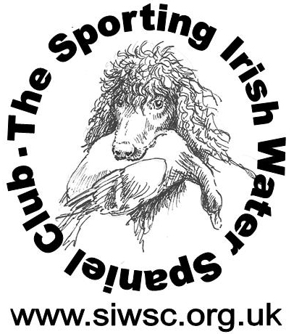
Club No 2056

Training Day on April 26th

Open to members & non-members of SIWSC
Or persons who are interested in IWS’S
With
Lucy Tunstill of Canine in-tuition

Polo Club, Station Road, Dullingham, nr. Newmarket, Suffolk, CB8 9UT,
The Polo field is situated off the A1304, which runs from the A11 at Six Mile Bottom to Newmarket.

Training:-will cater from basic training for beginners/puppies through to advanced levels
6-8 places available

Please provide your own lunches and drinks for the day

Cost £ 40 Meet: 9.30 for 10.00am

Any queries call or message
Ursula Wilcox on 07917 026379, email – ursulawilcox@btinternet.com

To assist with gathering numbers of attendees, it would help if you could email your details to me
Thank you

Name ………………………………………………………………….

Dog’s age ………………………………………………………………

Disclaimer.

Attendance and participation in the training will be at your own risk.

