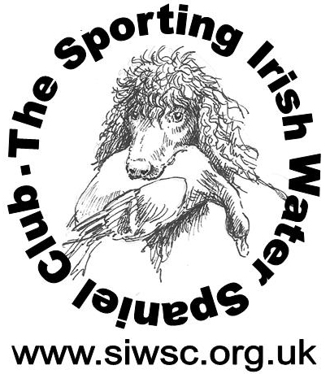
Club No 2056
Training Day on August 16th
Open to members & non-members of SIWSC
Or persons who are interested in IWS’S
With
Laurina Blankenspoor
at Chedworth, Cotswold Area. Nearest post code GL54 4NE
Directions. GL54 4NE take you to Chedworth Village Hall, where SIWSC signs wll be posted taking
you to the training field ,that has a sign on the gate showing ‘Cleynehage’

Training:-will cater from basic training for beginners/puppies through to advanced levels

Tea, Coffee, and cakes will be provided during the day. But you will need to provide your own lunches

Cost £ 40 per Day Meet 9.30 for 10.00am

Any queries call
Melvyn Hurst mob- 07989432126, email – meldenkirkmarsh@gmail.com

There is provision to camp for the weekend either caravans or tents.
so to assist with gathering numbers of attendees, it would help if you could email your details to me
Thank you

Name ………………………………………………………………….

Dogs age ………………………………………………………………

Disclaimer.

Attendance and participation in the training will be at your own risk.

