Pictures Books for Children about Safety Skills, Private Parts, Sexuality, and Boundaries

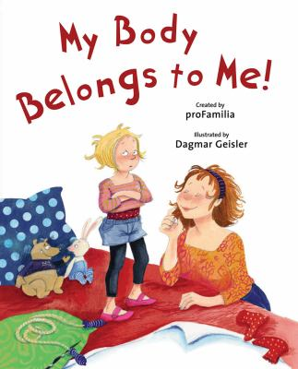
My Body Belongs to Me! proFamilia

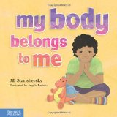
My Body Belongs to me – Jill Starishevsky
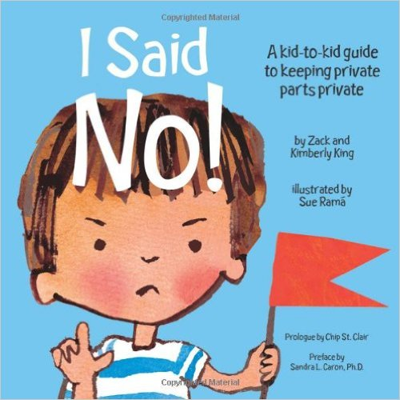
A kid-to-kid guide to keeping private parts private – Zack and Kimberly King

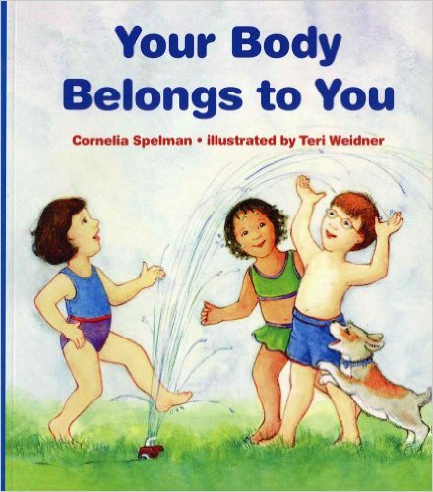
Your Body Belongs to You – Cornelia Spelman

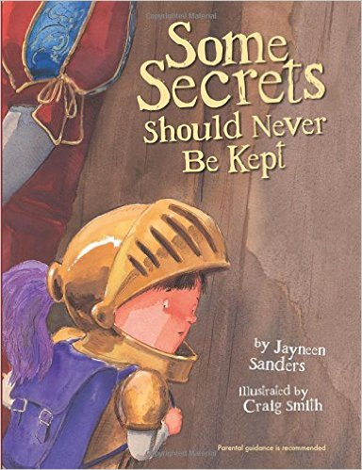
Some Secrets Should Never be Kept – Jayneen Sanders

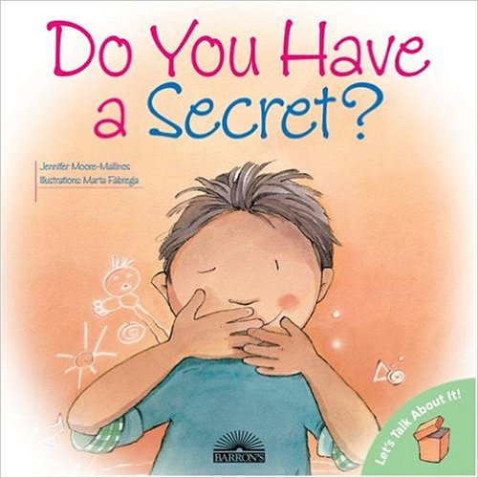

Do You Have a Secret? – Jennifer Moore-Mallinos
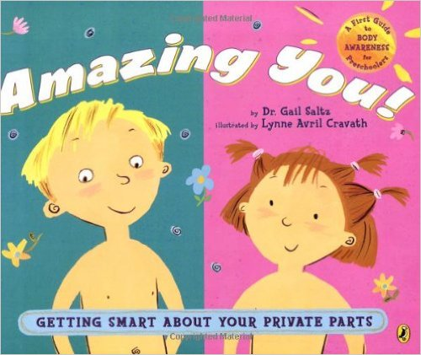
Amazing You! Getting Smart about your private parts – Dr. Gail Saltz

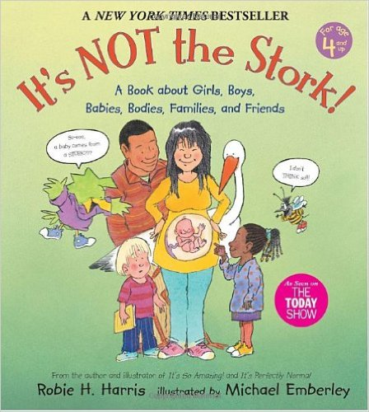
It’s NOT the Stork! – Robie H. Harris

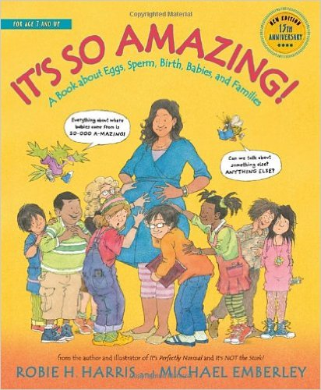
It’s So Amazing – Robie Harris
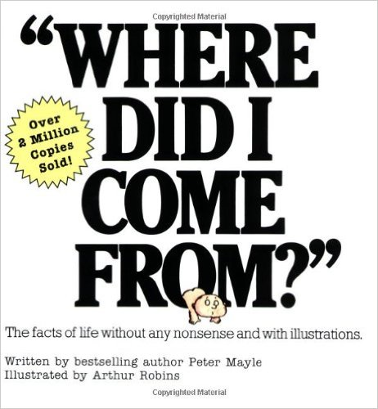
Where Did I Come From? – Peter Mayle

