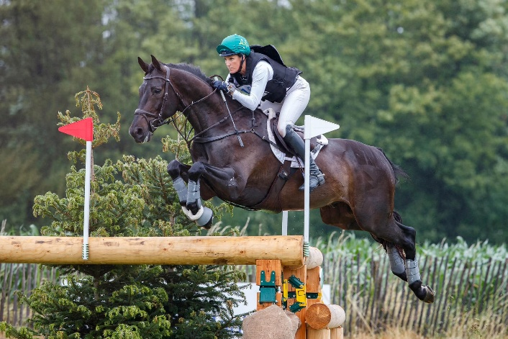
Bec Braitling USEA 2-Day Eventing Clinic
Isaacks Ranch is pleased to bring a USEA 2-Day Eventing Clinic with Bec Braitling.
Bec Braitling is an accomplished 5* eventer based in the Central Coast of California, where she is the head trainer of Arnelle Sporthorses at Twin Rivers. Bec grew up in AU competing at the 5* level to compete at Adelaide CCI5*L at age 20. In 2008, she relocated to the United States to start out at Phillip Dutton's before moving to California. She was selected to compete in the 2000 Sydney Olympic Test Event and is a USEA ICP level IV certified instructor. Plus, she's coached the Area VI Young Riders and NAYC Eventing Team since 2017.
This Clinic is open to all current USEA members and will be held on February 7 & 8, 2026 at Isaacks Ranch. Isaacks Ranch is located at 65 Cattle Guard Trail, Las Cruces, NM 88012.
Priority given to complete entries with full payment. Entries will be considered “accepted” with 50% down to reserve your spot. No refunds unless your spot can be filled from the wait list.
The clinic fee is $350 for current Area X Adult Rider & Young Rider Program Members. Fees include a daily lunch, beverages, snacks.
The clinic fee for all other USEA members is $450 and includes all the same.
The clinic is limited to 20 riders per day total. No more than 4 riders per group.
Stabling is not included in this entry. 80 permanent 10x10 stalls available: $25/night stall or $10/day stall. Shavings bags $10.
Complete this form below and mail with fees along with signed copies of the USEA Educational Activity form, Isaacks Ranch Release form to: Clinic at Isaacks, 5514 El Camino Real, Las Cruces, NM 88007. Email; isaacksranch@gmail.com, digital pay accepted.
*USEA Educational Activities & Isaacks Ranch Release from required to be signed before riding in this clinic.
**For participants under 18, all forms MUST be signed by parent or guardian.

Bec Braitling USEA 2-Day Clinic Checks payable to Isaacks Ranch
Your Name: __________________________________
Phone #: _____________________________
Street Address: ______________________________________________________________________
City/State/Zip: ________________________________
Email: ________________________________
Horse’s Name/Age/Breed:_________________________________________________
Mark your current level of competition with the horse named above:
____Intro ____Starter ____ B. Nov ___Nov ____Training ____Mod ____Prelim ____Intermediate ______ Advanced
________ $350 Area X Adult/Young Rider Program Member (Must hold current Area X membership) (2 days)
_______ $400 USEA member (MUST hold current USEA membership) (2 days)
_______$250 Show Jump Only (1 day)
_______$250 Cross Country Only (1 day)
_______$25 Night stall
_______$10 Day stall
_______$10 Shavings bag
_______$Total

