First Coast Miata Club Membership Enrollment Form (2022-2023)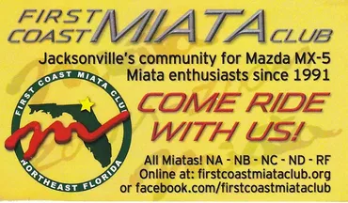
Instructions:
-Print & Fill out this Form
-Write your check payable to
“FIRST COAST MIATA CLUB”
-Mail to:
First Coast Miata Club
Membership
12533 Woodfield Circle West Jacksonville, FL 32258

Required
Membership Type: New ( ) Renewal ( ) Date: ____ /____ / ______ Names(s): ________________________________Birth Month _________ _________________________________________ Birth Month _________ Street Address: ________________________________________________ City: __________________________ State: _________Zip: _________ E-Mail(s): _______________________ ____________________________ Phone #: ________ - ______ - ________ ________ - ______ - ________

Car Information:

Model Year: _______Package: ________Color: _____________________

Club Directory Information Sharing: Check to allow use in directory

Name ( ) Address ( ) City ( ) Zip ( ) E-Mail ( ) Phone # ( ) Car ( )

Payment Information:
The FCMC membership year runs from June 1 –May 31st. Membership dues are $30 from June to May or $15 from Jan to May. Badges are $14each. Any questions should be directed to: Membership, (904) 518-5300 or email: zoomzoom91miata@aol.com. Mail completed application with check to address above.

How did you hear about us?:
Contact Card ( ) Friend ( ) Dealership ( ) Website ( ) Other ( )

First Coast Miata Club Name Badge Order Form
Instructions: Place your information where you want it on the badge – be aware of centering, capitalization, spaces and spelling. There is some leeway for long names or extra information. If you have a question, call or text Membership, (561) 789-6554 or email: zoomzoom91miata@aol.com.
Make your check payable to “First Coast Miata Club”. Each badge costs $14.00. Whenever possible, deliveries will be made at the next event after the order is received.

