First Coast Miata Club Membership Enrollment Form (2023-2024)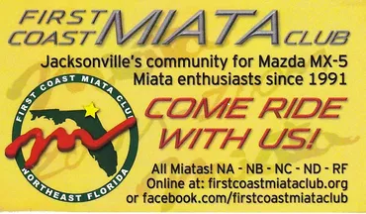
Instructions:
-Print & Fill out this Form
-Write your check payable to
“FIRST COAST MIATA CLUB”
-Come to one of our monthly First Coast Miata Club Meetings. See Website Event Calendar for dates, times and location.
Required
Membership Type: New ( ) Renewal ( ) Date: ____ /____ / ______ Names(s): ________________________________Birth Month _________ _________________________________________ Birth Month _________ Street Address: ________________________________________________ City: __________________________ State: _________Zip: _________ E-Mail(s): _______________________ ____________________________ Phone #: ________ - ______ - ________ ________ - ______ - ________

Car Information:

Model Year: _______Package: ________Color: _____________________

Club Directory Information Sharing: Check to allow use in directory

Name ( ) Address ( ) City ( ) Zip ( ) E-Mail ( ) Phone # ( ) Car ( )

Payment Information:
The FCMC annual membership year runs from June 1 –May 31st. Annual Membership dues are $30 which covers 2 people per household. The ½ year membership runs from January 1 – May 31st. Bi-Annual Membership dues are $15 which covers 2 people per household. Any questions should be directed to club leadership at one of our monthly meetings or Drive events. See website Event Calendar for Dates, Times, Locations.
How did you hear about us?:
Contact Card ( ) Friend ( ) Dealership ( ) Website ( ) Other ( )

Visit our Club Store: If you care interested as a club member in getting a Name Tag, Shirt, Car Magnets and more, visit our club store and contact: Logo Xpress 2245-6 Plantation Center Drive Fleming Island, FL 32003 Phone: 904-278-7774 Email: info@mylogoxpress.com Hours: 10am-6pm Mon-Fri . Prices subject to change.

