no development plan submitted

to the county yet
The Country Club at Deer Run is currently owned by the Golf Group of Central Florida. Representatives of the Golf Group informed the county in January 2019 that it was their intent to close the golf course in Deer Run effective June 1, 2019. As of March 15, 2019, representatives of the Golf Group of Central Florida (owned by Mr. Robert Dello Russo of Del-Air Heating & Air Conditioning) have yet to submit any formal plans to the Seminole County Department of Planning and Zoning.

Until an official development proposal is submitted to the county, details as to what type of development is being planned by the golf course’s owner remains unconfirmed speculation.

Once the owner submits a development proposal to the county, it will likely call for major rezoning. Any rezoning proposals will require public hearings with both the Planning and Zoning Committee and the Board of County Commissioners. We will keep everyone updated on when these meetings/public hearings are scheduled so everyone can attend.

Save Deer Run Newsletter

kings point hoa passes resolution

in favor of save deer run C.A.G.

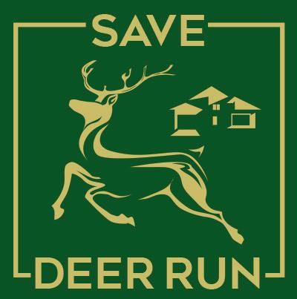
March 15, 2019 - Volume 1, Issue 1

On March 12, 2019, members of the Deer Run Homeowner’s Association #10 passed a formal resolution to join the Save Deer Run Citizen’s Action Group at their annual meeting. This HOA is comprised of 119 homes located in the King’s Point neighborhood.

The Save Deer Run Citizen’s Action Group is honored by this resolution. We look forward to working with the King’s Point HOA and all its members to ensure that residents’ voices are heard during our struggle to preserve our subdivision.

Any other homeowner’s associations in the Deer Run subdivision are encouraged to reach out to the Save Deer Run Citizen’s Action Group to find out how they can become involved, if they haven’t done so already! Please email admin@savedeerrun.com for more information.

We’re on the Web!
See us at: http://www.savedeerrun.com/
E-mail address: admin@savedeerrun.com

Did you know there’s a Facebook group where you can discuss matters about the golf course closing? Check us out!

https://www.facebook.com/pg/SaveDeerRun/groups/?ref=page_internal

Save deer run gets its own facebook group

email campaign to county commissioners kicks off
The most important thing residents of Deer Run can do right now is TO MAKE THEIR VOICES HEARD! A number of people have asked “who should we talk to?” People have also asked “what is the governing board that makes the final decision about zoning and proposed development in Deer Run?” The answer to both questions is the Seminole County Board of Commissioners.

The county commission is an elected board that is made up of five members who serve four-year terms. The commissioners must live in the district they are elected from, but all commissioners serve the county at large. This means that each commissioner represents ALL the citizens of Seminole County, regardless of their home district.
The current list of commissioners include: Bob Dallari (District 1), Jay Zembower (District 2), Lee Constantine (District 3), Amy Lockhart (District 4), and Brenda Carey (District 5).

The county commission is the ultimate decision maker for any zoning changes that would be necessary to allow development of the Country Club at Deer Run. Although no formal development plan has been submitted as of 3/15/2019, we encourage residents to send emails to ALL the commissioners to let them know how you feel about potential development of the area.

For more details on how to contact your commissioners, please visit the following URL:

https://savedeerrun.com/latest-news/f/update-3-314---kicking-off-our-email-campaign

Save deer Run Newsletter Page 2


A lot of people are concerned about the closing of the golf course. There has been a LOT of gossip, rumors, and unconfirmed facts circulated about the closing.

The Save Deer Run Citizen’s Action Group wanted to create a centralized place where everyone can discuss these issues. To achieve that goal, we have created a Facebook Group. Once you join the group, you can ask questions, share opinions, or just look to see what your neighbors are saying!

If you have a Facebook account, you can find the group at the URL below:
https://www.facebook.com/pg/SaveDeerRun/groups/?ref=page_internal

