Save deer run yard signs available
On Thursday, March 28th, the Fairway Oaks @ Deer Run Homeowner’s Association passed a resolution of support to join in the efforts of the Save Deer Run Citizen’s Action Group. The Fairway Oaks HOA joins the King’s Point (Deer Run #10) HOA and many other residents whom have already formally become a part of the citizen’s action group.

The Save Deer Run Citizen’s Action Group was formed only thirty days ago in response to a need to provide a centralized point where all the separate HOAs and neighborhoods in the Deer Run Planned Development could join forces to fight any attempts to irresponsibly develop the land upon which the Deer Run golf course now stands.

Several other homeowner’s associations in the Deer Run P.D. are in the process of passing similar resolutions and plan to do so very soon.

FAIRWAY OAKS HOA FOLLOWS KING’S POINT EXAMPLE

& VOTES TO JOIN DEER RUN C.A.G.
Save Deer Run Newsletter

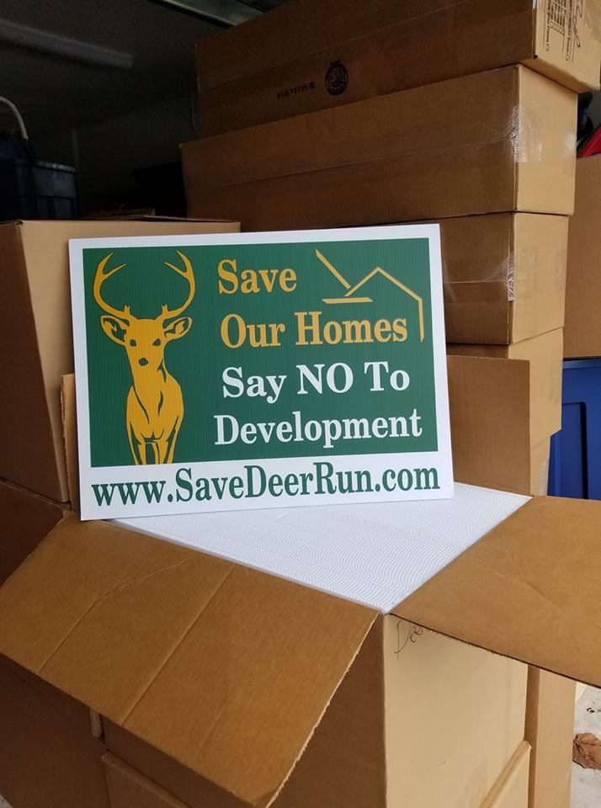
March 29, 2019 - Volume 1, Issue 2
In response to many requests from people that have asked if they might be able to get a yard sign to show their support of Save Deer Run, similar to a sign campaign that was launched by the residents of the Rolling Hills neighborhood in Altamonte Springs, we have worked with a volunteer to get a yard sign order placed. The yard sign is 24x18, is made of hard corrugated plastic, is printed in two-color on one side, and comes with a metal H-stand so it will be ready to go on display in your yard!
Thanks to the efforts of a hard-working volunteer in Fairway Oaks, an initial run of 500 yard signs and metal stands was ordered. They were delivered on 3/28. 350 of the 500 signs have already been reserved and/or purchased. This resident has volunteered to front the money for the order of these signs out of her own pocket. If you would like a sign, we are asking that you help defray the cost and consider contributing $3.00. No profit it being made on these signs. We just want to help our volunteer maybe recoup a bit of the money she has spent on the signs--which is a significant chunk of change, since we've got a first run of 500 signs!
Hurray up and get your sign(s) today by emailing admin@savedeerrun.com to get on the reservation list! We are happy to deliver the sign(s) to you. And, don't worry if you don't get a sign from the first run. We plan on ordering more very, very soon!
We’re on the Web!
See us at: http://www.savedeerrun.com/
E-mail address: admin@savedeerrun.com

Did you know there’s a Facebook group where you can discuss matters about the golf course closing? Check us out!

https://www.facebook.com/pg/SaveDeerRun/groups/?ref=page_internal

Still waiting – owner still has not submitted plan to county

Citizen’s action group collecting golf course wildlife photos
We know that many people who live on the golf course already realize how diverse a wildlife population calls it home.

But did you know some of the specific species that live on the golf course?

Deer Run is home to ducks, rabbits, possum, armadillos, Wood Storks, Egrets, Spoonbill Roseatte, Sandhill Cranes, Owls, Bald Eagles, turtles, racoons, Osprey, Woodpeckers, Sandpipers, Blue Heron, Snowy Egret, Terns, Gulls, Muscovy Ducks, Anhinga. foxes, raccoons, squirrels, and wild peacocks.

We’re sure we might be missing a few. If you see something that should be added to the list, please let us know by sending an e-mail to admin@savedeerrun.com. We are also collecting any photos you might have snapped of the wildlife on or near the course. Please feel free to email us those photos as well!

Sandhill cranes, including a mother and baby, on the golf course. Photo courtesy of Dotti Dennis.
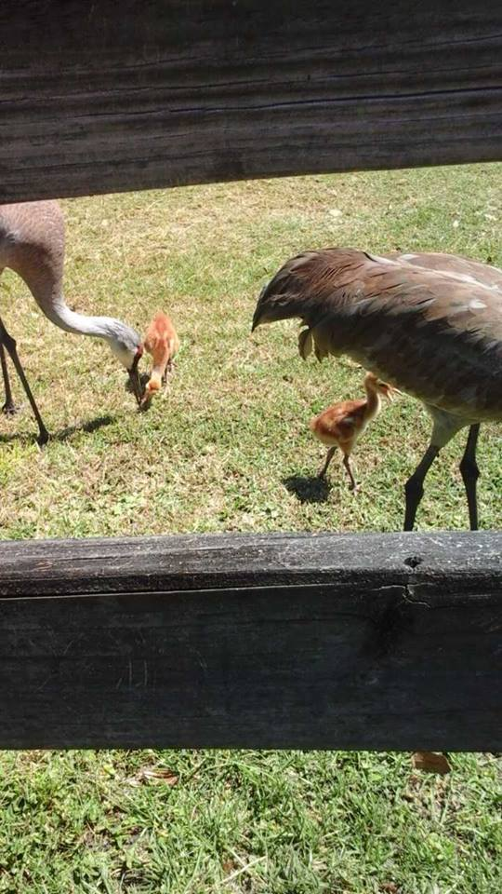

Save deer Run Newsletter Page 2

Although the owner of the Country Club at Deer Run informed Seminole County Commissioner Bob Dallari it was their intention to close the golf course in June 2019 and submit a development proposal to the county, the Growth Management Department has yet to receive an official application.
Remember, until the county receives an official application from the owner, the county is very limited in the specific information it can give the public about the future of the land upon which the course now sits.
Once a development plan is formally submitted, the county staff will begin a process to review the application. 

