On Wednesday, April 10th, the Save Deer Run Citizen’s Action Group Inc. held a meeting at the Sterling Park HOA Clubhouse at 7pm for various representatives of homeowner’s associations located within the Deer Run Planned Development.
Twenty-eight individuals attended the meeting, including representatives from ten homeowner’s associations. The following HOA’s had representatives present: Sterling Park HOA, King’s Point HOA, Fairway Oaks HOA, the Villas at Deer Run HOA, Eagle’s Nest HOA, Deer Run Court HOA, Deer Run Cove HOA, the Terraces HOA, Pinesong Cove HOA, and Mystic Woods HOA. This was the largest meeting of HOA representatives for the Deer Run PD in more than thirty years. Twenty-two HOAs exist with the Deer Run PD. If your HOA did not send a representative to this meeting (and several were invited, but they declined to attend), we encourage individual residents to reach out to their boards to make certain they have representation at future meetings.
At the meeting, several topics were discussed. This included news about the formation of the Save Deer Run non profit, purchase of Save Deer Run yard signs, planning of the Save Deer Run Night community meeting in May, and distribution of literature about the latest news on the golf course’s potential closure. Individual HOAs were encouraged to go to their archives and look for any documents that they may have detailing their relationship with the golf course. It was also suggested other HOA board to consider passing resolutions of support in favor of Save Deer Run as others have done.
Minutes for the meeting were taken and will be available shortly on the SaveDeerRun.com website. Another meeting is planned in the near future. Details will be available soon.

SAVE DEER RUN INCORPORATES AS NONPROFIT

homeowner’s REP MEETING held

Save Deer Run Newsletter

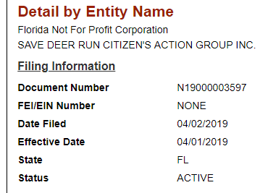
April 19, 2019 - Volume 1, Issue 3
On April 1st, 2019, the Save Deer Run Citizen's Action Group decided to formally incorporate as a nonprofit with the State of Florida. This gives the Citizen's Action Group a legal identity under state law.
The following individuals agreed to serve as the initial six members to form the Board of Directors: Deborah Bauer (Sterling Park); Allen Sutton (Sterling Park); Robert J. Mungoven, Sr., (King's Point); Debbie Gembecki (King's Point); Toby J. Bouckhuyt (Fairway Oaks); and Denise Grant (The Villas at Deer Run).
It is the hope of the Save Deer Run Citizen's Action Group Inc. (nonprofit) that other HOA's within the Deer Run Planned Development will nominate a representative from their HOA's to serve on the board.
We’re on the Web!
See us at: http://www.savedeerrun.com/
E-mail address: admin@savedeerrun.com

Did you know there’s a Facebook group where you can discuss matters about the golf course closing? Check us out!

https://www.facebook.com/pg/SaveDeerRun/groups/?ref=page_internal

SAVE DEER RUN RECEIVING MEDIA COVERAGE

Second run of yard signs in the works!
A little more than a month ago, Save Deer Run was able to purchase an initial run of 500 yard signs for our community. Over the last six or seven weeks, several volunteers have been working on distributing these signs.
The bad news is that we have temporarily run out of yard signs. The good news is that we are placing a second order of yard signs on Monday, and we should hopefully have them within a week. The even better news is that these yard signs are within almost every neighborhood in the subdivision, and we’re not done yet!
If you\ve already sent an email to admin@savedeerrun.com and haven’t received a response yet, please don’t worry. We’ve created a waitlist for people who wants signs, but haven’t gotten them yet. Your patience while we catch up with getting the signs to you is very much appreciated. We promise that no one who wants one won’t be able to get them! In the meantime, if you still haven’t gotten a yard sign yet, reserve yours today!

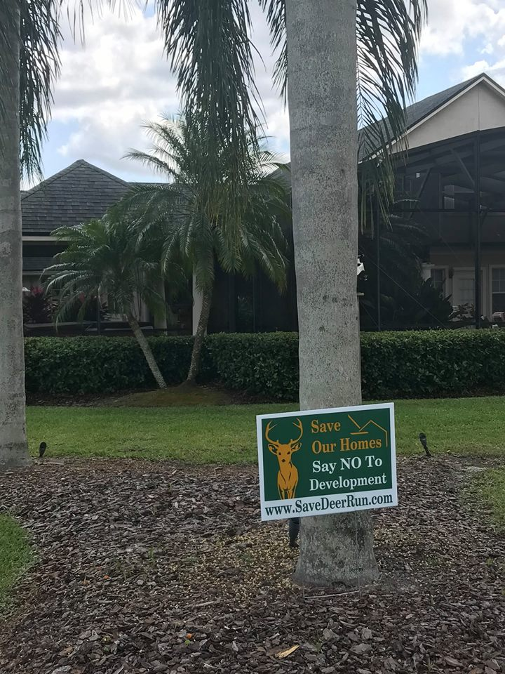

Save deer Run Newsletter Page 2

The situation at the Country Club at Deer Run has begun to get some impressive attention from both print and television media.
The Orlando Sentinel ran an article on the potential closing of the golf course. It ran on the front page on Monday, April 8th. New13 (available to Spectrum customers), also ran a piece during their five o’clock news hour on Friday, April 19th. The News13 piece includes comments from the owner of the golf course, Mr. Robert Dello Russo, whom indicated he would be willing to sell the course at a price of $6 million.
In case you missed either piece, links to online versions can be viewed in the Latest News section of the savedeerrun.com website.


