second homeowner’s REP MEETING held

On Thursday, May 2nd, the Save Deer Run Citizen’s Action Group Inc. held a meeting at the Sterling Park HOA Clubhouse at 7pm for various representatives of homeowner’s associations located within the Deer Run Planned Development.
Twenty-five individuals attended the meeting, including representatives from ten homeowner’s associations. The following HOA’s had representatives present: Sterling Park HOA, King’s Point HOA, Fairway Oaks HOA, Eagle’s Nest HOA, the Terraces HOA, and Mystic Woods HOA. New HOAs that were welcomed for the first time included Ironwood HOA, Polo Club/Normandy Place HOA, and Deer Pointe HOA. In the past, Deer Run Court HOA, Deer Run Cove HOA, Pinesong Cove HOA, and the Villas HOA have also sent representatives. As with the first HOA Representative meeting that was held in April, if your HOA did not send a representative to this meeting, we encourage individual residents to reach out to their boards to make certain they have representation at future meetings.
At the meeting, several topics were discussed. This included the announcement that Save Deer Run Yard Signs are back in stock as a second run of 500 signs has been purchased and delivered. Details about the Save Deer Run Night Community Meeting scheduled for 5/9 were shared and volunteers solicited to work the event. The topic of the rumor of that the City of Casselberry wanted to annex Deer Run in order to facilitate sale of the golf course was also raised.
Minutes for the meeting were taken and can be requested by sending an email to admin@savedeerrun.com.

This community meeting is being organized by the community of Deer Run for the community of Deer Run. It will be held on Thursday, May 9, 2019. Doors will open at 6pm. All events are scheduled to end at 9pm. It will be held in the Auditorium of the Metro Life Church located at 910 S. Winter Park Drive, Casselberry, FL 32707.

The community meeting is open to all residents, homeowners, and friends of the Deer Run community. It is free, and families are encouraged to attend.

Planned activities include: distribution of printed literature about the current state of the potential closing of the Country Club at Deer Run and possible development plans; a petition signing drive; and a Save Deer Run Coloring Contest for the youngest members of the Deer Run family. Prizes will be awarded for the top three winners. All entries will be displayed on the SaveDeerRun.com website. Save Deer Run Yard Signs and Save Deer Run T-shirts will also be available for purchase. The evening will conclude with a Question & Answer (Q&A) Session with questions from the audience that will begin at 7:45pm.

We encourage you to join us for a night of fellowship as we get to meet our neighbors, information as we learn about the latest news on the potential closing and development of the golf course, and action as we unite to demonstrate why the Deer Run community is one of the most well-informed, active, and determined communities in all of Seminole County!

SAVE DEER RUN NIGHT COMMUNITY MEETING TWO DAYS AWAY!

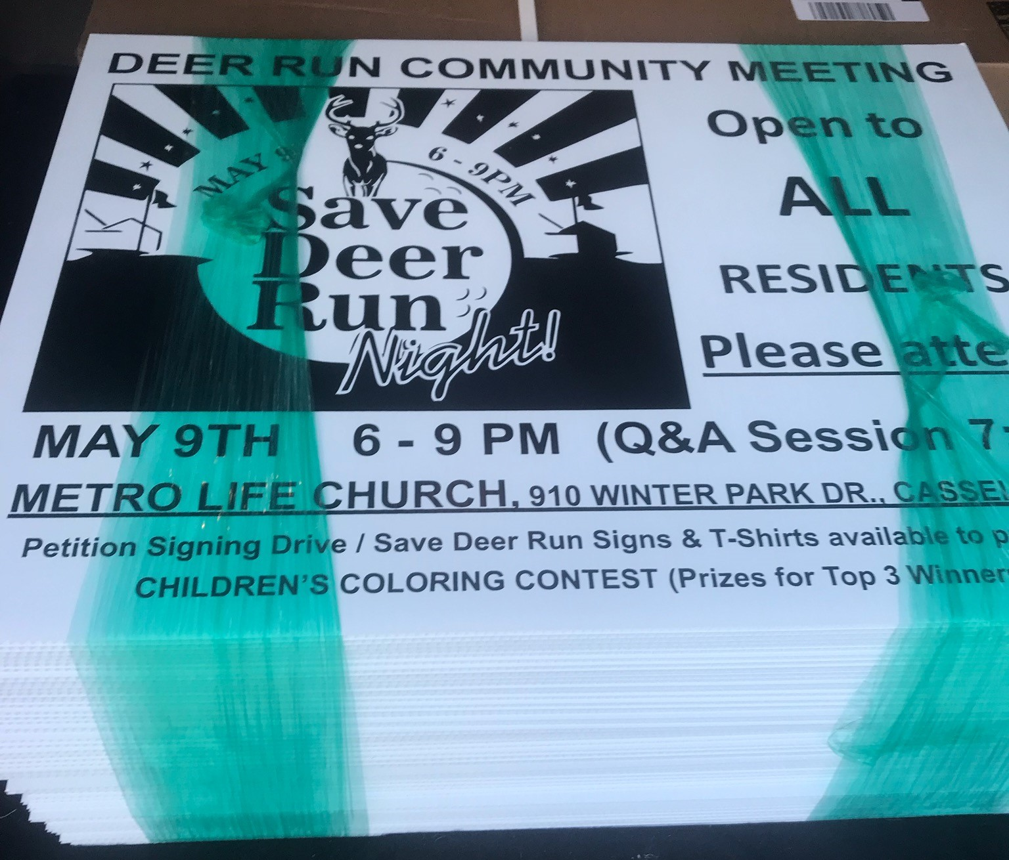
Save Deer Run Newsletter
May 7, 2019 - Volume 1, Issue 4
We’re on the Web!
See us at: http://www.savedeerrun.com/
E-mail address: admin@savedeerrun.com

Did you know there’s a Facebook group where you can discuss matters about the golf course closing? Check us out!

https://www.facebook.com/pg/SaveDeerRun/groups/?ref=page_internal

When a golf course is more than a golf course

Yard signs back in stock!

Save deer Run Newsletter Page 2

We temporarily ran out of Save Deer Run signs a few weeks ago. Our initial run of 500-yard signs was distributed to several hundred homes throughout the dozens of neighborhoods in the subdivision.
But we are happy to announce we ordered a second run of 500-yard signs and they have been delivered! If your name was on the wait list, we have your sign and will be reaching out to make arrangements to get it to you ASAP if we haven’t done so already.
For those of you who don’t have a yard sign yet, what are you waiting for? Get your yard sign today by emailing admin@savedeerrun.com!

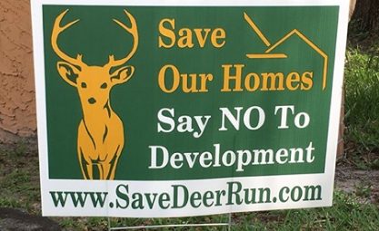
Get your yard sign today!

The Country Club at Deer Run as existed for almost forty-five years. In that time, it has served as the center of our community. For over four decades, it has hosted memorable events from golf tournaments to charity fundraisers on the course itself to a wide range of private functions at the club house, like homeowner's association meetings, weddings, wedding receptions, baby showers, and birthday parties to name a few. But what about when a course is more than a course? What about when it is a memorial?
Chip Jaap's mother & father were original homeowners in Deer Run. Like so many people, they frequented the course. In 2014, Chip's mother passed away. To commemorate her life and relationship with Deer Run, a memorial was placed on the 18th hole between two magnolia trees. To this day, there it sits in remembrance of her. Her husband frequented the course and her memorial until he passed away in June 2018.
If the course is torn down, what will become of the memorial? Will those magnolia trees be ripped out at the roots to make way for houses and apartments? Stories like this are easily forgotten. They shouldn't be. They won't be. The Jaaps allowed us to share their story with you to remind each of us that the golf course IS more than just a course. To each one of us.

.