SAVE DEER RUN NIGHT A SMASHING SUCCESS!
vandalism on the course. It is Save Deer Run’s hope, prayer, and strong desire that these issues will not continue.

Some residents have been concerned about who will maintain the land upon which the course sits. The golf course lands must be maintained by the owner per county statute that was changed five years ago. Seminole County changed the law in 2014 in so far as what responsibilities the owner has regarding property upkeep. This was spurred, in part, but the closing of the Rolling Hills Golf Course. County statute now state all grass must be kept 8 inches or shorter. Failure to do so can result in up to $250 a dollar per violation in fines. It is possible the owner could choose to disregard the law. However, if residents view any evidence of the grass growing higher than eight inches, we strongly encourage you to reach out to Seminole County Code Enforcement and file a complaint.

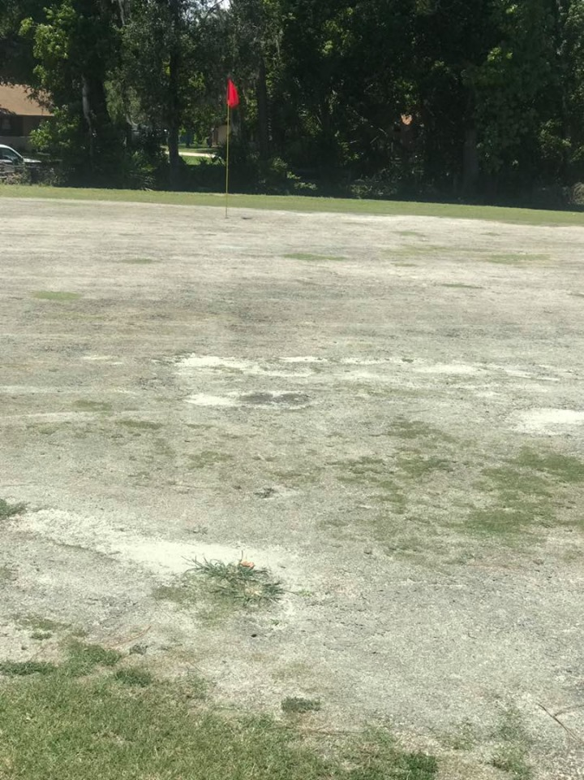

Some residents have been concerned about who
will maintain the land upon which the course sits. The golf
course lands must be maintained by the owner per county
statute that was changed five years ago. Seminole County
changed the law in 2014 in so far as what responsibilities the
owner has have regarding property upkeep. This was spurred, in part, but the closing of the Rolling Hills Golf Course. County statute now state all grass must be kept 8 inches or shorter. Failure to do so can result in up to $250 a dollar per violation in fines. It is possible the owner could choose to disregard the law. However, if residents view any evidence of the grass growing higher than eight inches, we strongly encourage you to reach out to Seminole County Code Enforcement and file a complaint.

On Saturday, May 26, 2019, the remaining employees of the Country Club at Deer Run were fired. The golf course officially closed on Sunday, May 27th. The owner claimed that he no longer had enough staff required to operate the course. The closing on Memorial Day weekend predated the June 1st closing deadline that the golf course owner and his representatives had been advertising as the expected close date going back to January 2019.

Now that the golf course has closed, we know there has been a lot of concern about what happens next. Here is what is known so far. As of 6/4, the golf course is still owned by Mr. Dello Russo and the Florida Golf Group. It has not been sold. It does not appear as if he plans to sell the golf course. It appears he plans to attempt to develop the land upon which the golf course sits himself. Also, as of 6/4, the owner has not submitted plans to the county to request the rezoning that would be required before any construction could begin on the land the golf course now occupies. He has told reporters that his representatives plan to file the proposed development plan sometime within the next two to three months.

The owner has installed 'No Trespassing' signs and security cameras on the golf course. It is strongly advised that all residents, homeowners, and visitors to Deer Run DO NOT TRESSPASS on the golf course and its surrounding lands. It is private property, and if you trespass, you could be fined and/or even arrested. There has been at least one rumored incidence of

On Thursday, May 2, 2019, Save Deer Run Citizen’s Action Group sponsored a community meeting for the residents, homeowners, and friends of the Deer Run Subdivison. It was held in the Auditorium of the Metro Life Church located at 910 S. Winter Park Drive, Casselberry, FL 32707. The doors opened at approximately 6pm. Over a dozen volunteers manned sign in tables, distributed literature about the closing of the golf course, and answered questions. Approximately 500 guests attended the three-hour event.
Volunteers Michael and Patti Hannah worked hard at the yard sign and t-shirt table. More than 75 yard signs and 100 t-shirts were sold. Other volunteers, like Debbie and John Gembecki and Allen Sutton, worked hard to help collect 462 individually signed petitions that will be delivered to the Seminole County Board of Commissioners as soon as the golf course submits its development proposal to the county. Beginning at 7pm, Save Deer Run C.A.G. founder and director Deborah Bauer took to the stage for the Q&A session. Guests were asked to submit their questions in writing before the session began. Ms. Bauer spent the next two hours answering almost 50 questions. The questioned ranged in topics from the potential annexation of Deer Run by the City of Casselberry, who was responsible for maintaining the golf course once it closed, how Sterling Park Elementary would be impacted by the creation of a new housing development, and what the citizen’s action group believed its next steps would be.
The Save Deer Run Citizen’s Action Group would personally like to thank Mr. Chip Carew and the wonderful staff at Metro Life Church for helping to facilitate the logistics of the evening on relatively short order. We would also like to thank the Sterling Park Homeowner’s Association, the King’s Point Homeowner’s Association, and several individual Deer Run residents for donating the funds needed to put on the event.
Given the success of the event, Save Deer Run is researching the possibility of hosting a town-hall style meeting in late July or early August where residents would have the ability to ask questions of local elected officials on how the possibility of development could impact Deer Run.

GOLF COURSE CLOSED

MEMORIAL DAY WEEKEND
Save Deer Run Newsletter
June 4, 2019 - Volume 1, Issue 5
We’re on the Web!
See us at: http://www.savedeerrun.com/
E-mail address: admin@savedeerrun.com

Did you know there’s a Facebook group where you can discuss matters about the golf course closing? Check us out!

https://www.facebook.com/pg/SaveDeerRun/groups/?ref=page_internal

SAVE DEER RUN T-SHIRTS ON SALE

Media blitz continues on news13 and wesh2

Save deer Run Newsletter Page 2

Save Deer Run has continued its efforts to raise awareness of the situation in Deer Run in the local press. In case you missed it, News13 (Spectrum News) ran a follow up piece on May 29th that included an interview with a former employee, Chris Derosier. WESH2’s reporter Dave McDaniel has filed two pieces, one that aired on 5/13 and a second that aired on 6/2. In case you missed any of these news story, links on the Save Deer Run website have been posted which feature the video and a written transcript of each piece.

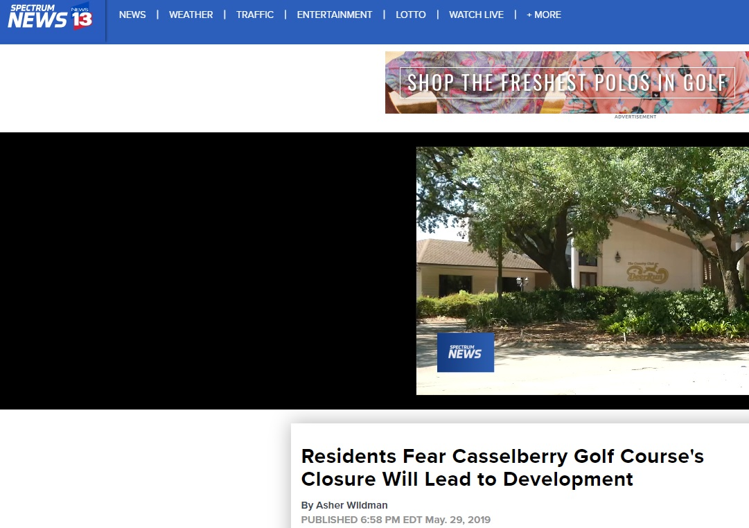
News13 followup piece by reporter Asher Wildman.

We're pleased to announce that thanks to a generous loan from a kind supporter in the Fairway Oaks neighborhood, we are pleased to offer Save Deer Run t-shirts for sale.

The shirts are printed on the back and front. They are cotton. We have the following sizes currently available: M, L, XL, and 2X. The cost is $5.00.

We are almost half-way through the first order we placed on these shirts if you can hardly believe it! If you are interested in purchasing a shirt, the best way to do so is to please send an email to admin@savedeerrun.com. Additionally, if you are interested in reserving a shirt of a different size (we know there have been some requests for children's sizes), please send your request via email, and we will get everyone's info down and place another order when we have a large enough commitment.



