On Friday, June 14th, several residents who live on the golf course reported the arrival of a construction dumpster, several dump trucks, and at least one backhoe. It appeared that some type of construction effort had begun at the golf course when the backhoe was leveling the hole closest to the clubhouse and trucking fill dirt from the site to another location. Upon closer examination, it was determined that the Florida Golf Group had begun unpermitted construction at the Country Club at Deer Run Golf Course. Residents reported seeing the concrete fence that separated the pool area from the parking lot had been knocked down, and it appeared construction was being carried out on the pool area in addition to the demolition of the hole closest to the golf course. As of June 30th, no demolition permit or any type of building permit has been pulled by the Florida Golf Group with the Building Division at Seminole County as required by law. The construction permit system is available to the public online. You can view any permits (active, inactive, closed) on the website by typing in the physical address of the property in question.
There has been some confusion as to if a permit was needed for the type of work that was being carried out at the golf course clubhouse. One of the Deer Run residents reached out to Jeff Johnson, Chief Building Plans Examiner for Seminole County. Mr. Johnson stated that owners of the golf course 100% need a permit for this type of activity. They need to knock holes in the bottom of the pool so that water can flow out, in order to prevent mold (which is a health issue). They also need grading done and need to have the electric wiring capped. County engineering would have to be involved, and a final inspection would need to be conducted. When asked if a permit was needed to fill in any type of swimming pool in Seminole County, Mr. Johnson said YES. As to why conflicting

Several months ago, Save Deer Run Citizen's Action Group legally incorporated as a private not-for-profit foundation with the State of Florida. This means we created a formal Board of Directors, registered with the state of Florida as a corporation, and registered with the Internal Revenue Service. This means we keep detailed minutes of board meetings, maintain records, and keep track of expenses. These steps were taken for several different reasons, but one of them had to do with why, up until this point, we have had to turn down people who wished to make financial contributions to the Save Deer Run initiative. Over the last few months, one of the questions we most frequently have gotten from our supporters is "when can we help you with fundraising?" We can now answer that question by saying "TODAY!" Currently, our operating expenses are rather low. We like to think we're a frugal group. Most of our expenses are related to the following: domain name registration, website hosting, and email services. We have also used free services like Mailchimp to organize our contact list, but have also incurred expenses when it comes to photocopies, ink/toner, and paper to make hard copies of flyers, petitions, etc. So, if you wish to donate ($0.01, $1.00, or something else), we don't care what amount. We will be humbled and honored to accept it. We can take donations in two ways.

1.) You can mail a check made payable to 'Save Deer Run Citizen's Action Group' to 423 Eagle Circle, Casselberry, FL 32707.
2.) You can make a donation via Paypal which will allow you to use credit cards. Please visit the 'Donate' page on the Save Deer Run website for more information. https://savedeerrun.com/donate

At the current time, please note that these donations are NOT tax-deductible. Save Deer Run is not a tax-exempt agency at this point in time. However, our board is working on registering as a 501(c)3 group with the IRS. We will keep you updated on our efforts!

information was being distributed to the public on the matter, Mr. Johnson said, "I have no idea why anyone on staff would say you don't need a permit to fill a swimming pool (of any size)."

Mr. Johnson further suggested that residents file reports for the unpermitted construction with the Unpermitted Construction Compliant Line. They can be reached on the telephone at 407-665-7338; via fax at 407-665-7407; or via e-mail at bpcustomerservice@seminolecountyfl.gov. Please note that this is a different enforcement agency than the Seminole County Code Enforcement line that some people have contacted and who were told that there is no code violation at the golf course. Seminole County Code Enforcement (via the Seminole County Sheriff's Department) is different than the Building Permit Enforcement. For more information, please visit:

https://www.seminolecountyfl.gov/departments-services/development-services/building/

SAVE DEER RUN NONPROFIT NOW ACCEPTING DONATIONS

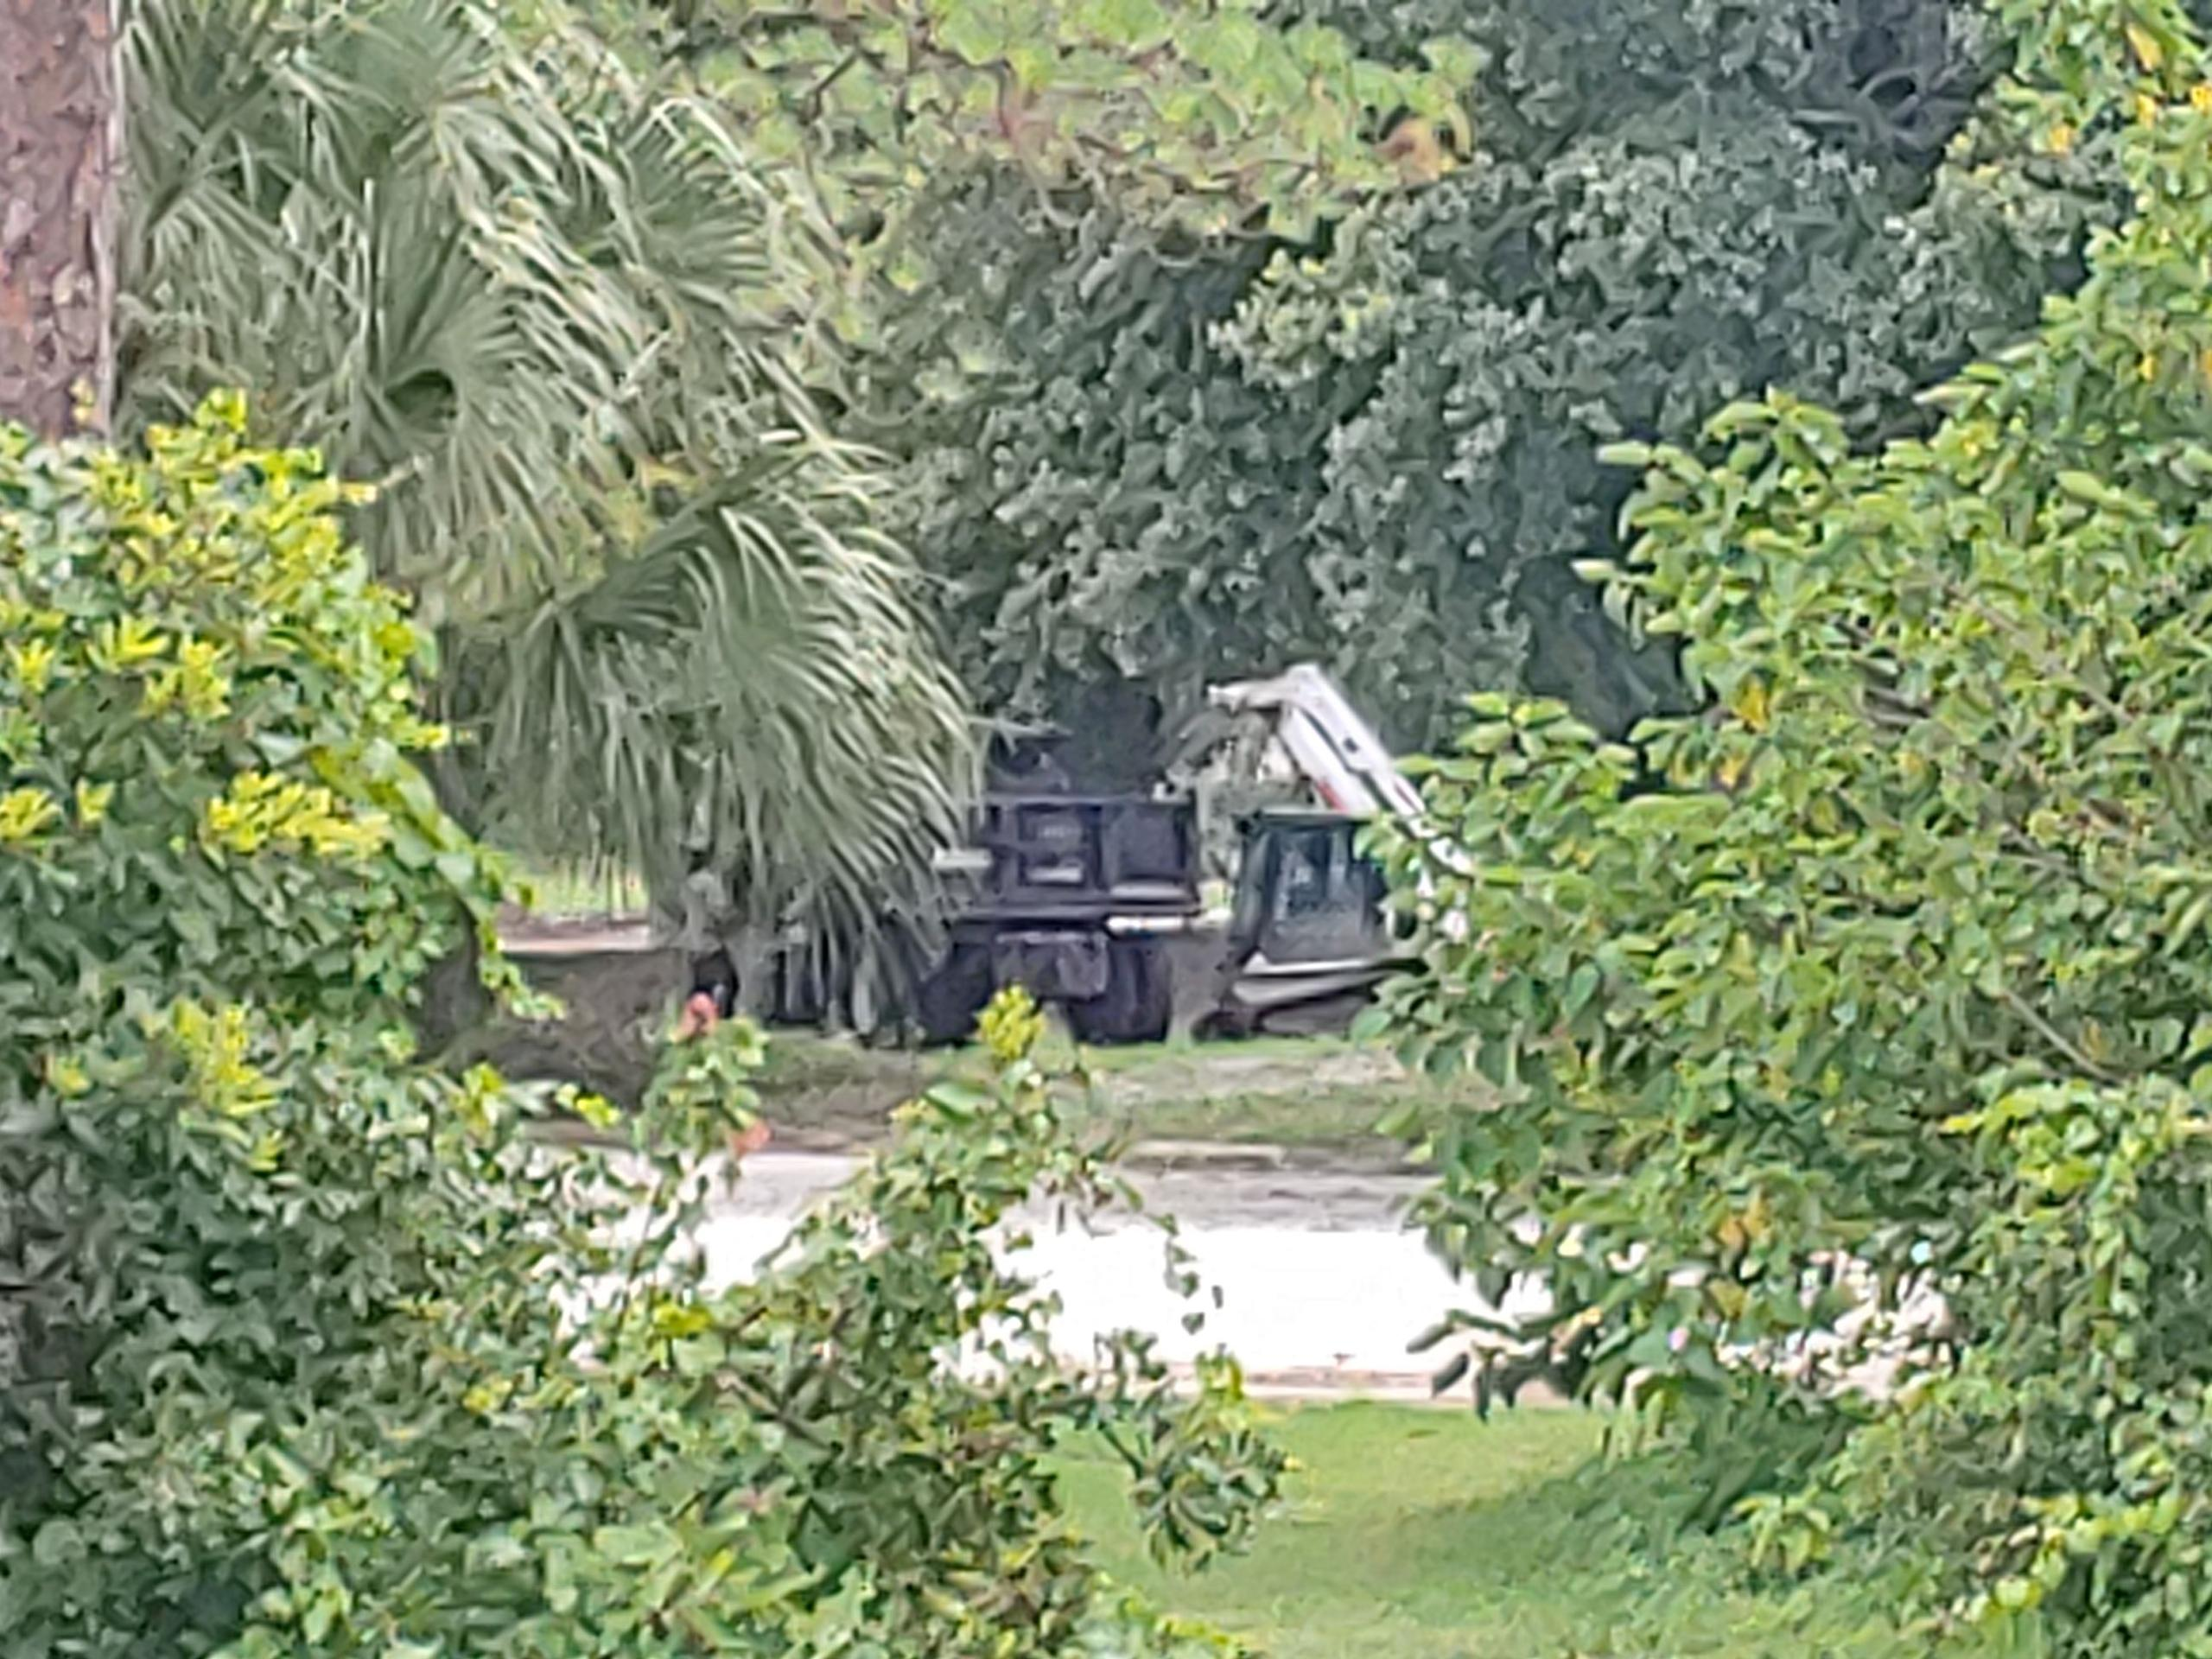

Some residents have been concerned about who
will maintain the land upon which the course sits. The golf
course lands must be maintained by the owner per county
statute that was changed five years ago. Seminole County
changed the law in 2014 in so far as what responsibilities the
owner has have regarding property upkeep. This was spurred, in part, but the closing of the Rolling Hills Golf Course. County statute now state all grass must be kept 8 inches or shorter. Failure to do so can result in up to $250 a dollar per violation in fines. It is possible the owner could choose to disregard the law. However, if residents view any evidence of the grass growing higher than eight inches, we strongly encourage you to reach out to Seminole County Code Enforcement and file a complaint.

Unpermitted building construction commenced at golf course
Save Deer Run Newsletter
June 30, 2019 - Volume 1, Issue 6
We’re on the Web!
See us at: http://www.savedeerrun.com/
E-mail address: admin@savedeerrun.com

Did you know there’s a Facebook group where you can discuss matters about the golf course closing? Check us out!

https://www.facebook.com/pg/SaveDeerRun/groups/?ref=page_internal

save deer run yard signS disappearing

Save deer Run Newsletter Page 2

Over the last month or two, we have received some complaints from residents who have seen their Save Deer Run signs disappear from their yards.

If your sign has disappeared, it is likely that the sign was not deliberately removed by someone out of malice. The most common reason the signs have disappeared is because landscapers and lawn maintenance crews have removed the signs to cut grass and don't put them back. However, a few people asked if Code Enforcement might have removed the signs. If you were displaying the sign in a public right of way, Code Enforcement might have indeed removed it. A limited number of HOAs in the subdivison have also banned the residents from putting out the signs. Sometimes signs have blown away because of the fierce storms we've had lately.

The moral of the story is the signs probably haven't disappeared because someone stole them. But if you see anyone removing a sign from someone's yard or the entrance to individual neighborhoods whose HOAs have approved the signs being on display there, please let us know immediately!

See something? Say something!

not a loss of momentum, but a summer lull

The month of June has been one of the hottest in recorded memory in Central Florida. The heat has reminded all of us in Deer Run of one thing -- it's summertime! People leave to go out of town on vacation, kids are home from school, and the heat makes it two or three times harder to do things than if it weren't feeling like it's 105F on any given day.

As the summer progresses, sometimes larger projects and initiatives like that of the Save Deer Run Citizen's Action Group may seem to have gone into hibernation. A few volunteers have shared with us their opinion that they feel like we have lost momentum. This is what we have been sharing in response. When we started Save Deer Run, we all knew this was a long game. This is not a fight won in one, two, or three months. It is likely it could go on for a year or more. So, like all tides, there will be ebbs and flows. That is natural. That is to be expected. But the key, we believe, is remaining active and present. That is why we must keep our yard signs in our yards, keep wearing our Save Deer Run t-shirts, and keep telling people what is going on!

We must thwart the hopes of the golf course's owner whom, we believe, hopes that the resistance in the subdivision will dwindle away, fade away, and disappear completely. We are in this for the long haul, and we hope you are too!

