Construction Begins

on Apartment Complex at

Eagle Circle &

Red Bug Lake Road
On Monday, July 29th, 2019, ground broke on a new construction project on the parcel of land located at the intersection of Eagle Circle and Red Bug Lake Road. This property has been vacant for many years. In the past, it has been used as pasture for cattle. It consists of 29.57 acres spread out over 11 parcels along the shores of Lake Howell. One land parcel was located in the City of Casselberry. The remaining ten parcels were in unincorporated Seminole County. The land was owned by the Mayflower Retirement Center, Inc. In the past, it has been generally understood that the Mayflower was going to build an assisted living/retirement community on the land there.
On March 26, 2018, the Casselberry City Commission met and voted 5-0 to accept the property owner's request to voluntarily annex the 10 parcels located in unincorporated Seminole County into their city. The owner also requested a zoning change to the land use designation of those properties. Previously, the parcels were zoned agricultural, low density residential, and medium density residential. In a vote of 5-0, the city commission voted to change all 11 parcels to medium-density multi family dwellings at the same time they voted to annex the land.

As reported in the Volume 1, Number 6 (June 30th) edition of the Save Deer Run Newsletter, residents reported seeing construction crews working at the golf course club house in late June. It was determined that unlawful and unpermitted construction work was being done at the country club. Thanks to numerous tips that were reported to the Seminole County Building Division tipline, Seminole County Field Inspector Vicky Hathaway went out to see what was going on at the golf course. The Building Division found the golf course owners to be in non-compliance with Seminole County codes because they did not pull any building permits before construction began. A citation was issued with instructions that the owners had a specific number of days to hire appropriate contractors, apply for the required permits, or face fines from the county.

On July 11, 2019, a building contractor (Seminole State Construction LLC) and an electrical contractor (Seminole State Construction LLC) applied to the county for a building demolition permit and an electrical permit. After review by the county, the two permits were finally issued on July 29, 2019. The golf course owner must still submit to the county for final inspections of the site before the work will be approved and the permits closed.
On December 10, 2018, the city commission voted to approve a site plan that was submitted by the owners of the property, now known as the Jefferson Property Group. The site plan includes several multi-floor apartment buildings totaling 384 units. This apartment complex will be known as the Jefferson Lake Howell Apartments.
Some residents in Deer Run have asked if this building project is related to the closing of the golf course. The answer is no. It is owned by different people. Also, zoning changes and site plan approval for these apartments were given by the City of Casselberry, not Seminole County. While this large apartment complex will have a significant impact on Deer Run, it is not related to the issues of the golf course. However, we share this information so people can see what can happen when residents are not proactive and vigilant when it comes to fighting zoning changes at the municipal and county-level during planning stages.

PERMITS FINALLY PULLED AT THE GOLF COURSE

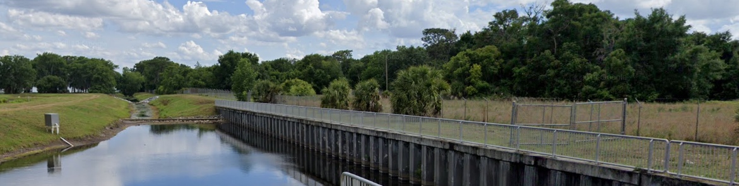

Some residents have been concerned about who
will maintain the land upon which the course sits. The golf
course lands must be maintained by the owner per county
statute that was changed five years ago. Seminole County
changed the law in 2014 in so far as what responsibilities the
owner has have regarding property upkeep. This was spurred, in part, but the closing of the Rolling Hills Golf Course. County statute now state all grass must be kept 8 inches or shorter. Failure to do so can result in up to $250 a dollar per violation in fines. It is possible the owner could choose to disregard the law. However, if residents view any evidence of the grass growing higher than eight inches, we strongly encourage you to reach out to Seminole County Code Enforcement and file a complaint.

Save Deer Run Newsletter
July 31, 2019 - Volume 1, Issue 7
We’re on the Web!
See us at: http://www.savedeerrun.com/
E-mail address: admin@savedeerrun.com

Did you know there’s a Facebook group where you can discuss matters about the golf course closing? Check us out!

https://www.facebook.com/pg/SaveDeerRun/groups/?ref=page_internal

Save deer Run Newsletter Page 2

Save Deer Run has always been an organization that has been created for, run by, and working for the residents and friends of the Deer Run subdivision. Our organization is nothing without resident and community support. One of the most important ways that residents can show that crucial support is to petition their individual homeowner's associations to pass resolutions of support for their HOA to work with Save Deer Run. On May 14, 2019, the Terraces Homeowner's Association became the most recent HOA to pass such a resolution. They join the efforts of Sterling Park HOA, King's Point HOA, Fairway Oaks HOA, and others who have already done the same out of approximately 22 separate HOAs in the subdivision.
The most current question anyone associated with Save Deer Run has been asked is..."what's going on at the golf course?" Unfortunately, (or fortunately, perhaps, depending on your perspective) the land's owner, Mr. Robert Dello Russo of the Central Florida Golf Group, still has not submitted an application for permits and building plans that would require the county to approve rezoning. So the answer to that question right now is “not much.” However, we continue to expect the owner to submit his plans any day.
Rest assured, if and when these plans are submitted, Save Deer Run will work hard to make sure all residents know as quickly as possible.

The TERRACES HOA PASSES RESOLUTION OF SUPPORT – OTHER HOAS ENCouraged to do so

SDR Stories: Grocery shopping on saturday morning

One of the things we love hearing at Save Deer Run are stories from our members about how our efforts have been received in the larger community of Seminole County. We share one such story with the names changed to protect the anonymity of our members.
Sue and her husband George needed to go grocery shopping one weekend. Early on a busy Saturday morning, George's Save Deer Run T-shirt (available for purchase by emailing admin@savedeerrun.com) was up in the laundry rotation. George thought nothing of wearing it while he and Sue went shopping.
While in the Neighborhood Walmart on Red Bug Lake Road, Sue and George were stopped multiple times by people when they saw the shirt. They were asked several times "why does Deer Run need saving?" Many people in the store, neighbors who live close by, had no idea that golf course had closed in late May or that the land was under threat of development. Sue and George explained what was going on and suggested the people who had asked to visit the Save Deer Run website to learn more information about what’s happening and how we are fighting it.
The moral of the story is that our greatest challenge continues to be raising awareness in the community. Look at how a simple thing like wearing your Save Deer Run tshirt while you run your normal errands helped us with this goal?
Do you have a Save Deer Run story you'd like to share? We hope to feature more stories like this in future newsletter volumes. Please feel free to email us your stories for possible future publication.

