Until those development plans are officially submitted to Seminole County, we strongly encourage all residents to disregard any rumors and gossip about what may or may not happen to the course. Speculation at this point has only caused undue stress and worry to homeowners when it turns out the rumors that they heard had no truth whatsoever. Rest assured, as soon as verifiable facts have been found to be truthful, SDR will publish the news immediately. Until that point, any reference to rumors and unsubstantiated hearsay will be ignored.



Some residents have been concerned about who
will maintain the land upon which the course sits. The golf
course lands must be maintained by the owner per county
statute that was changed five years ago. Seminole County
changed the law in 2014 in so far as what responsibilities the
owner has have regarding property upkeep. This was spurred, in part, but the closing of the Rolling Hills Golf Course. County statute now state all grass must be kept 8 inches or shorter. Failure to do so can result in up to $250 a dollar per violation in fines. It is possible the owner could choose to disregard the law. However, if residents view any evidence of the grass growing higher than eight inches, we strongly encourage you to reach out to Seminole County Code Enforcement and file a complaint.

On September 14, 2019, several homeowner’s in the King’s Point, Sterling Park, & Fox Hollow neighborhoods reported that their Save Deer Run yard signs had been stolen out of their yards sometime between late Friday evening and early Saturday morning. A witness in the King’s Point neighborhood believed he saw a person driving either a black GMC pick up truck or black Suburban SUV driving around the neighborhood and pulling signs out of people’s yards sometime between 6am & 9am on Saturday morning. They struck a second time on the morning of September 21st during approximately the same period.

Some people have asked if Seminole County Code Enforcement could have picked up these signs. The answer is no. Code Enforcement does not pick up signs when their offices are closed. These signs were taken during a suspicious window. Also, Code Enforcement only removes signs from public areas such as right of ways, not private property.

As a reminder, people who purchased the yard signs own them. It is their property. Florida law states that a person commits theft when “he or she knowingly obtains or uses, or endeavors to obtain or to use, the property of another with intent to, either temporarily or permanently to 1) deprive the other person of a right to the property or a benefit from the property, or 2) appropriate the property to his or her own use or to the use of any person not entitled to the use of the property.” (Fla. Stat. Ann. § 812.014.) Theft of an item under $300 is a misdemeanor in Florida. So, by stealing someone’s property (SDR signs) that person is committing a misdemeanor. Several residents have been greatly upset by this theft and told SDR that they plan to file police reports with the Seminole County Sheriff’s Office. If anyone has had their signs stolen, or might have seen something, please reach out to us as soon as you can. Remember, see something, say something!

SDR Yard sign bandits stealing signs
September 30, 2019 - Volume 1, Issue 8

residents continue to worry with lack of development plan still not submitted to seminole county
The number one question that is on the minds of all Deer Run residents is when will the owner of the Country Club at Deer Run submit a development plan to Seminole County? The golf course closed three months ago. In all that time, rumors have continued to spread like wildfire that the plans would be submitted "soon" even as the months go by without the plans being submitted.
As of September 30, 2019, Save Deer Run has verified with Seminole County staff that the owner has not yet submitted any development plans. As soon as those plans are submitted to the Department of Development Services for evaluation, the plan becomes public record. SDR wants to reassure all readers that as soon as those plans become public record, we will make certain everyone knows about them. We consider one of our primary goals as SDR to be to inform, so if news hasn’t been posted, it’s because there was no factual information to share.
Save Deer Run Newsletter
We’re on the Web!
See us at: http://www.savedeerrun.com/
E-mail address: admin@savedeerrun.com

Did you know there’s a Facebook group where you can discuss matters about the golf course closing? Check us out!

https://www.facebook.com/pg/SaveDeerRun/groups/?ref=page_internal

Save deer Run Newsletter Page 2

Longtime readers may remember that residents who live along the golf course reported the arrival of construction equipment at the golf course clubhouse in late June. Upon further investigation, it was determined the golf course owner had begun unpermitted construction work at the clubhouse. After residents reported the unpermitted work to the Building Construction complaint hotline in Seminole County, the golf course owner finally pulled permits for the project on July 11th.

According to county records, Seminole County Building Inspector Austin Young visited the site on August 21, 2019. Mr. Young approved two requested final electrical and final building inspections. The inspector noted that the "pool [was] filled in with dirt and fenced." With these inspections passed, Seminole County officially closed the permit on 8/21.

Currently, there are no other active permits for the physical address assigned to the Country Club at Deer Run (300 Daneswood Way, Casselberry, FL 32707). Residents should see no other signs of demolition and/or construction until if and when new permits are pulled with Seminole County.

Permitted work at golf course club house finally completed

flooding in deer run featured in news13 story

On August 16, 2019, News13 (a channel available on Spectrum) ran a newstory about the prevalent flooding that has been a persistent problem for homes and roads that back up to the golf course. The News13 reporter interviewed homeowners in the Sterling Park neighborhood who lives near Fairway Ten Drive. The homeowners provided the reporter with photographic evidence of the flooding that happens every time there is a heavy rain. The reporter was able to verify that the county has been made aware of the issue.
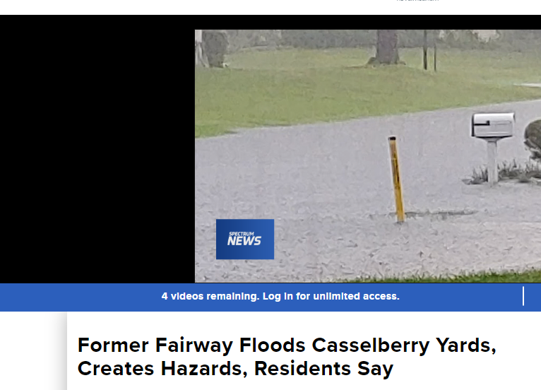
View the newstory yourself at the URL below:
https://www.mynews13.com/fl/orlando/news/2019/08/16/former-fairway-floods-casselberry-yards--creates-hazards--residents-say

