
US-Spaceplanesystems.com

The SUV is:
- Responsive to changing mission requirements
- Upgrades quickly at low cost
- Can be used manned or unmanned
- Variable sizes based on mission

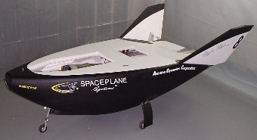

UAV/Orbital SUV

US-Spaceplane systems
can ensure the Nation’s commercial
ability to :
- Maintain access to space
- Use space for U.S. national and homeland security
- Support the War Fighter
- Support civil, scientific, and commercial purposes

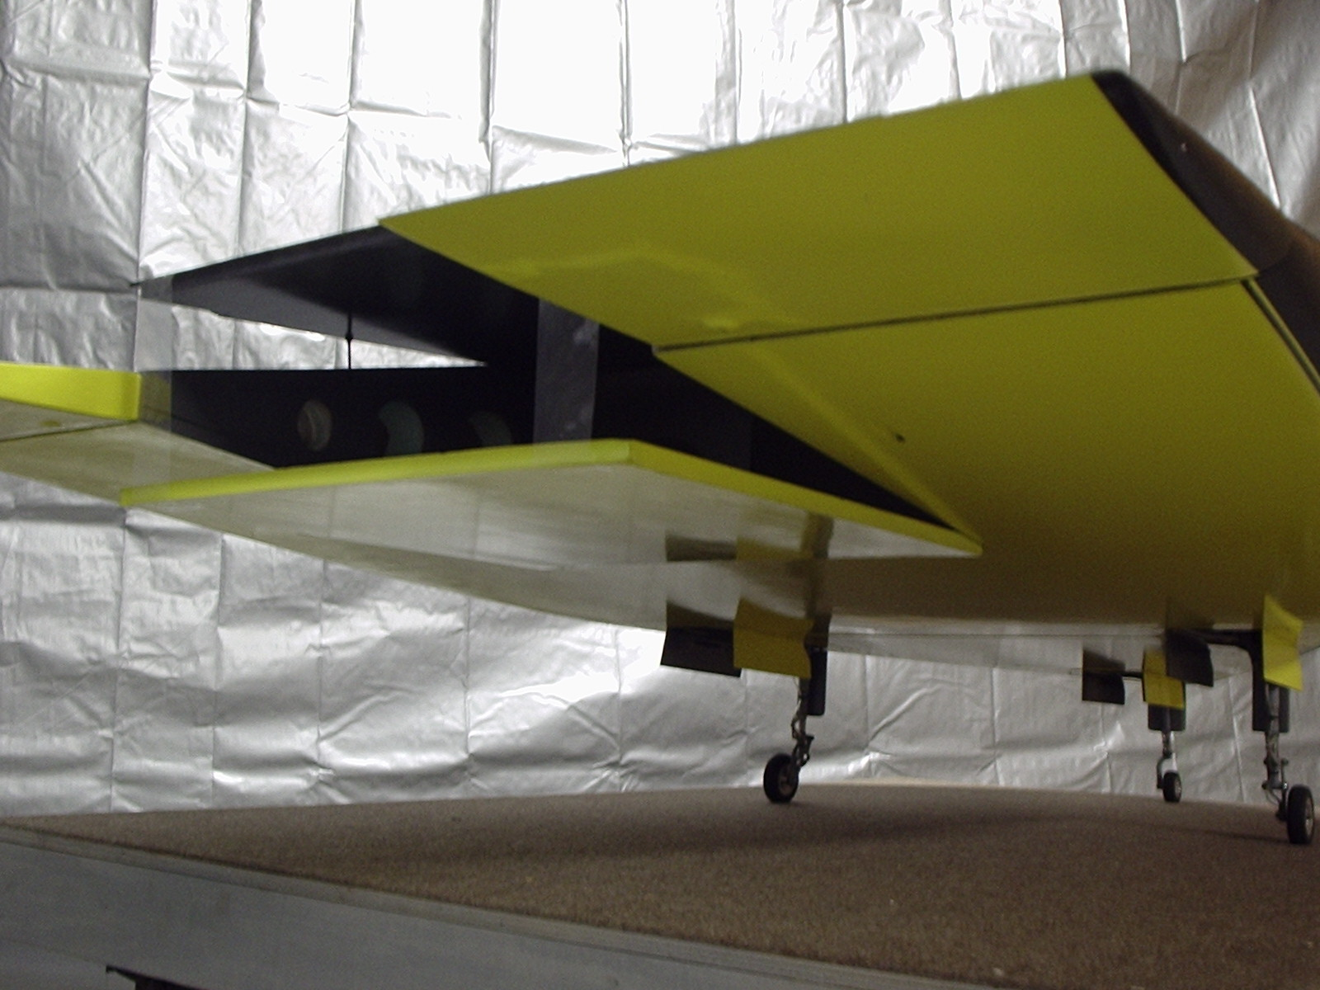

Carrier STV (Sub Orbital Transport Vehicle)

An enabling technology for sustain is to use a “duel” air vehicle system!
A Space Utility Vehicle for orbital access, and a large Intercontinental Sub-Orbital Transport space plane
For supporting
War Fighters and for
Homeland Defense

The Space Utility Vehicle (SUV) is a product derived from an advanced lifting body technology with remarkable capabilities.

Two basic configurations are:
- Orbital SUV for Low Earth Orbit manned and unmanned missions (Orbital and Sub-Orbital)
- Carrier STV (ie. Mother ship) for launch of Orbital SUV, other payloads, and sub-orbital intercontinental troop/cargo transportation

The US needs commercially provided, low cost, reliable support for all air/space operations

The three configurations of the SUV supports:
- ICBM long range planning
- Rapid response anywhere in the world
- Manned and unmanned training in space
- Space situational awareness for the war fighter/homeland security
- Real time reconnaissance for the war fighter/homeland security

The Technology is fully adaptable and up-gradable: with regards to internal components and sub systems

The Technology can support multiple military rolls: From main battle groups to stealth and “covert operations”.

US-Spaceplanesystems.com

Typical Uses of an SUV:

Orbital version
- Real-Time stealth global reconnaissance
- Manned and unmanned LEO and sub-orbital missions
- War-Fighter space based training
- On orbit satellite repair
- Reusable and retrievable platform for satellites

Carrier Version
- Deliver Orbital SUV to LEO
- Deliver personnel, cargo, or munitions half way around the globe in less than 2 hours

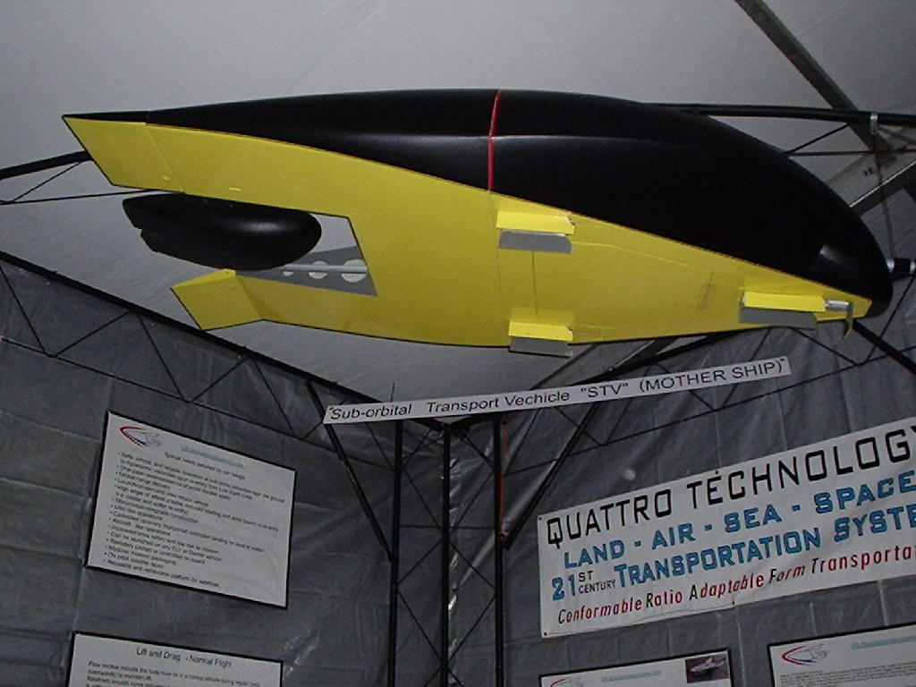

STA- Global flyer (Mother Ship)

Special needs satisfied by our design include:
- Safe, simple, and reliable operation at sub-sonic velocities
near the ground to hypersonic velocities upon re-entry
from Low Earth Orbit
- Innovative design that maintains a low risk to crew
and mission
- Can be launched on any ELV or Carrier STV
- Remotely piloted
- Modular design allows for quick response to future
requirements and modifications

our business strategy would include:

International cooperation and
requirement driven technology investment
- Use of existing technology and contracts with expert
companies and experienced consultants will improve
performance and reliability while reducing the cost of
maintaining outdated hardware and feeding a
“standing army”
- Lease or buy options allow for reduced cost acquisition
for the government, commercial, international, or
scientific enterprises
- Allows the government to focus on performance
capabilities not maintaining national assets
- Fosters competition (we provide complete or partial
systems to any buyer)
- Our “Building Block” strategy provides for a usable
system in the future regardless of program changes or
cancellations
- Low cost and low schedule risk for new and modified
vehicles
- Allows for new technology to be implemented down
stream

Typical customers include:
- NASA (Manned/Unmanned LEO requirements)
- DOD (Reconnaissance, Delivery of payload/missile
from CONUS location to anywhere on the globe in less
than 2 hours)
- International space programs
- Commercial space efforts
- Scientific/University programs

Appendix A

Orbital/Sub Orbital Applications

Option A
Option B

Orbital /Sub-Orbital SUV:
- Sub-Orbital and LEO options
- Manned or unmanned
- Remote controlled or piloted

Option A:
- Sub Orbital to any spot on the Globe
- Sub Orbital once-around; return to initial launch site
- Can be launched by ELV or Carrier STV

Option B:
- Low Earth Orbit
- Can be launched by ELV or Carrier STV

Appendix B

Carrier Applications

Carrier STV:
- Sub-Orbital flights only
- Carry and launch mid-air Orbital SUV or other payloads
- Transport people and cargo half way around the world in less than 2 hours
- Take off and land horizontally

