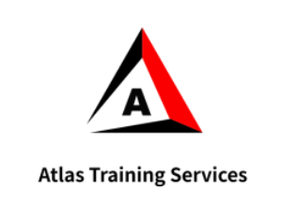 | ATLAS TRAINING SERVICES
 | Safety Observation Card

Safety Observation Card
Name
Date & Location

Check One Box:
Safe act
Unsafe act
Unsafe condition
Description of what you Observed:
Action You Took to Eliminate the Risk:
Safety follow up Suggestion:

