King County Landmark Registration Form

1. Name of Property
historic name: | Mill Creek Historic Residential District
other names/site number: |  | King County HRI#:

2. Location
street & number: |  |  | See Attachment A & Attachment B
city, town: |  | Kent
state: | WA |  |  | code: | WA | county: | King | code: |  | 033 |  |  | zip code: |  |  | 98030

3. Classification
Ownership of Property |  |  | Category of Property |  |  | Number of Resources within Property
 | x | private |  |  | building(s) | Contributing |  |  |  | Non-Contributing
 | x | public-local |  | x | district |  | 49 |  |  | 7 | buildings
 |  | public-State |  |  | site |  |  |  |  |  | sites
 |  | public-Federal |  |  | structure |  |  |  |  |  | structures
 |  |  |  |  | object |  |  |  |  |  | objects
 |  |  |  |  |  |  |  |  |  |  | Total

Name of related multiple property listing:  (Enter "N/A" if property is not part of a multiple property listing.) |  | Number of contributing resources previously designated as King County Landmarks:
NA |  |  | 1 (Map #47)

4. Owner of Property
name: | Multiple: See Attachment A - Contributing Properties Master List  See Attachment B - Non-Contributing Properties Master List
street & number
city, town: |  |  |  | state: |  | zip:

5. Form Prepared By
name/title: | Mimi Sheridan [edited by King County HPO]
organization: |  | King County Landmarks & Heritage Program |  | date: | August 2014
street & number: |  |  | 201 S. Jackson St., Seattle, WA 98104 | telephone: |  | 206-477-4528

6. Function or Use
Historic Functions (enter from instructions) |  |  | Current Functions (enter from instructions)
Domestic |  | Domestic
 |  | Museum

7. Description
Architectural Classification  (enter from instructions) | Materials  (enter categories from instructions)
Residential Vernacular; Craftsman; Workers Foursquare: Tudor; Minimal Traditional; | foundation: |  | concrete; concrete block; post & pier
Ranch | walls: | horizontal wood siding; wood shingle; vertical wood; T1-11; asbestos shingle; stucco; Roman brick; cast stone; Hardiplank
 | roof: | Composition shingle; wood; metal

Describe the present and historic physical appearance of the property on one or more continuation sheets.
SEE CONTINUATION SHEETS / CONTRIBUTING PROPERTIES LIST

8. Statement of Significance
Applicable Designation Criteria
 | A1 | Property is associated with events that have
 |  | made a significant contribution to the broad patterns of national, state, or local history.
 | A2 | Property is associated with the lives of
 |  | person significant in national, state, or local history.
X | A3 | Property embodies the distinctive
 |  | characteristics of a type, period, style, or method of design or construction or represents a significant and distinguishable entity whose components lack individual distinction.
 | A4 | Property has yielded, or is likely to yield,
 |  | information important in prehistory or history
 | A5 | Property is an outstanding work of a
 |  | designer or builder who has made a substantial contribution to the art.

Criteria Considerations
(Mark "x" in all the boxes that apply.)
Property is:
a cemetery, birthplace, or grave
owned by a religious institution/used for religious purposes
moved from its original location.
a reconstructed historic building
a commemorative property
less than 40 years old or achieving significance within the last 40 years

Areas of Significance
(Enter categories from instructions)
Architecture
Social History
Significant Person
(Complete if Criterion A2 is marked above)
N/A
Architect/Builder
N/A

Period of Significance: |  | Significant Dates:
1904 - 1962

Cultural Affiliation

State significance of property, and justify criteria, criteria considerations, and areas and periods of significance noted above on one or more continuation sheets. SEE CONTINUATION SHEETS / CONTRIBUTING PROPERTIES LIST

9. Major Bibliographical References
Bibliography
(Cite the books, articles, and other sources used in preparing this form on one or more continuation sheets)

Previous documentation on file: |  |  | Primary location of additional data:
 | x | included in King County Historic Resource Inventory #: |  |  | State Historic Preservation Office
 | x | previously designated a King County Landmark #47 |  |  | Other State agency
 |  | previously designated a Community Landmark |  |  | Federal agency
 |  | listed in Washington State Register of Historic Places |  | X | Local government
 |  | preliminary determination of individual listing |  |  | University
 |  | (36 CFR 67) has been requested |  | x | Other (specify repository)
 |  | previously listed in the National Register |  | King County Landmarks & Heritage Program
 |  | previously determined eligible by the National Register
 |  | designated a National Historic Landmark
 |  | recorded by Historic American Buildings, Survey #:
 |  | recorded by Historic American Engineering, Rec. #:

10. Geographical Data
Acreage of Property: |  | N.A.
Quadrangle Name: | Renton |  | Quadrangle Scale: | 1:24,000
Verbal Boundary Description
See Continuation Sheet (page 47)
Boundary Justification

7. Historic District Physical Description

The historic district is a subarea of the Mill Creek neighborhood, located east of downtown Kent, on the edge of East Hill. The historic district consists of approximately five blocks. Its boundaries are irregular, but lie generally between Hazel Avenue N. and the alley west of Clark Avenue N., and from E. Temperance Street to Cedar Street. In addition, most of the large block between Jason and Hazel avenues, south of E. Temperance Street to E. Smith Street/E. Canyon Drive, plus some nearby parcels, is included. (See attached map.)

West of the historic district is the large property occupied by Mill Creek Middle School; Central Avenue and downtown Kent are just west of the school. The Mill Creek neighborhood and its grid pattern continue for two blocks north of the boundary at Cedar Street; beyond this is a large undeveloped area owned by the City of Kent. James Street, a busy arterial, leading to the East Hill, is one block north of the district boundary. At the south edge of the district is Canyon Road, an arterial providing the primary access to the East Hill. Across the street is Mill Creek Canyon Earthworks Park, with the stream called Mill Creek. East of the historic district, the hill becomes steeper, with houses built along curving streets rather than in the grid pattern found in the older part of the neighborhood.

The historic district is comprised primarily of portions of two of Kent's early plats: most of the southern half of Clark's First Addition and the central section of Clark's Second Addition. William and Laura Clark filed the plat for Clark's First Addition to the Town of Kent in April 1890. It consists of four blocks in a grid pattern, running from James Street on the north to Temperance Street, and from Jason Street east to Hazel Street. It is bisected by Prospect and Cedar streets. Each block had 26 lots, with a north-south alley. The lots were 30 feet wide and 110 feet deep; because of the narrowness of the lots, many houses sit on more than one lot.

Clark's Second Addition to the Town of Kent was filed in May 1907 by I. C. and Grace Clark and H. L. and Norma Clark. It is located immediately adjacent to the west side of the First Addition. It also has a grid pattern with six blocks, but extends one block farther south, from James Street to Smith Street, and from Jason Street west to Kennebeck Avenue. It is bisected by Cedar and Temperance streets (east-west) and Clark Street (north-south). The lots were considerably larger than in the original plat. Each block had only 12 lots, typically measuring 60 feet wide and approximately 115 feet deep. Lot son the north side of E. Temperance street are 90 feet wide. Block 5, at the southwest corner of the plat, has eight lots, mostly measuring 62 by 120 feet, oriented north-south. The southeastern block evidently already had some houses on it and was divided into larger parcels rather than small lots.

Landscape Character

The district is on the west slope of the east hill, so it slopes down toward the west. The east-west streets ascend the hill. Most houses front on to the north-south streets, which are relatively flat. Because of the topography, houses on the east side of the street typically are set above the street, with a rockery or retaining wall (of concrete or concrete block) in front. West side houses are at grade level or, in some cases, below street grade.
The streets are relatively narrow and paved with asphalt. The strips flanking the paved roadway vary in character from block to block and, sometimes, from house to house. These strips are most typically used for parking. Most have gravel or bare dirt; some have lawn or asphalt. The few sidewalks are narrow and non-continuous.

Most houses have a front lawn and foundation shrubs; many have larger shrubs and small trees extending to the front of the lot as well. Fences in front are atypical, although some houses have picket fences. Many, but not all, rear yards have wood fences. Front and side yards are relatively narrow and the larger space is in the rear; however, some houses sit on double lots (or larger) with spacious side yards. The large trees are usually in the rear or side yards, framing the house, rather than being in front. Many houses have detached garage at the rear. Sheds and even accessory dwellings are also found at the rear.

Land Uses and Activities

The historic district is entirely residential. However, the Bereiter house, at the south edge of the district, is now owned by the City of Kent and used as museum.

Buildings and Structures

The buildings within the Mill Creek Historic Residential District date from the early to mid 20th century and reflect three periods of development: Dairy Production (1890s-1920s); Truck Farming (1920s-1940s); and the beginning of Industrialization ( 1950s-1960s). The contributing properties are generally modest in design and reflect the variety of styles and forms that were popular in the first half of the 20th century.

Residential Character

Contributing houses in the district were built between 1904 through 1959. One house dates to 1903, but it has been significantly altered and is not a contributing property. The only newer residence is a house E. Jason Street built in 1993. None of the residences in the historic district are known to have been designed by architects. Most are vernacular in character and may have been based on plans acquired from popular standardized builders’ house plan catalogs. Although many of the houses have been modified, as a group they retain a strong historic character.

All of the housing stock within the district appears to be conventional wood-frame construction. In scale, the homes vary from simple, one-story or 1-1/2 story cottages to spacious two-story dwellings. Most have gabled roofs, with some hipped roofs on smaller houses. Some older ones have front porches, but often there is instead a concrete stoop sheltered by a gabled hood. Various types of wood cladding (narrow or wide clapboard, shingles, vertical boards) are almost universal, with minimal use of brick, stone or stucco accents. Brick veneer is found on some of the Minimal Traditional and Ranch houses from the 1940-50s.

The majority of the buildings (especially the older ones) have been altered in some way. The most common alteration is roofing, as most of the original wood shingle roofs have been replaced with asphalt/composition shingles or a similar material. Some dwellings have replacement cladding, notably asbestos shingles. Many dwellings have had some or all of the original windows replaced with aluminum or vinyl sash; in most cases, the original openings remain. Replacing original tripartite windows on the main facade with picture windows is common. Another frequent change is the replacement of front doors or garage doors, typically with no change to the opening. In some cases, the original front porch has been removed or altered. Rear additions are also common, but they do not affect the character of the houses. Some of the older residences were modified significantly in the 1940s-50s and exhibit features characteristic of that period rather than when they were built.

Examples of the architectural styles and forms represented in the historic district include:

Craftsman

Murker House, 617 E. Temperance Street (1909)

Barton House, 701 E. Temperance Street (1909)

Kendall House, 426 Jason Avenue N. (1911)

E. Reed House, 512 Jason Avenue N. (1911)

John Reed House, 431 Clark Avenue N. (1914)

Robert E. Young House, 526 Prospect Avenue N. (1916)

Workingman's Foursquare

Churchill House, 438 Clark Avenue N. (1909)

Dunbar House, 412 Clark Ave N. (1908)

Berg House, 347 Hazel Avenue N. (1910)

Vernacular

W.W. Young House, 438 Prospect Ave. N. (1906)

George Berlin House, 833 E. Smith Street (1909)

Anderson House, 414 Jason Avenue N. (1910)

Calhoun House, 431 Prospect Ave N. (1910)

Anna Pays House, 425 Clark Avenue N. (1930)

S. A. Matson House, 404 Prospect Avenue N. (1937)

Minimal Traditional

Hirfeman House, 314 Jason Avenue N. (1944)

Henning House, 808 E. Temperance Street (1942)

Unk House #3, 415 Hazel Avenue N. (1954)

Ranch

Knapstad House, 704 E. Temperance Street (1947)

Bargo House, 432 Clark Avenue N. (1950)

Williams House, 431 Hazel Avenue N, (1958)

Refer to the CONTRIBUTING PROPERTIES LIST for property descriptions for each of the contributing properties located within the Mill Creek Historic District.

- Statement of Significance

The Mill Creek Historic Residential District is significant under Criterion A3 of King County Code 20.62 (adopted by reference in Kent City Code chapter 14.12) as a well-preserved concentration of historic dwellings that reflect the growth and development of the city during the first half of the 20th century. Because of its proximity to downtown Kent, many of the town's leading citizens built residences here and lived here, so it is directly associated with the community's social and commercial development

The district’s historic period of significance extends from 1903, the construction date of the oldest house in the district, to 1962, the date when the Howard A. Hanson Dam was completed. This event began the transformation of the valley from agricultural use to large scale commercial/industrial uses.

Kent Historic Overview

The physical development of the City of Kent was shaped most significantly by changing agriculture products and the methods to process and ship those products. From its initial development by homesteaders in the 1860s and 1870s, to boom periods of hops production (1880s), dairy production (1900s-1920s), and truck farming (1920s-1940s), the city served as the primary location for farmers and producers to conduct their commercial and social activities. Subsequent development as an industrial center occurred largely because of its location in a broad flat valley with access to various modes of transportation.

The Rivers

The river system of the White River Valley was vital to natives and their lifestyle and, subsequently, to early white settlement and agriculture. The significant modifications in these rivers in the first half of the 20th century reflect the social, economic and natural developments of the period. The valley once had a complex of several rivers, dominated by the White River. The White River joined with the Green River to form a short stream, the Black River, near Lake Washington. Farther north, the White and the Green became the larger Duwamish River, flowing into Elliott Bay. The regular flooding of these rivers not only provided fertile farmland but also prevented large-scale development.

A major flood in 1906 changed the course of the White River, directing it south toward the Puyallup River and relieving some of the flooding in the valley. After this, the Green River was dominant, although the name "White River Valley" continued to be used. The opening of the Chittenden Locks in 1916 lowered the level of Lake Washington, eliminating the Black River in Renton. During the same period, the Port of Seattle straightened the meandering Duwamish River in Seattle, encouraging industrial development along its banks. The Green River continued to flood until the construction of the Howard A. Hanson Dam in 1962. This storage dam controlled flooding and allowed development that led to the transformation of the valley from agriculture to industrial and warehouse use.

Native Peoples

This valley was occupied by several native groups, ancestors of the present-day Muckleshoot tribe. Several native villages sat along the White River with Kent's current city limits. Families lived together in cedar longhouses during the winter. Summers were a time to travel throughout the area to hunt, fish and gather berries and other plants that would allow them to survive through the year. The river system allowed people to easily travel to through the region and to Puget Sound, gathering foodstuffs and forming relationships with other native groups.

Early Euro-American Settlement (1850s-70s)

The Donation Land Claim Act of 1850 drew settlers to the Oregon Territory. Flat, fertile bottom land was the most highly prized, and the White River Valley was the most desirable and quickly claimed. Settlers immediately cleared land for planting and built log cabins. Settlers came to the White River Valley, attracted by the fertile soil and availability of river transportation. As the number of settlers increased, farms began to impinge on villages, traditional fishing places and the land used by natives for food gathering.

Tension between the settlers and the natives developed gradually. Governor Isaac Stevens initiated treaty negotiations in an attempt to control the Indians and extinguish their title to the land. This increased the distrust and resentment. In October 1855, violence erupted in the White River settlement of Auburn, where several pioneer families were attacked. The "White River Massacre," as it was termed, sent settlers fleeing to Seattle for safety. In January 1856, a group of several tribes attacked Seattle itself, but the presence of the U.S. warship Decatur prevented significant damage. However, more than 60 people, native and white, died in the months of conflict.

In 1857, the White River tribes ratified the treaties presented by the U.S. government. Those from the lower part of the river were sent to the Suquamish Reservation at Port Madison, across Puget Sound. People from the upper valley went to the Muckleshoot Reservation near Auburn; these tribes became known as the Muckleshoot Tribe.

Half of the White River Valley settlers sold their claims; many others stayed away for a year or two before returning to their homes. However, many families eventually returned to farming, or sold their claims to people who established their own farms. By 1870, all the best bottomland had been claimed. Activity focused on the river, which was the primary transportation artery. Early settlers operated ferries to cross the river, and established landings to accommodate the sternwheelers going to Seattle. Although a rough military road was surveyed in the late 1850s, the construction of usable roads took many years.

It was during this period that the first settlers in the Mill Creek neighborhood arrived. James W. Clark and his wife Laura came to Kent from Indiana in 1865. Their first cabin was near the present intersection of Central Avenue and James Street, just west of the historic district. Their three sons (Jason, David and James Irving) purchased land nearby.

The river settlement now known as Kent was briefly called as Yesler, since Seattle resident Henry Yesler owned property nearby. However, it later acquired the name Titusville for James Henry Titus, whose claim included a commercial center with a store, a post office and a hotel.

Hops Production (1880s)

The first commercial crops were potatoes, onions and fruit. Land was continually cleared, increasing the amount of land for crops, orchards and pasture. Soon, milk, butter, eggs, beef and pork were being shipped to Seattle by steamboat. Logging was another important industry, with the opening of the Kent Mill Company in 1881. This company, which logged off the East Hill, was located on the stream above what is now Earthworks Park just south of the Mill Creek neighborhood. Logging was a significant industry into the 1920s.

The scale of agriculture changed in the late 1870s, when local farmers began planting hops, a plant used to flavor beer. Hops were relatively easy to grow and proved well suited to the climate. White River Valley hops were shipped to brewers across the county and even to Europe. It was a high value crop, commanding premium prices, and brought considerable wealth to the valley. Land values increased and more land was cleared. Picking was done primarily by Native Americans, who gathered from throughout the region during harvest season. It was during this period, in 1889, that the name was changed from Titusville to Kent, recalling the County of Kent, one of England's primary hop-growing regions. The boom brought great wealth but was short-lived; in 1892, an infestation of the hop louse quickly destroyed the crops and ended the boom. Many properties went into foreclosure.

Railroad service began in 1883 with the arrival of the Great Northern Railway. However, this lasted only a month. It was not until 1886 that the valley got regular train service to Seattle. With this, settlement began to turn away from the river, with stores and other facilities being located closer to the railroad tracks.

The first plat in Kent was filed in July 1888 by John Alexander and Ida Guiberson, with more additions soon afterwards. Kent was incorporated in 1890, only the second city in King County to do so; its population was 793.

Dairy Production (1890s-1920s)

After the hops failure, many land owners turned to dairy production, producing milk for the rapidly-growing Seattle-Tacoma population. Demand increased dramatically with the opening of the Pacific Coast Condensed Milk Company in 1899. This plant shipped condensed milk across the world. The company became the Carnation Milk Company in 1916 and moved production to the town of Tolt, which was re-named Carnation, although the Kent plant continued to produce cans.

Particularly important to the success of the dairy industry was the initiation of the Puget Sound Electric Railway in 1902. This line provided frequent, efficient service to Seattle and Tacoma, taking both passengers and freight. It enabled milk producers to get their highly perishable products to market safely and quickly. Automobiles were beginning to be popular and, accordingly, road construction increased. The first long-distance road in the vicinity was the West Valley Highway (1912), which became part of the Pacific Highway in 1915. In the 1920s, this road would extend from the Canadian border at Blaine to the Mexican border.

The U. S. Census recorded 853 people in Kent in 1890; by the turn of the century, the population had fallen to 755. However, after that it increased to 1,908 in 1910. Nearly half of the properties in the historic district were built between 1903 and 1916; only one house dates from the 1920s.

Truck Farming (1920s-40s)

By the 1920s, the population of the Seattle-Tacoma area had grown significantly and truck farming became increasingly profitable. Efficient railroad and sea connections meant that agriculture products could be shipped across the county and even overseas. The White River valley produced a large proportion of western Washington's milk and produce. Kent came to be known as the "Lettuce Capital of World," but it also shipped many other vegetables, berries and fruit. Dairies and poultry farms continued to thrive. Products that were not fresh went to the local canneries.

Japanese immigrants were a vital element of the White River Valley--both as part of the agricultural economy and as participants in the social and commercial life of the community. By 1930, about 200 Japanese families were farming in the valley. They also operated stores and processing plants. The Anti-Alien Law, passed in 1923, prohibited Japanese immigrants from owning land, so they had to either lease land or, if they had an American-born child, put land in their name. The community suffered a significant blow in 1942, when all Japanese, including those who were born in this country, were sent to internment camps. This left a severe shortage of labor to plant, harvest and process crops, and changed the valley permanently. Relatively few Japanese families returned after the war, as much of their land was redistributed to other farmers.

Industrialization (1950s - 1980s)

The transformation of the valley into an industrial and warehousing district began in 1962. Damming the upper reaches of the Green River to control flooding had long been proposed. Active work on the project finally began in the 1950s, and in 1962, the U.S. Army Corps of Engineers completed the Howard A. Hanson Dam. This storage dam prevented major flooding, enabling uses other than farming to take advantage of the flat terrain. In anticipation of this change, the City of Kent annexed surrounding land, growing from one square mile in 1953 to 12.7 miles in 1960. The first major plant in Kent was the Boeing Aerospace Center, which opened in 1965. Other plants came soon afterwards. These changes were accompanied by the construction of major freeways, including I-5 on the west side of the valley (1966), I-405 (1967) and the Valley Freeway (1969), which tied Kent directly to Seattle. Nearby, the Seattle-Tacoma International Airport expanded as well. With these transportation improvements, the entire valley , including the Kent vicinity became a distribution hub with large warehouse complexes covering the farmland.

Accompanying the new jobs and increased access were residential developments, many of which were on the hills surrounding the industrialized valley floor. The city also continued to annex nearby communities. After the war, in 1950, Kent's population was 3,278. It began to grow rapidly thereafter, reaching 9,017 in 1960 and 16,275 in 1970. By 1980, the city had 21,152 residents.

CONTRIBUTING PROPERTIES LIST AND HISTORIC DISTRICT MAP

The following section contains a brief Property Description for each of the Contributing Properties within the historic district. They are shown on the attached Mill Creek Historic Residential District Map. Contributing properties are those directly associated with the historic period (1904 through 1962) and which continue to exhibit good integrity of design, materials, association, setting, feeling, and location. Specific aspects of physical integrity used to evaluate property include overall massing, roof configuration, porch configuration, exterior cladding, fenestration and sash.

The historic district has a total of 56 properties. All are privately-owned residences. with the exception of the Bereiter House, which is currently used a museum and is owned by the City of Kent. Of these 56 properties, 49 are Contributing Properties. The other seven are Non-Contributing Properties, either because they were built after 1962 or because they have been substantially altered and do not possess sufficient historic or physical integrity. For all properties, the significant feature is the exterior of the house, unless otherwise specified.

HRI#: MAP#: 1
Address: 431 Clark Avenue N.

Historic Name: John Reed House
Common Name:
Legal Description: Clarks 2nd Add. to Kent, Block 4 Lots 11-12 Parcel #161250-0260
Date built: 1914

Property Description: This 1-1/2 story Craftsman bungalow has a shallow-pitched front gable roof with brackets and a shed dormer on the main facade. It has a full-width porch with four paired columns; a ramp has been added to access the porch. Another entry, at the north end of the east facade, has a small projecting porch with a gabled roof supported by two posts. Newer wood stairs with a wood railing descend to the south. Cladding is combed shingles. Windows have vinyl sash with a Craftsman-style pattern set in wide wood surrounds. The first floor of the east facade has two pairs of windows and a single one at the north end, and a pair of windows in the gable end. The south facade has two large windows on the first floor and a group of four windows in the dormer. A large deck with wood railing is attached to the rear of the house.

This house was built by John Reed, a carpenter who also worked on the Bereiter House.

Current Photograph:
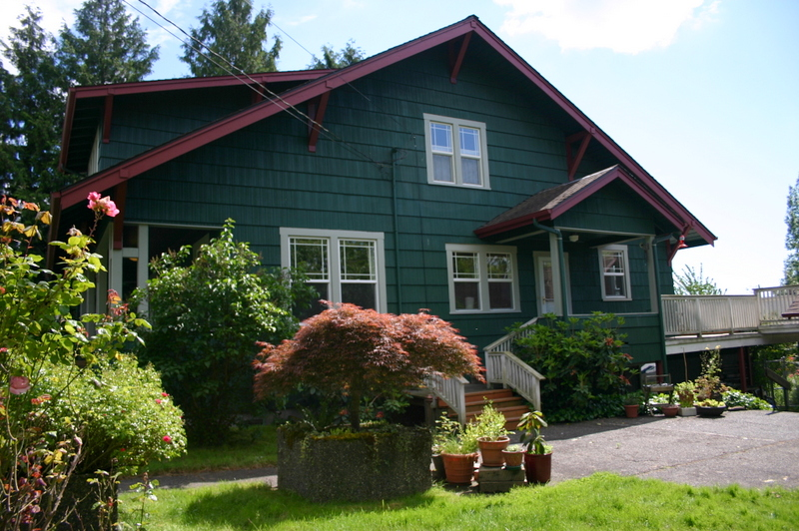

HRI#: MAP#: 2
Address: 425 Clark Avenue N.

Historic Name: Anna Pays House
Common Name:
Legal Description: Clarks 2nd Add. to Kent, Block 4 Lots 9-10 Parcel #161250-0250
Date built: 1930

Property Description: This 1-1/2 story vernacular house lot sits on a mid-block lot with lawn, foundation shrubs and a picket fence along the front. The house has a clipped cross gable roof with a front gable that is not clipped. The enclosed eaves have returns. The entry, near the center is within a small gabled enclosure. Windows have wide wood surrounds and newer vinyl sash; the openings do not appear to have been modified.. There is a square hanging bay with a gabled roof on the south side.

Assessor’s records indicate that the first owner of the house was probably Anna E. Pays. In the 1950s, it was owned by Joanne and Tom Stafford; Tom worked at Boeing and later at Kent Hardware.

Current Photograph:
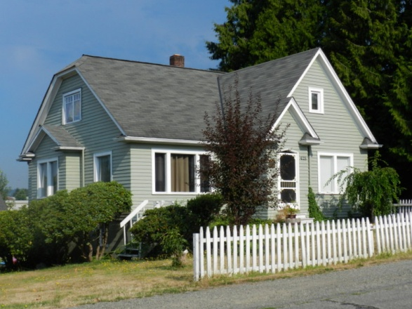

HRI#: MAP#: 5
Address: 438 Clark Avenue N.

Historic Name: Churchill House
Common Name:
Legal Description: Clarks 2nd Add. to Kent, Block 3, Lot 12 Parcel #161250-0135
Date built: 1909

Property Description: This 1-1/2 story Workers Foursquare house

Mrs. Churchill, founder of the first Kent Garden Club lived here, holding meetings in her home. In 1940s, Charles, Jr., and Doris Becvar lived here. Their sons developed Kent's first airport.

Current Photograph: (tax assessor photo)

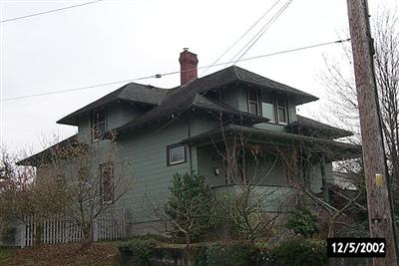

HRI#: MAP#: 6
Address: 432 Clark Avenue N.

Historic Name: Bargo House
Common Name:
Legal Description: Clarks 2nd Add. to Kent, Block 3, Lot 2 Parcel #161250-0140
Date built: 1950

Property Description: This Ranch house was moved here from Central Avenue in 1950.

Current Photograph:

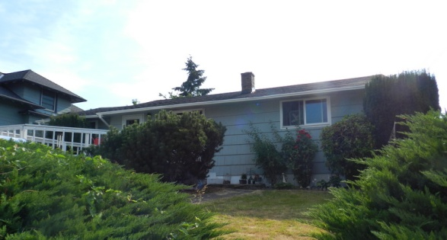

HRI#: MAP#: 7
Address: 426 Clark Avenue N.

Historic Name: Schaley House
Common Name:
Legal Description: Clarks 2nd Add. to Kent, Block 3, Lot 3 Parcel #161250-0145
Date built: 1912; altered c. 1950

Property Description: This Craftsman bungalow was altered in the 1950s with a remodeled porch, replacement cladding and removal of the original deep eaves.

In the 1940s-50s, Mrs. Grimes, a widow, and her daughters Judy and Maxine, lived here.

Current Photograph:

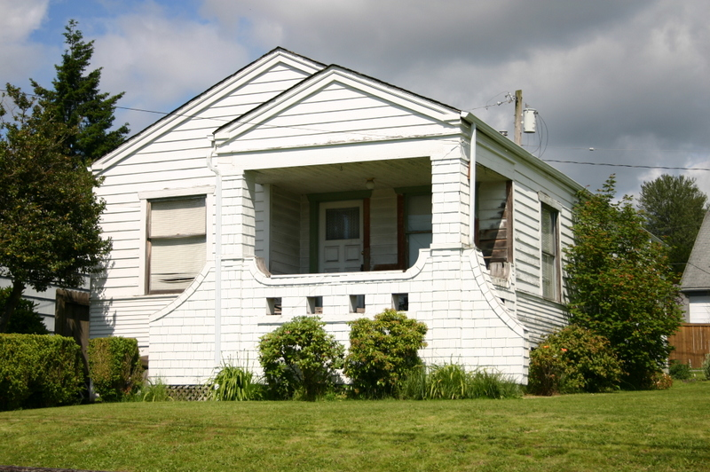

HRI#: MAP#: 8
Address: 424 Clark Avenue N.

Historic Name: Scott House
Common Name:
Legal Description: Clarks 2nd Add. to Kent, Block 3 Lot 4 Parcel #161250-0150
Date built: 1954

Property Description: Ranch

Current Photograph:
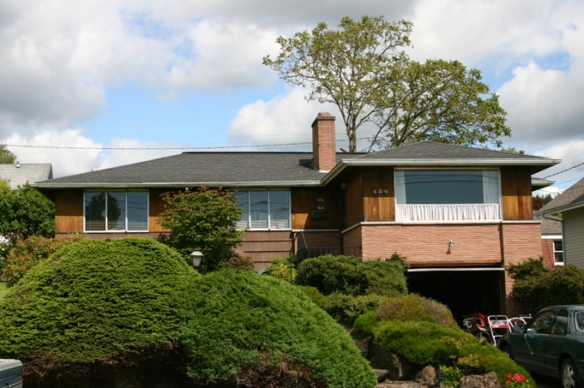

HRI#: MAP#: 9
Address: 420 Clark Avenue N.

Historic Name: Neibling House
Common Name:
Legal Description: Clarks 2nd Add. to Kent, Block 3 Lot 5 Parcel #161250-0155
Date built: 1919

Property Description: Craftsman bungalow

The Neiblings owned a five-and-dime store in downtown Kent.

Current Photograph:

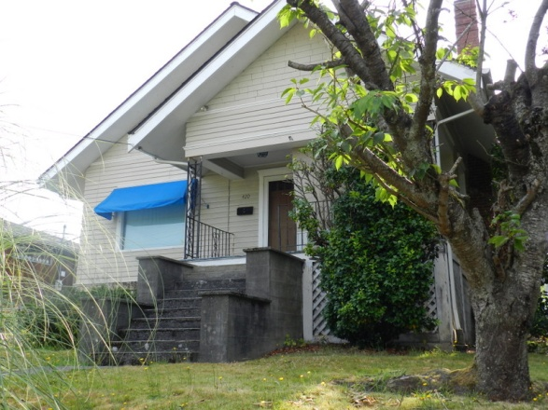

HRI#: MAP#: 10
Address: 412 Clark Avenue N.

Historic Name: Dunbar House
Common Name:
Legal Description: Clarks 2nd Add. to Kent, Block 3 Lot 6 Parcel #161250-0160
Date built: 1908

Property Description: This 1-1/2 story Craftsman-influenced Workers Foursquare house
sits on a corner lot with lawn and numerous shrubs and large mature trees. The house has a hip roof with a hip dormer on the front and smaller hip dormers on the sides. The wide eaves have exposed rafter tails with decorative rounded ends. The recessed full-width front porch has square wood columns. The entire building is clad in concrete asbestos shingles. Windows are simply framed and are mostly single hung vinyl windows, except the front first floor windows and a large side window still retain the original leaded transoms. There is a garage in the basement on the Temperance Street side.

Grant Dunbar, who was mayor of Kent from 1943-46, lived here.

Current Photograph:

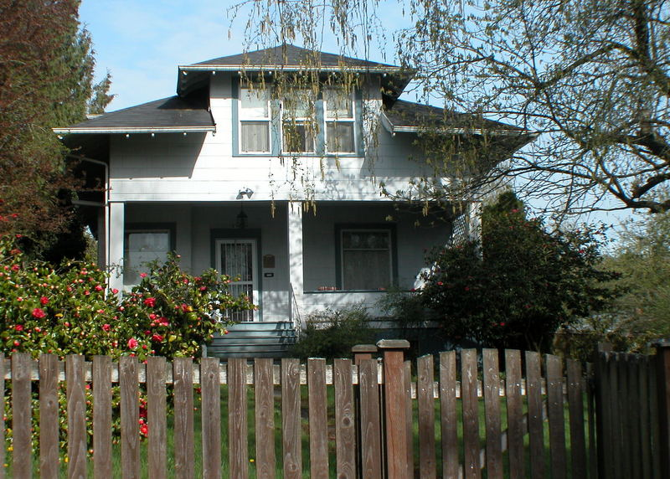

HRI#: MAP#: 11
Address: 604 E. Temperance Street

Historic Name: Erion House
Common Name:
Legal Description: Clarks 2nd Add. to Kent, Block 6 Parcel #161250-0314
Date built: 1951

Property Description: Ranch house

Current Photograph:
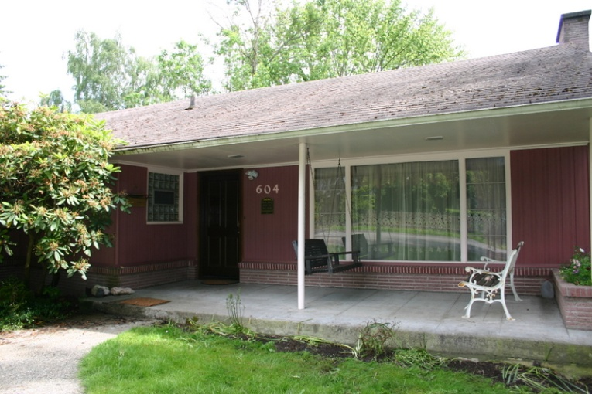

HRI#: MAP#: 12
Address: 509 Jason Avenue N.

Historic Name: Thomas House
Common Name:
Legal Description: Clarks 2nd Add. to Kent, Block 2 Lot 8 Parcel #161250-0110
Date built: 1941

Property Description: Minimal Traditional house

Current Photograph:

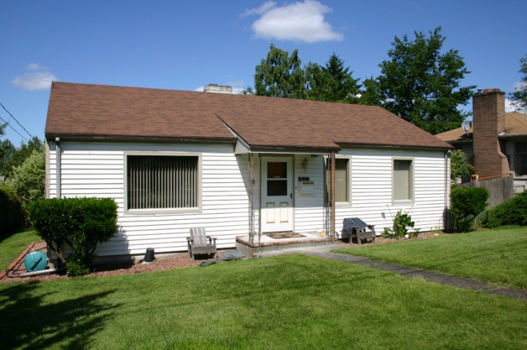

HRI#: MAP#: 13
Address: 501 Jason Avenue N.

Historic Name: Nelson House
Common Name:
Legal Description: Clarks 2nd Add. to Kent, Block 2 Lot Parcel #161250-0105
Date built: 1937

Property Description: This vernacular Tudor house

In the 1940s, Clyde Fox, owner of the Fox grocery store in downtown Kent. lived here.

Current Photograph:

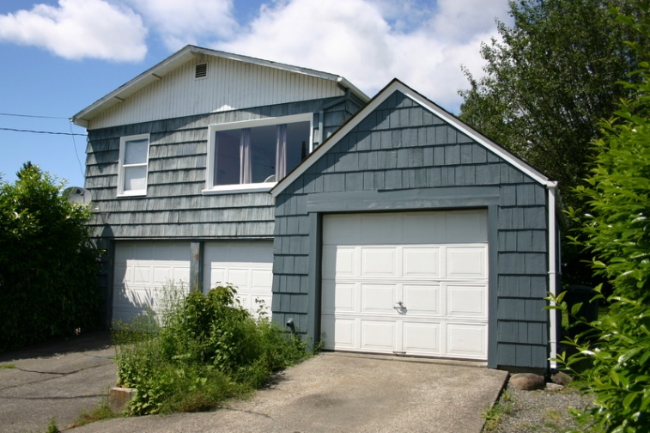

HRI#: MAP#: 14
Address: 437 Jason Avenue N.

Historic Name: Smith House
Common Name:
Legal Description: Clarks 2nd Add. to Kent, Block 2 Lot Parcel #161250-0190
Date built: 1909

Property Description: This vernacular house

Later owners included Frank and June Heutmaker; Frank's brother, Norman, founded Valley Glass in Kent.

Current Photograph:

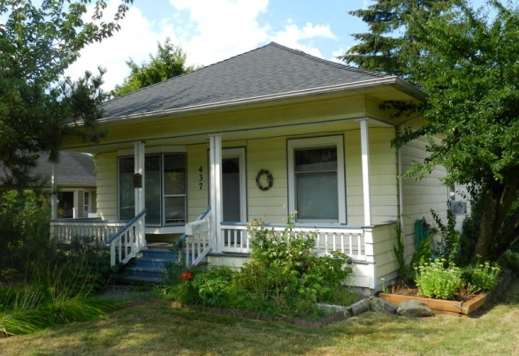

HRI#: MAP#: 15
Address: 429 Jason Avenue N.

Historic Name: Ward Rader House
Common Name:
Legal Description: Clarks 2nd Add. to Kent, Block 2 Lot Parcel #161250-0185
Date built: 1907

Property Description:

Ward Rader owned the Rader Bottling Company at 211 Central Avenue N. It made glass bottles in many shapes and sizes and bottled the popular Raders Root Beer.

Current Photograph:
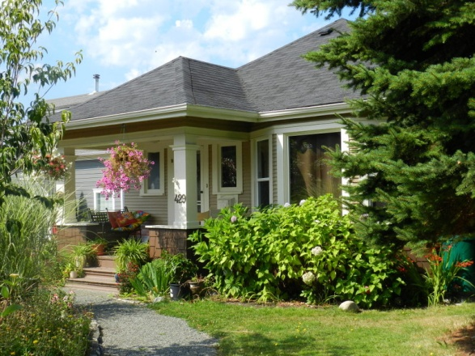

HRI#: MAP#: 16
Address: 425 Jason Avenue N.

Historic Name: William Lee House
Common Name:
Legal Description: Clarks 2nd Add. to Kent, Block 3 Lot 10 Parcel #161250-0180
Date built: 1910

Property Description: Side gable vernacular
porch removed c. 1954

owned by William Lee, Harvey Lee's brother.

Current Photograph:

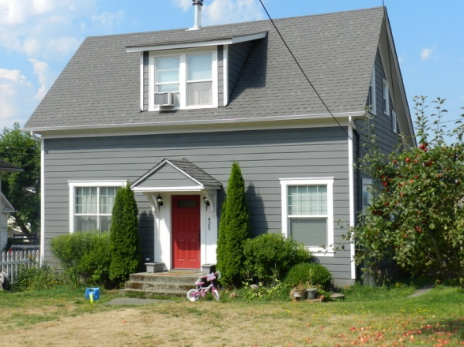

HRI#: MAP#: 17
Address: 419 Jason Avenue N.

Historic Name: Lyons House
Common Name:
Legal Description: Clarks 2nd Add. to Kent, Block 3 Lot Parcel #161250-0175
Date built: 1908

Property Description

Current Photograph:

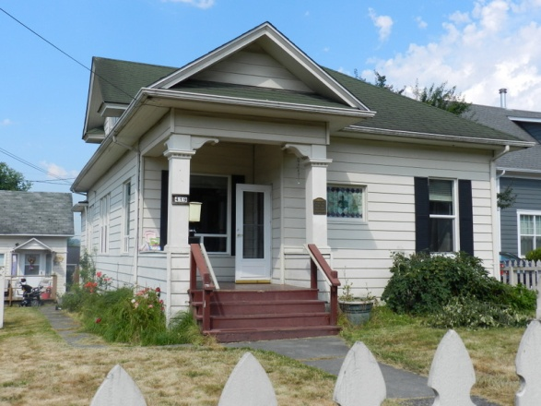

HRI#: MAP#: 18
Address: 411 Jason Avenue N.

Historic Name: H. Lyons House
Common Name:
Legal Description: Clarks 2nd Add. to Kent, Block 3 Lot Parcel #161250-0170
Date built: 1939

Property Description: Minimal Traditional

IN 1940 Allen Playford lived here; he worked for the railroad and his father owned Playford Blacksmith in Kent.

Current Photograph:

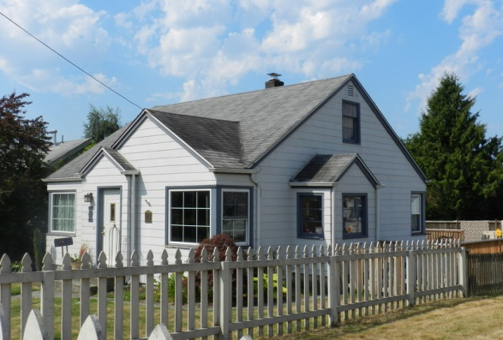

HRI#: MAP#: 19
Address: 617 E. Temperance Street

Historic Name: Murker House
Common Name:
Legal Description: Clarks 2nd Add. to Kent, Block 3 Lot Parcel #161250-0165
Date built: 1909

Property Description: This Craftsman bungalow sits on a level mid-block lot with lawn and shrubs. It has a side gable roof with a large gabled dormer on the main facade. The roof has deep eaves with knee brackets and exposed rafter tails. The recessed full-width porch has four pairs of square wood columns and older . Central front steps lead to a
concrete sidewalk. The entire building is clad in coursed wood shingles. Windows have wood surrounds and are mostly 1/1 vinyl sash. The front gable has a pair of windows and the front porch has two sets of triple windows.

The original owners, the Murker family, owned a store at Meeker and Central in the early 1900s. In the 1940s, Lloyd (Duffy) and Adelaide Armstrong owned the house in the 1940s. Duffy had a beverage distribution company and was involved with the Becvar brothers in developing Kent’s first airport.

Current Photograph:

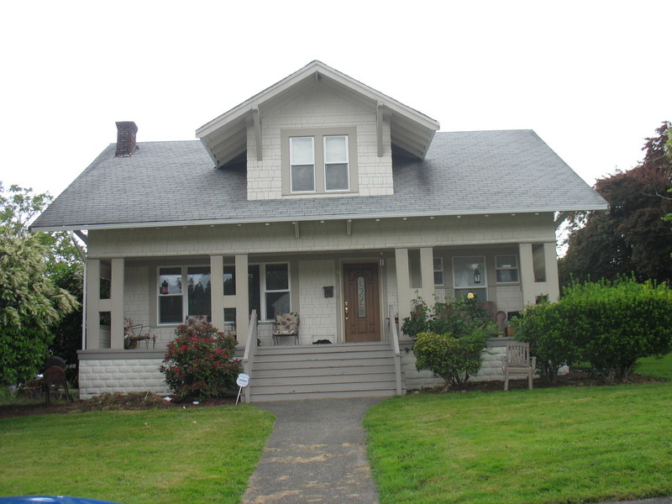

HRI#: MAP#: 20
Address: 512 Jason Avenue N.

Historic Name: E. Reed House
Common Name:
Legal Description: Clarks 2nd Add. to Kent, Block 3 Lot Parcel #161250-0045
Date built: 1911

Property Description: Craftsman bungalow
Current Photograph:

HRI#: MAP#: 22
Address: 436 Jason Avenue N.

Historic Name: Harold & Elizabeth Mergens House
Common Name:
Legal Description: Parcel #161200-0425
Date built: 1941

Property Description: This Colonial Revival Cape Cod style house is sits on a mid-block lot with lawn and numerous ornamental shrubs. It has a side gable roof with a pair of small front gabled dormers with no
eaves. The house has an extended front gable entry and the door is surrounded by wood pilasters and
lintel. An exposed front porch extends from the entry and is bordered by a simple railing and balustrade.
The entire building is clad in wide wood clapboard. Windows are minimally framed and are 6/6 double
hung wood. They are mostly original with the exception of one front window replaced with a fixed frame picture window. The only other modification to the house appears to be a non-original front storm door.

It was built by Harold Mergens and the family moved in on Dec. 6, 1941.

Current Photograph:

HRI#: MAP#: 23
Address: 430 Jason Avenue N.

Historic Name: Lloyd & Imogene (Bush) Ottini House
Common Name:
Legal Description: Parcel #161200-0435
Date built: 1938

Property Description: Minimal Traditional

Current Photograph:

HRI#: MAP#: 24
Address: 426 Jason Avenue N.

Historic Name: Nellie Kendall House
Common Name:
Legal Description: Clarks 1st Add. to Kent, Block 3 Lot __ Parcel #161200-0445
Date built: 1911

Nellie Kendall Botting worked at the Carnation Condensed Milk Company in Kent until it closed in __.
Property Description: Craftsman bungalow

Current Photograph:

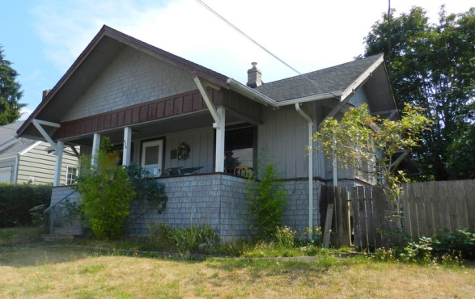

HRI#: MAP#: 25
Address: 416 Jason Avenue N.

Historic Name: Louis & Pearl Becvar House
Common Name:
Legal Description: Clarks 1st Add. to Kent, Block 4 Lots 7-8 Parcel #161200-0455
Date built: 1941

Louis and Pearl Becvar lived here from 1941 into the 1960s.
Property Description: Minimal Traditional

Current Photograph:

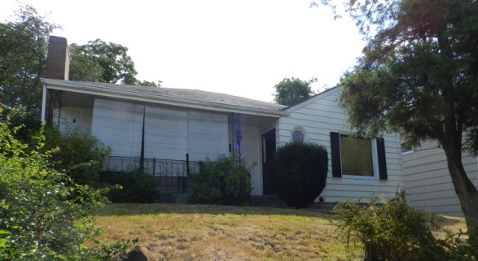
HRI#: MAP#: 26
Address: 414 Jason Avenue N.

Historic Name: Anderson House
Common Name:
Legal Description: Clarks 1st Add. to Kent, Block 4 Lot Parcel #161200-0465
Date built: 1910

Property Description: Gable front vernacular
Current Photograph:

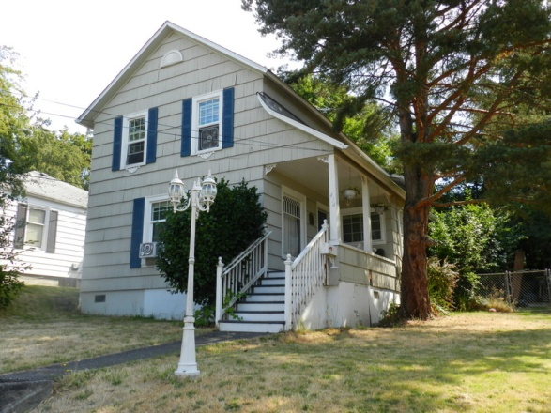

HRI#: MAP#: 27
Address: 701 E. Temperance Street

Historic Name: Barton House
Common Name:
Legal Description: Clarks 1st Add. to Kent, Block 4 Lot Parcel #161200-0480
Date built: 1909

Property Description: This front-gable Craftsman house sits on a corner lot, slightly above the street with a rockery and lawn. It has deep eaves with knee brackets. Cladding is large wood shingles on the lower level with smaller shingles above; wide belt courses run above the window on both the first and second stories, dividing the facade into three sections. The recessed entry is at the southeast corner, with paired posts at the corner.

Jack Bush, owner of Bush Hardware at 1st Avenue and Gowe Street, lived here from 1940-50.

Current Photograph:

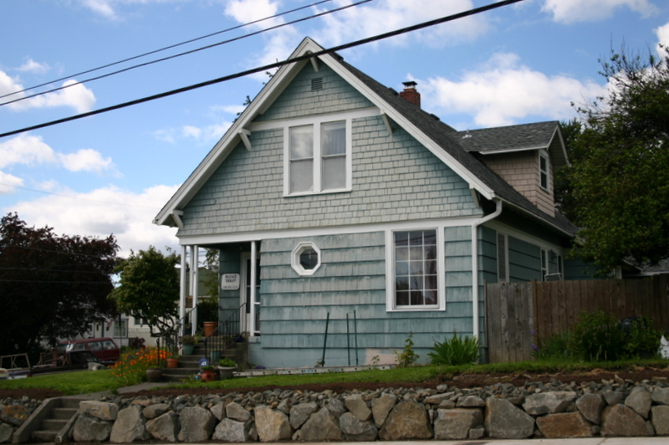

HRI#: MAP#: 28
Address: 709 E. Temperance Street

Historic Name: Wall House
Common Name:
Legal Description: Clarks 1st Add. to Kent, Block 4 Lot Parcel #161200-0475
Date built: 1910

Property Description: Vernacular

Current Photograph:

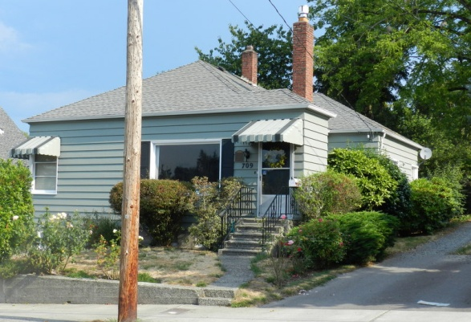

HRI#: MAP#: 29
Address: 704 E. Temperance Street

Historic Name: Knapstad House
Common Name:
Legal Description: Parcel #192205-9035
Date built: 1947

Property Description: Ranch

Current Photograph:

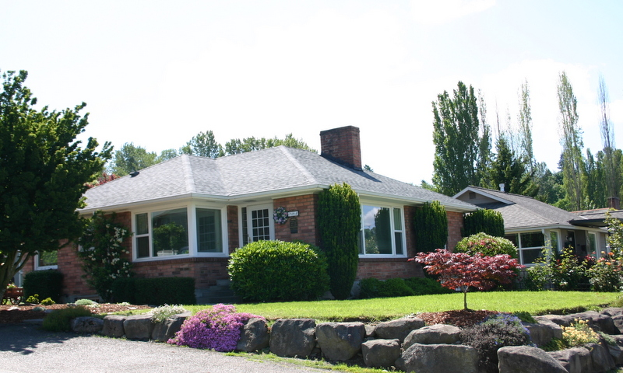

HRI#: MAP#: 31
Address: 314 Jason Avenue N.

Historic Name: Hirfeman House
Common Name:
Legal Description: Parcel #192205-9155
Date built: 1944

Property Description: Minimal Traditional

Current Photograph:

HRI#: MAP#: 32
Address: 431 Prospect Avenue N.

Historic Name: Calhoun House
Common Name:
Legal Description: Clarks 1st Add. to Kent, Block 4 Lot Parcel #161200-0550
Date built: 1910

Property Description: This vernacular house sits on a mid-block lot with a narrow front yard plus rear and side yards landscaped with lawn, numerous ornamental shrubs and several large mature trees. It has a gable-and-wing form with narrow enclosed eaves. It has an at-grade concrete stoop covered by a hip roof. Cladding is wide wood clapboard. Windows are simply framed and are mostly 1/1 double hung vinyl or aluminum, but retain original openings. It was converted from a single family to a fourplex in the 1940s. ????

It was the home of I.P. (Ike) Calhoun, the 9th mayor of Kent from 1911-1912.

Current Photograph:

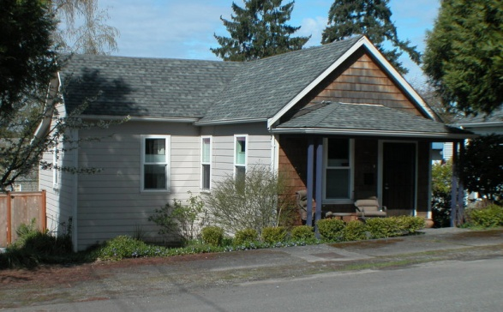

HRI#: MAP#: 33
Address: 421 Prospect Avenue N.

Historic Name: Ramstead House
Common Name:
Legal Description: Clarks 1st Add. to Kent, Block 4 Lot Parcel #161200-0540
Date built: 1931

Property Description: Side Gable vernacular

Current Photograph:

HRI#: MAP#: 34
Address: 417 Prospect Avenue N.

Historic Name: Unk House
Common Name:
Legal Description: Clarks 1st Add. to Kent, Block 4 Lot Parcel #161200-0530
Date built: 1947

Property Description: Ranch

Current Photograph:

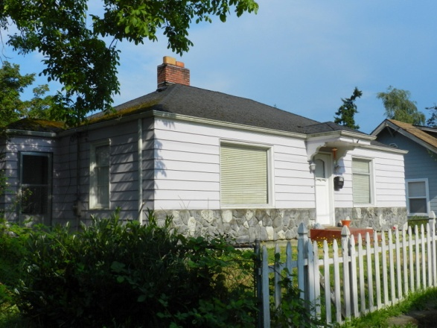

HRI#: MAP#: 35
Address: 413 Prospect Avenue N.

Historic Name: Calhoun House
Common Name:
Legal Description: Clarks 1st Add. to Kent, Block 4 Lot Parcel #161200-0515
Date built: 1904

Property Description: Vernacular side gable

Calhoun was mayor of Kent 1911-1912.

Current Photograph:

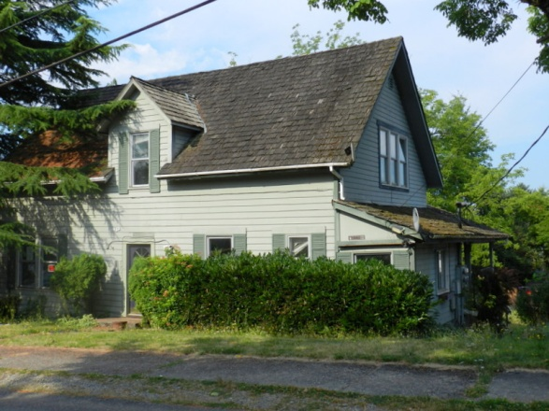

HRI#: MAP#: 36
Address: 715 E. Temperance Street

Historic Name: Harold Anderson House
Common Name:
Legal Description: Clarks 1st Add. to Kent, Block 4 Lot Parcel #161200-0505
Date built: 1959

Property Description: Ranch

Harold Anderson was a fireman with the Kent Fire Department and later worked as a supervisor at Howard Manufacturing.

Current Photograph:

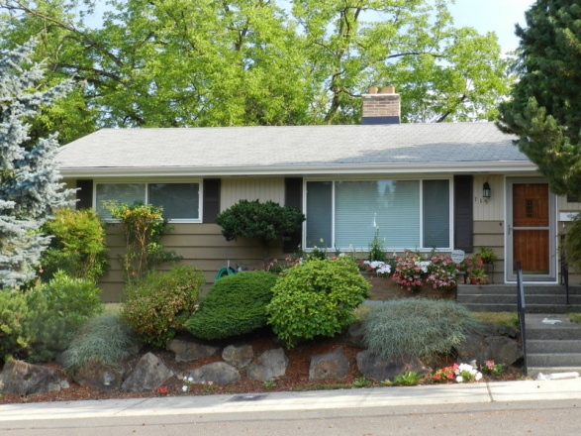

HRI#: MAP#: 39
Address: 808 E. Temperance Street

Historic Name: Henning House
Common Name:
Legal Description: Parcel #192205-9138
Date built: 1942

Property Description:

In the 1940s-50s, the house was owned by Phyllis Cavanaugh.

Current Photograph:

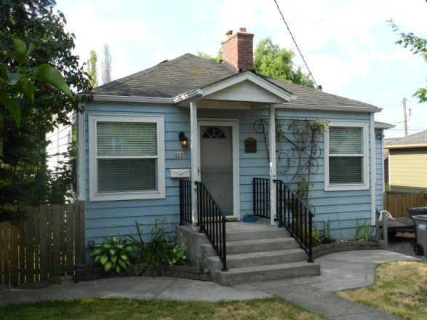

HRI#: MAP#: 40
Address: 438 Prospect Avenue N.

Historic Name: W. W. Young House
Common Name:
Legal Description: Clarks 1st Add. to Kent, Block 4 Lot Parcel #161200-0280
Date built: 1906

Property Description: Gable and wing vernacular
Father of R. E. Young.

Current Photograph:

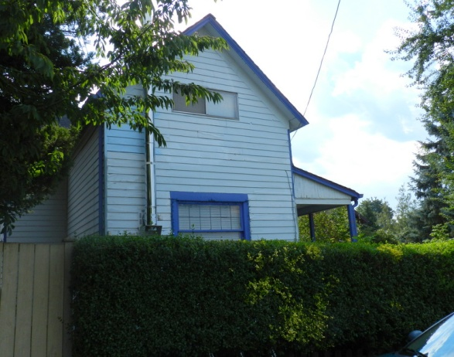

HRI#: MAP#: 41
Address: 426 Prospect Avenue N.

Historic Name: Robert & Sadie Young House
Common Name:
Legal Description: Clarks 1st Add. to Kent, Block 3 Lots 3-6 Parcel #161200-0295
Date built: 1916

Property Description: Craftsman bungalow

R.E. (Rob) Young was the first Rural Postal Carrier of Kent. Rob bought his property from his father W.W. Young. He and his wife Sadie built this house along with a carriage barn for his horse and buggy which he used for mail delivery. Mrs. Sadie Young lived in the home until 1980. There is still a cousin in the Young family living in the neighborhood on Clark Avenue.

Current Photograph:

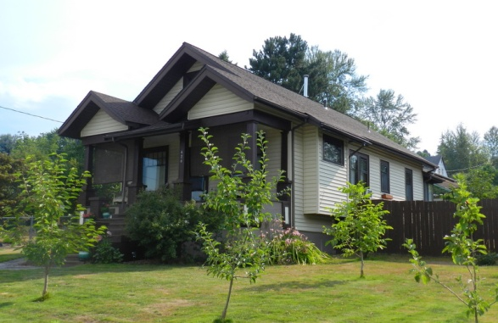

HRI#: MAP#: 42
Address: 420 Prospect Avenue N.

Historic Name: Cook House
Common Name:
Legal Description: Clarks 1st Add. to Kent, Block 3 Lot Parcel #161200-0320
Date built: 1922

Property Description: Craftsman bungalow

Current Photograph:

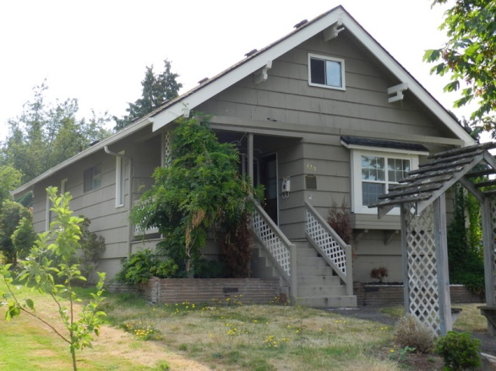

HRI#: MAP#: 43
Address: 410 Prospect Avenue N.

Historic Name: Louis & Pearl Bevcar House
Common Name:
Legal Description: Clarks 1st Add. to Kent, Block 3 Lot Parcel #161200-0330
Date built: 1940

Property Description: Vernacular

Current Photograph:

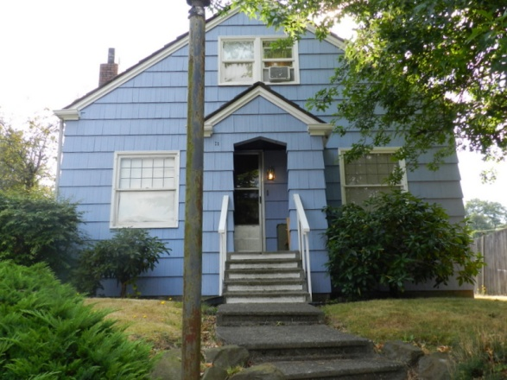

HRI#: MAP#: 44
Address: 404 Prospect Avenue N.

Historic Name: Matson House
Common Name:
Legal Description: Clarks 1st Add. to Kent, Block 3 Lot Parcel #161200-0350
Date built: 1937

Property Description: Vernacular

Current Photograph:

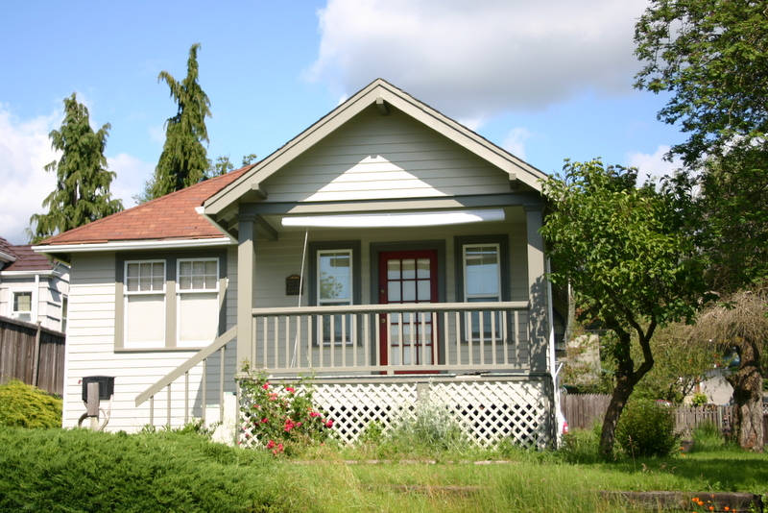

HRI#: MAP#: 47
Address: 855 E. Smith Street

Historic Name: Bereiter House
Common Name:
Legal Description: Parcel #192205-9105
Date built: 1908

Property Description:

Mr. Bereiter was Mayor in 1912-1913. The property was originally bought from Jason Clark by William E. Swentzel on January 16, 1900. Several others owned the property until Emil W. Bereiter bought the property on July 26, 1907 from August Teel. Bereiter began construction of a house using wood from the Bereiter Mill located in the Covington area. He finished the house in 1908, moving in with his wife and two small boys. Designated a City of Kent landmark in 2008.

Features of Significance:

Current Photograph:

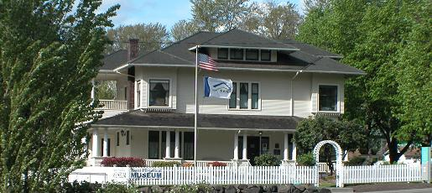

HRI#: MAP#: 49
Address: 431 Hazel Avenue N.

Historic Name: Williams House
Common Name:
Legal Description: Clarks 1st Add. to Kent, Block 3 Lot Parcel #161200-0410
Date built: 1958

Property Description: Ranch

Current Photograph:
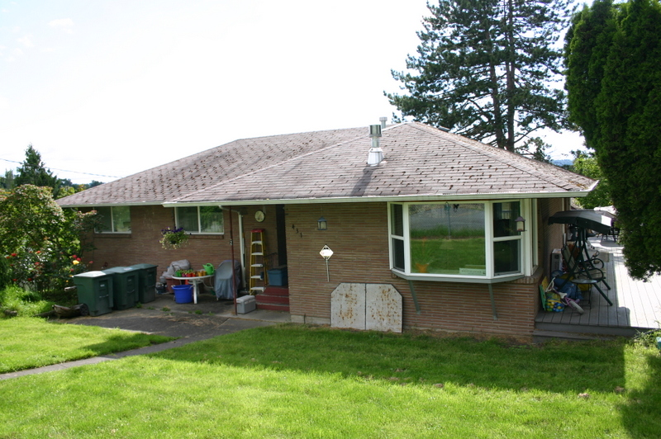

HRI#: MAP#: 52
Address: 415 Hazel Avenue N.

Historic Name: Unk House #3
Common Name:
Legal Description: Clarks 1st Add. to Kent, Block 3 Lots 3-6 Parcel #161200-0380

Date built: 1954

Property Description: Minimal Traditional

Current Photograph:

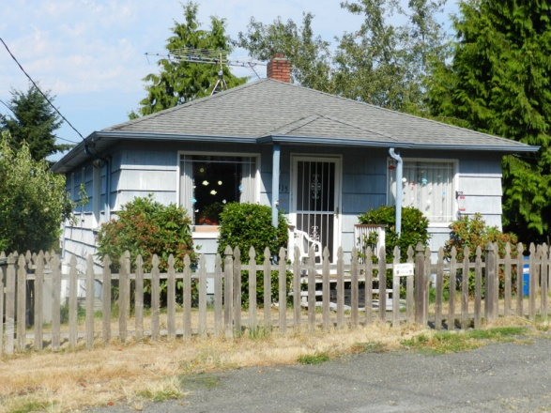

HRI#: MAP#: 54
Address: 387 Hazel Avenue N.

Historic Name: Albert E. Smith House
Common Name:
Legal Description: Parcel #192205-9344
Date built: 1908

Property Description: Hip-roofed cottage

Albert Smith operated the Kent Mill Company.

Current Photograph:

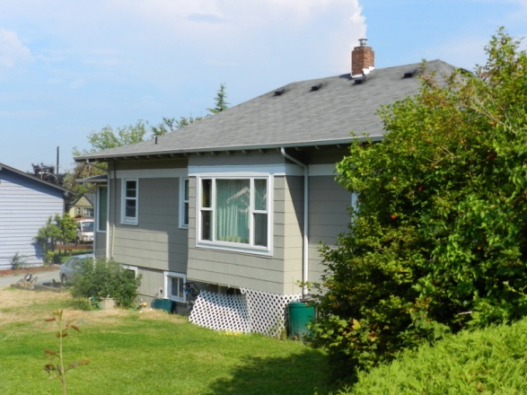

HRI#: MAP#: 56
Address: 347 Hazel Avenue N.

Historic Name: Berg House
Common Name:
Legal Description: Parcel #192205-9124
Date built: 1910

Property Description: This house sits on a mid-block lot with lawn and numerous ornamental shrubs. It has a hip roof with a central hipped front dormer. The eaves are wide and are supported by exposed rafter tails with a decorative rounded end. The house has a full width porch with a hipped roof and a closed, coursed shake railing. Columns are an extension of the coursed wood shakes
with the upper half composed of two or three square wood columns grouped together. The upper 2/3 of
the building is clad in wood drop siding and the lower 1/3 below a simple water table consists of coursed
wood shakes. Windows are simply framed and are mostly multi-light/1 single hung wood. The front
gable has a pair of windows. Several windows have been replaced with multi-light/1 vinyl or aluminum.

Current Photograph:

HRI#: MAP#: 57
Address: 833 E. Smith Street

Historic Name: George Berlin House
Common Name:
Legal Description: Parcel #192205-9106
Date built: 1909

Property Description:

This vernacular front gable house sits on a corner lot with a narrow front yard plus rear and side yards with several
mature trees and numerous ornamental shrubs. there is a large 1-1/2 story garage facing east. The house has a full width front porch with a hipped roof and a closed, short, horizontal wood sided railing. Columns are narrow turned wood
columns. A one-story side addition has a side gable roof and full width porch with similar details. Cladding wood tongue & groove siding. Windows have wide wood surrounds with decorative hoods. All windows appear to be 1/1 double hung wood, and several have narrow shutters. The chimneys have been enclosed with wood siding.

Current Photograph:

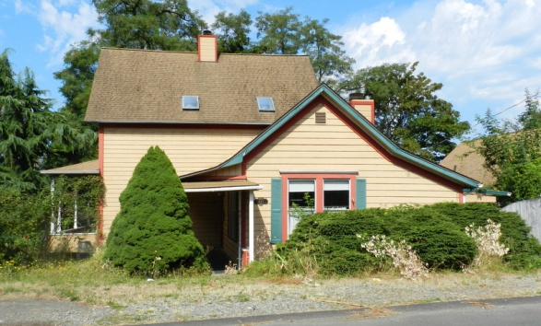

HRI#: MAP#: 59
Address: 336 Hazel Avenue N.

Historic Name: Goss House
Common Name:
Legal Description: City View Add. To Kent Block 1 Lot 12 Parcel #159860-0120
Date built: 1937

Property Description:

Current Photograph:

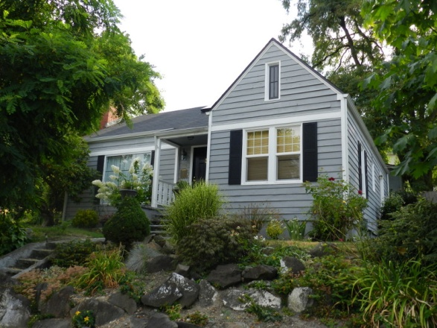

Bibliography

Bagley, Clarence. History of King County, Washington. Chicago-Seattle: Clarke Publishing Company, 1929.
Greater Kent Historical Society. "Kent …Then and Now 1900 to 1960."

King County Property Records, Washington State Archives Puget Sound Branch.

Lentz, Florence K. Kent Valley of Opportunity: An Illustrated History. Chatsworth, CA: Windsor Publications, 1990.

Polk’s King County Directory. R.J. Polk Publishing Co.

Van Nest, Linda. Kent, Washington a Historical Overview

- Owners of Property

See CONTRIBUTING PROPERTIES MASTER LIST (attached)

See NON-CONTRIBUTING PROPERTIES MASTER LIST (attached)

Verbal Boundary Description

The geographic area bounded on the east by Hazel Avenue N., on the west by the alley west of Clark Avenue N., on the south by E. Temperance Street, and on the north by Cedar Street (excluding Clarks First Addition to Kent, Block 4, Lots 25-26), and including all bounding roads and alleys to their centerlines.

Also included within the boundary these parcels:

Clarks First Addition to Kent
Block 1, Lots 9-13

Clarks Second Addition to Kent
Block 2, Lots 7-8

City View Addition to Kent Block 1 Lot 12

(Note: I need to add parcel numbers for the unplatted lots south of Temperance)

